revised Feb.12, 2011

How Can Commodity Exporters
Make Fiscal and Monetary Policy Less Procyclical?
Jeffrey Frankel, Harvard University

In Beyond the Curse: Policies to Harness the Power of Natural Resources,
edited by Rabah Arezki, Thorvaldur Gylfason and Amadou Sy,
(International Monetary Fund, Washington, DC, 2011).

This paper was originally prepared for a High Level Seminar on Natural Resources,
IMF Institute and Central Bank of Algeria, Algiers, November 4-5, 2010.
The author would like to thank Jesse Schreger for exceptional research assistance; Rabah Arezki, Thorvaldur Gylfason, Philippe Martin, and Klaus Schmidt-Hebbel for comments; and the Weatherhead Center for International Affairs at Harvard for support.

Abstract
Fiscal and monetary policy each has a role to play in mitigating the volatility that stems from the large trade shocks hitting commodity-exporting countries. All too often macroeconomic policy is procyclical, that is, destabilizing, rather than countercyclical. This paper suggests two institutional innovations designed to achieve greater countercyclicality, one for fiscal policy and one for monetary policy. The proposal for fiscal policy is to emulate Chile’s structural budget rule, and particularly its avoidance of over-optimism in forecasting. The proposal for monetary policy is called Product Price Targeting (PPT), an alternative to CPI-targeting that is designed to be more robust with respect to terms of trade shocks.

- The problem of procyclicality

Countries dependent on exports of oil, minerals, and other primary commodities tend to have pronounced economic cycles. Although this cyclical variability is to some extent inevitable, some of its impact can be reduced through well-chosen regimes for monetary and fiscal policy.
That developing countries tend to experience larger cyclical fluctuations than industrialized countries is only partly attributable to commodities. It is also in part due to the role of factors that “should” moderate the cycle, but in practice seldom operate that way: procyclical capital flows, procyclical monetary and fiscal policy, and the related Dutch Disease. Capital flows, fiscal policy, monetary policy, and sectoral allocation each tend to be more procyclical in commodity producing countries than economists’ models often assume. If anything, they tend to exacerbate booms and busts instead of moderating them. It does not have to be this way. The hope that improved policies or institutions might reduce this procyclicality makes this one of the most potentially fruitful avenues of research in emerging market macroeconomics.

  - The procyclicality of capital flows to developing countries
According to the theory of intertemporal optimization, the problem of commodity volatility should be solved by international financial markets. Countries should borrow during temporary downturns, to sustain consumption and investment, and should repay or accumulate net foreign assets during temporary upturns. In practice, it does not always work this way. Capital flows are more often procyclical than countercyclical. Most theories to explain this involve imperfections in capital markets, such as asymmetric information or the need for collateral.
In the commodity and emerging market boom of 2003-2008, net capital flows typically went to countries with current account surpluses, especially commodity producers and Asian countries, where they showed up in record accumulation of foreign exchange reserves. This was in contrast to the two previous cycles, 1975-1981 and 1990-97, when the capital flows to developing countries largely went to finance current account deficits. As developing countries evolve more market-oriented financial systems, capital inflows during the boom phase show up increasingly in prices for land and buildings, and also in prices of financial assets.

One interpretation of procyclical capital flows is that they result from procyclical fiscal policy: when governments increase spending in booms, some of the deficit is financed by borrowing from abroad. When they are forced to cut spending in downturns, it is to repay some of the excessive debt that they incurred during the upturn. Another interpretation of procyclical capital flows to developing countries is that they pertain especially to exporters of commodities. We consider procyclical fiscal policy in the next sub-section, and return to the commodity cycle (Dutch disease) in the one after.
  - The procyclicality of fiscal policy

Many authors have documented that fiscal policy tends to be procyclical in developing countries, in comparison with industrialized countries. Procyclicality is especially pronounced in countries that possess natural resources and where income from those resources tends to dominate the business cycle. Most studies look at the procyclicality of government spending, because tax receipts are endogenous with respect to the business cycle. An important reason for procyclical spending is that government receipts from taxes or royalties rise in booms, and the government cannot resist the temptation or political pressure to increase spending proportionately, or even more than proportionately.

Figure 1, taken from Kaminsky, Reinhart and Vegh (2005), displays each country’s correlation between government spending and GDP. They range from a correlation approaching -1 for Finland, denoting a strongly countercyclical policy, to a correlation approaching +1 for Oman, denoting a strongly procyclical policy. The interesting thing about the graph is that a heavy majority of the advanced countries, which are represented by black bars, show countercyclical spending, while a heavy majority of the other countries show procyclical spending.

Figure 1: Cyclical correlation of government spending and GDP
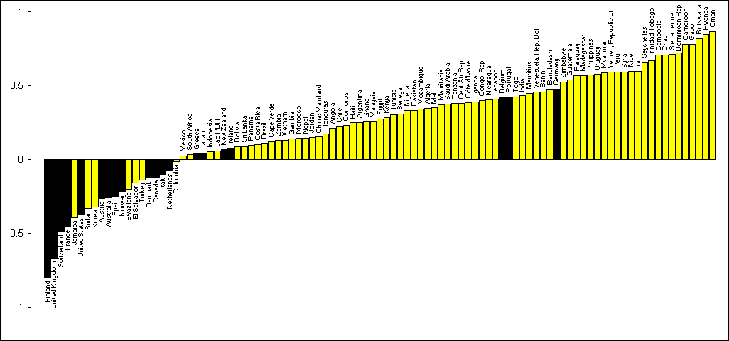
Source: Kaminsky, Reinhart & Vegh (2005)
Two large budget items that account for much of the increased spending from commodity booms are investment projects and the government wage bill. Regarding the first budget item, investment in infrastructure can have large long-term pay-off if it is well designed; too often in practice, however, it takes the form of white elephant projects, which are stranded without funds for completion or maintenance when commodity price goes back down (Gelb, 1986). Regarding the second budget item, Medas and Zakharova (2009) point out that oil windfalls have often been spent on higher public sector wages. They can also go to increasing the number of workers employed by the government. Either way, they raise the total public sector wage bill, which is hard to reverse when oil prices go back down.
In a boom such as 2003-08, one does not want expansionary spending and monetary policy that exacerbate overheating, loss of competitiveness, debt, asset bubbles, and overexpansion of the construction sector, at the expense of manufacturing and other non-mineral exports.

  - The macroeconomics of the Dutch Disease
The Dutch Disease can be viewed as an example of the procyclicality we have in mind, defined as a boom in government spending, construction, and other non-traded goods and services, that arises in response to a strong, but perhaps temporary, upward swing in the world price of the export commodity. The typical symptoms include:
- a large real appreciation in the currency (taking the form of nominal currency appreciation if the country has a floating exchange rate or the form of money inflows and inflation if the country has a fixed exchange rate);
- an increase in spending (especially by the government, which increases spending in
- an increase in the price of nontraded goods (goods and services such as housing that are not internationally traded), relative to traded goods (manufactures and other internationally traded goods other than the export commodity);
- a resultant shift of labor, capital and land out of non-export-commodity traded goods (pulled by the more attractive returns in the export commodity and in non-traded goods and services);
- high interest rates (attracting a capital inflow); and
- a current account deficit (thereby incurring international debt that may be difficult to service when the commodity boom ends).

When crowded-out non-commodity tradable goods are in the manufacturing sector, the feared effect is deindustrialization. In a real trade model, the reallocation of resources across tradable sectors, e.g., from manufactures to agriculture, may be inevitable regardless of macroeconomics. But the movement into non-traded goods is macroeconomic in origin.
What makes the Dutch Disease a “disease?” One interpretation, particularly relevant if the complete cycle is not adequately foreseen, is that the process is all painfully reversed when the world price of the export commodity goes back down. A second interpretation is that, even if the perceived longevity of the increase in world price turns out to be accurate, the crowding out of non-commodity exports is undesirable, perhaps because the manufacturing sector has externalities for long-run growth from learning by doing (as in van Wijnbergen, 1984, Matsuyama, 1992, and Gylfason, Herbertsson and Zoega, 1999).

d. The cyclicality of monetary and fiscal policy
How can monetary and fiscal policy be made more countercyclical, or at least less procyclical? The first step is to recognize the problem. That is a real challenge. At any point in time, in any country, the debate is usually between those arguing in favor of or against government expansion. It takes a longer-term perspective to frame the case in terms of the complete business cycle: less government expansion during booms, counterbalanced by more during busts. This is especially true in commodity producing countries, where the temptation to spend the wealth at times when the world market for commodities is booming is overwhelming, and where the cut-off of funds when the market goes bust is absolute. Countries experiencing a commodity boom, especially those that have discovered oil or other resources for the first time, need to realize how many times other countries have been down this road before, and how often it has ended in tears.
But it is not enough just to recognize the desirability of countercyclical policy. We have learned that simply telling a country in a boom that it should take advantage of the opportunity to save won’t necessarily deliver the desired result – whether it is a small oil producer or the United States of America. Policy-makers are typically already aware of the point. But politics is too strong, including populist attitudes among the public and politicians who too often get away with spending to further their own ends while pretending to do the opposite.
We need longer-term institutions that will help governments achieve countercyclicality in the long run, in the real world where short-term political pressures are strong and leaders are human. We need to set up regimes ex ante, which are more likely to deliver the right result ex post, in a world inhabited by human beings, not angels.
Where to find examples of good institutions? Until recently, the answer seemed to be that developing countries should look toward the US and other advanced countries for models of good institutions: democracy, rule of law, Anglo-American style corporate governance and securities markets, etc. The last decade, including the global financial crisis, showed that all was not well with American or British institutions. The US, UK, and other advanced countries don’t have all the answers. This proposition has since 2007 become familiar in such areas as corporate governance and banking. But the topic at hand is monetary and fiscal policy. Even here, developing and emerging market countries can no longer rely uncritically on the institutions of advanced countries as their template.
An example in the making of fiscal policy is the role of government forecasting as an input to the process. There was a time when the major advanced countries tended, on average, to follow countercyclical fiscal policy: cutting taxes and increasing spending in recessions, followed by fiscal consolidation during booms. The last decade has been very different. The United States, United Kingdom and other advanced countries have forgotten how to run countercyclical fiscal policies. They failed to take advantage of the 2001-2007 expansion to run budget surpluses. Instead they ran up a lot of debt. Thus by 2010, they felt constrained by that debt to launch fiscal tightening at a time when unemployment was still very high. That describes a decade of fiscal policy that was procyclical, that is, destabilizing. Biased government forecasting played a major role in this policy mistake. The grossly overoptimistic budget forecasts made by the US Administration from January 2001 led directly to the adoption of long-term policies entailing massive tax cuts and accelerated government spending.
Continental European countries have not been much better. The worst cases of destabilizing or procyclical fiscal policy countercyclicality, of course are countries Iceland, Greece, and Portugal. Meanwhile, in the course of the same decade, some emerging market countries learned how to run countercyclical fiscal policy (China, Chile). Even many former debt crisis sufferers (Brazil, Indonesia, Malaysia, Mexico, and South Africa) now have higher credit ratings than some of the less fortunate advanced countries. This is part of a general historic role reversal between some emerging markets and advanced countries.
A second specific example, in the case of monetary policy, is Inflation Targeting. The first countries to adopt IT were rich countries: New Zealand, Canada, Sweden and the United Kingdom. Beginning around 1999, many middle-sized middle-income developing countries followed suit. IT became the new conventional wisdom, favored by colleagues in monetary economics, the IMF, and central bankers the world round. But the global financial crisis of 2007-09 pointed up some of the serious limitations of IT. Some modifications may be in order, as we will see.
The remainder of this paper aims to present two proposals, one pertaining to fiscal policy and one to monetary policy, for specific regimes or institutions that might help achieve more countercyclicality. Both are designed especially for countries that are subject to volatile terms of trade, such as exporters of oil or minerals. The proposals can be phrased briefly. For fiscal policy: I propose that many countries could usefully emulate the structural budget institutions that Chile has employed over the last decade. For monetary policy: I propose that countries which are vulnerable to high variability in their terms of trade should adopt a different form of Inflation Targeting that I call PPT, for Product Price Targeting. The difference versus regular IT is that instead of using the CPI as a target, central banks use a price index that emphasizes the commodities that are produced at home and exported. Oil producers should target a price index that gives a weight to oil commensurate with its importance in production, which will be much larger than its share in consumption, and that does not include products that it consumes solely by import.

II. Proposal to make fiscal policy more countercyclical:
emulate Chile’s structural budget rule institutions

Chile’s economic growth since 1984, presumably related to several waves of serious reforms, has far outstripped that of its Latin American neighbors. Its income per capita rose from 10% of the US level in 1984, to 14% in 2000, and 20% in 2010.
Since 2000, fiscal policy in Chile has been governed by a structural budget rule that has succeeded in implementing countercyclical fiscal policy. The key innovation is that the estimates of the two most important inputs in the breakdown of the budget between structural and cyclical components – trend output and the trend price of copper – are computed by independent expert panels and are thus insulated from the political process. Chile’s fiscal institutions could usefully be emulated everywhere, but especially in other commodity-exporting countries.

Chile is not the only country to have made progress in the direction of countercyclical fiscal policy in recent years. But it is a particularly striking case, because it has beaten the curse of procyclicality via the innovation of a set of fiscal institutions that are designed to work even in a world where politicians and voters are fallible human beings rather than angels. The proposition that institutions are key, that one is less likely to get good policies in the absence of good institutions, has popped up everywhere in economics in recent years. What is sometimes missing is examples of very specific institutions that countries might wisely adopt, institutions that are neither so loose that that their constraints don’t bind nor so rigid that they have to be abandoned subsequently in light of circumstances.
Chile’s fiscal policy is governed by a set of rules. The first rule sets a target for the overall budget balance. The target surplus was originally set at a surplus of 1 % of GDP, for three purposes: (i) recapitalizing the central bank, which inherited a negative net worth from bailing out the private banking system in the 1980s and from some sterilization of inflows in the 1990s, (ii) funding some pension-related liabilities, and (iii) servicing net external dollar debt. The target was subsequently lowered to ½ % of GDP in 2007, and again to 0 in 2009, as it was determined that the debt had been essentially paid off and that a structurally balanced budget was economically appropriate.

Budget rules do not necessarily help, in themselves
A budget balance target may sound like the budget deficit ceilings that supposedly constrain members of euroland (deficits of 3 % of GDP under the Stability and Growth Pact) or like the occasional U.S. proposals for a Balanced Budget Amendment (zero deficit). But those attempts have failed. They are too rigid to allow the need for deficits in recessions, counterbalanced by surpluses in good times.
It is not always the case that “tougher” constraints on fiscal policy increase effective budget discipline. Countries often violate their constraints. In an extreme set-up, a rule that is too rigid – so rigid that official claims that it will be sustained are not credible -- might even lead to looser fiscal outcomes than if a more moderate and flexible rule had been specified at the outset. The case of rules that are too onerous to last arises particularly in the stochastic context. A target that might have been a reasonable goal ex ante, such as an unconditionally balanced budget, becomes unreasonable after an unexpected shock, such as a severe fall in export prices or national output.
This is true both in cases where an ex post shock renders a given ex ante budget target undesirable in a short-term economic sense (so that maintaining long-term credibility is the only economic argument for abiding by the rule) and in cases where the target may remain economically desirable in itself, but is up against predictably irresistible political pressures. Common examples of the first sort are rigid balanced budget rules that do not allow the possibility of fiscal deficits in bad times. Common examples of the second sort are provisions for Special Fiscal Institutions that may have been written out to please the World Bank or IMF, but without local elites “taking ownership” of the reforms, let alone winning public support for them. Such institutions, which include fiscal rules and fiscal responsibility legislation, are often abandoned before long.

A sensible alternative is to specify rules that mandate changes in response to changed circumstances. In particular, instead of targeting an actual budget balance of zero, or some other numerical surplus, the rule can target a number for the structural budget. This alternative may not work, however, if the determination whether a deficit is or is not structural is made within the political process. The rule does not necessarily succeed in imposing discipline. Politicians can always attribute a budget deficit to unexpectedly and temporarily poor economic growth. Since there is no way of proving what an unbiased forecast of growth is, there is no way of disproving the politicians’ claim that the shortfall is not their responsibility.

The case of Chile and copper
Copper accounts for approximately 16% of Chile’s fiscal income: about 10% from the revenues of CODELCO, which is owned by the government, and the rest in tax revenue from private mining companies. That the figure is only 16% illustrates that Chile’s use of copper exports has not prevented it from achieving a diversified economy. Having said that, the number understates the sensitivity of the budget to copper prices. Copper profits are much more volatile than the rest of GDP. Furthermore, the mining industry tends to have a multiplier effect on the rest of GDP. Madrid-Aris and Villena (2005) argue that copper prices drive the Chilean economy. Other mineral and agricultural commodities are also important, though their prices on world markets are to some extent correlated with copper.

The central rule that makes up Chile’s structural balance regime is that the government can run a deficit larger than the target to the extent that:
(1) output falls short of its long-run trend, in a recession, or
(2) the price of copper is below its medium-term (10-year) equilibrium,
with the key institutional innovation that there are two panels of experts whose job it is each mid-year to make the judgments, respectively, what is the output gap and what is the medium term equilibrium price of copper. The experts on the copper panel are drawn from mining companies, the financial sector, research centers, and universities. The government then follows a set of procedures that translates these numbers, combined with any given set of tax and spending parameters, into the estimated structural budget balance. If the resulting estimated structural budget balance differs from the target, then the government adjusts spending plans until the desired balance is achieved.
Already by 2006 the structural budget policy had shown clear benefits. Between 2000 and 2005, public savings rose from 2.5 % of GDP to 7.9 % allowing national saving to rise from 21 % to 24 %. As a result, central government debt fell sharply as a share of GDP (especially central bank debt) and the sovereign spread gradually declined. By 2006, Chile had achieved a sovereign debt rating of A, several notches ahead of Mexico, Brazil, and other Latin American peers. By 2007 Chile had become a net creditor. By June 2010, its sovereign rating had climbed to A+, ahead of some advanced countries: Israel and Korea (A), let alone Iceland (BBB-) or Greece (BB+).
The announcement of the structural surplus rule in itself appears to have improved Chile’s creditworthiness in 2000, even before it had had time to operate. Even this early, better access to foreign capital may have helped the country to weather the 2001-02 crisis more easily than the crisis of 1982-83. Public spending fluctuated much less than in past decades, and less than income, helping to stabilize the business cycle. According to one estimate, the structural balance policy allowed a reduction in GDP volatility of 1/3 in 2001-05. Another study suggests that the policy can all-but-eliminate the effects of copper price fluctuations on the real economy.
The real test of the policy came during the latter years of the copper boom of 2003-2008. (See Figure 2.) As usual, the political pressure was to declare the increase in the price of copper permanent thereby justifying spending on a par with export earnings. The expert panel ruled that most of the price increase was temporary so that most of the earnings had to be saved. This turned out to be wise. The 2008 spike indeed partly reversed the next year. As a result, the fiscal surplus reached almost 9 % when copper prices were high. The country paid down its debt to a mere 4 % of GDP and it saved about 12 % of GDP in the sovereign wealth fund. This allowed a substantial fiscal easing in the recession of 2008-09, when the stimulus was most sorely needed.
Figure 2: The real price of copper relative to its trend
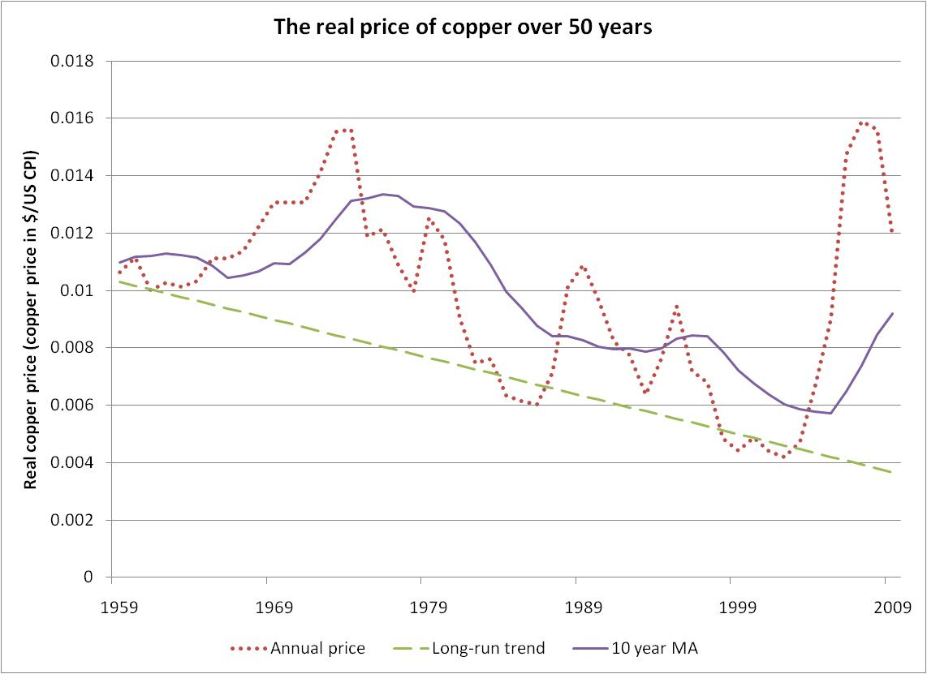

Part of the credit for Chile’s structural budget rule should go to earlier governments. But the structural budget rule became a true institution under the Bachelet government, which enshrined the general framework in law in 2006. Just as important, it abided by the law -- and in fact took extra steps to make sure the copper bonanza was saved -- when it was most difficult to do so politically. The tremendous approbation received in the public opinion polls in 2009 by President Bachelet and her Finance Minister Andres Velasco was in this sense a well-earned reward for having done the right thing.

Econometric findings of systematic over-optimism in government forecasts
Perhaps there is an error in officials’ perceptions: a high world commodity price today, during the boom, is extrapolated indefinitely far into the future, whereas in reality the real price will eventually return to some long-run equilibrium. Or else the political process may override sober judgments, so that spending responds to booms more than a rational intertemporal optimization would dictate.
I find statistical support for a series of hypotheses regarding forecasts by official agencies that have responsibility for formulating the budget (Frankel, 20010c).
- Official forecasts of budget deficits in a sample of 33 countries are overly optimistic on average.
- Official forecasts of GDP growth in the sample of 33 countries are also overly optimistic on average.
- The bias toward over-optimism is stronger the longer the horizon.
- The bias is greater among European governments that are politically subject to the budget rules in the Stability and Growth Pact. When the budget deficit is high officials are under pressure to project that it will come back down in the future, even if it won’t.
- The bias is greater at the extremes of the business cycle, particularly in booms, when the scope for wishful thinking is the greatest.
- In most countries, the real growth rate is the key macroeconomic input for budget forecasting.
- In Chile the price of copper is the key macroeconomic input for budget forecasting (as illustrated in Figure 3).
- Real copper prices mean-revert in the long run, but this is not always readily perceived.
- Private copper forecasters do incorporate a tendency for the real price to revert gradually to a long-run trend. (Figure 4 illustrates that when the price of copper goes up, neither the forward rate nor the forecasts of the Chilean expert panel rise fully in proportion.)
- Chile’s official budget forecasts are not overly optimistic on average. This is presumably a major explanation of how it has achieved its structural budget targets.

Figure 3:
The copper price is the dominant determinant of Chile’s budget balance, in the short term
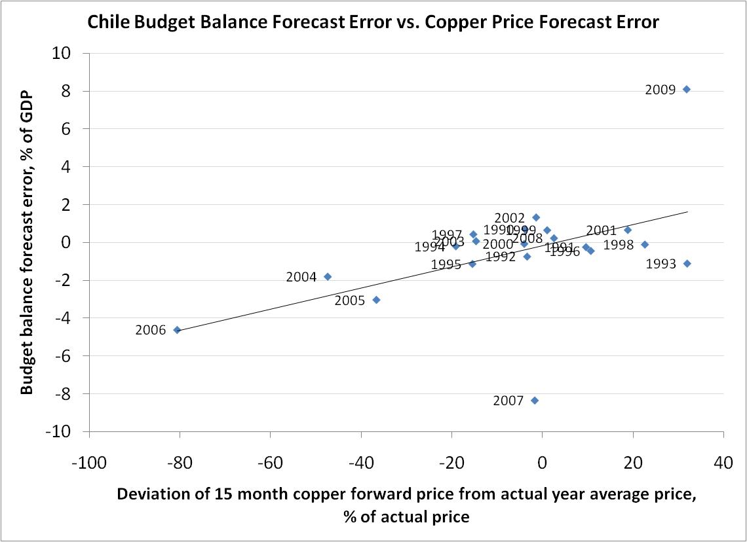
Figure 4: Copper prices – spot, forward, and forecast, 2001-2010

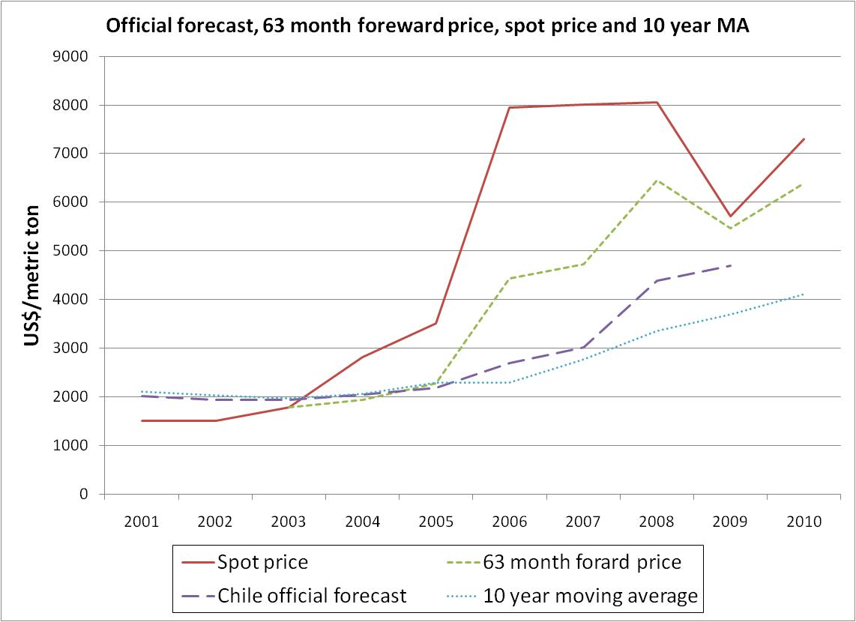

Taken together, these results tell a coherent story. Among many countries, there is a tendency toward wishful thinking in official forecasts of growth and the budget. The wishful thinking appears to take the form of unrealistic extrapolation of booms three years into the future. The bias is worse among countries that are supposedly subject to budget rules (the Stability and Growth Pact), presumably because those in the government who make the forecasts feel pressured to be able to announce that they are on track to meet the budget targets even if they are not. Chile is not subject to the same bias toward over-optimism in forecasts of the budget, growth, or the all-important copper price. This evidence is consistent with the idea that the key innovation that has allowed Chile in general to achieve countercyclical fiscal policy and in particular to run surpluses in booms is not just a structural budget rule in itself, but rather the regime that entrusts to two panels of independent experts the responsibility for estimating the extent to which contemporaneous copper prices and GDP have departed from their long-run trends.
A refinement would be to give the panels formal independence, analogous to independent central banks, so that the members could not be fired. In some countries it might be appropriate to mandate a place for foreign experts. There is nothing omniscient or magic about experts. A codified rule based on a simple 10- or 20-year moving average might do as well. The important idea is to protect budget forecasting from the inevitable political temptations.
III Proposal to make monetary policy more countercyclical:
Product Price Targeting

Three aspects of developing countries are particularly salient when choosing how to conduct monetary policy:
- They need a strong anchor for inflation expectations, some nominal variable that the central bank commits to and can be monitored by;
- They experience large supply shocks, especially fluctuations in their terms of trade;
- They cannot depend on countercyclical capital flows to smooth out trade shocks in the way that finance theory pretends.
What nominal variable should be the monetary anchor, taking into account these considerations?

The standard list of six candidates for nominal anchor
Of the nominal variables that could potentially anchor expectations, six candidates are familiar. Two were tried in the past in many countries, two were proposed in the past but never tried, and two are popular today.
Both of those that were tried historically encountered serious problems and are considered to have been somewhat discredited. The pre-1914 gold standard used the price of gold as the nominal anchor. Among its drawbacks were large shifts in the world demand and supply for gold that were needlessly translated into monetary fluctuations. Monetarism uses M1 as the nominal anchor. It was adopted by the central banks of the largest industrialized countries in the early 1980s. It was abandoned by them when shifts in the demand for money proved too destabilizing.
Economists had proposals to improve on each of those two regimes. A proposal to peg to a broader basket of commodities would have been more stable than pegging to gold alone. A proposal for Nominal Income targeting would have avoided the velocity shocks that plagued monetarism. Neither of these two candidates has ever been put into practice, however, and they are little discussed today.
That leaves the two nominal anchors that have dominated in recent years. One is the exchange rate. It remains an important option for many countries. Small open countries often go all the way to a fixed exchange rate or even monetary union. Middle-sized countries may follow a target zone or some other intermediate regime. Exchange rate targets lost some of their popularity, however, after the currency crises of the 1990s. The reigning champion, since that time, has been Inflation Targeting. Brazil, Chile, Colombia, Mexico, the Czech Republic, Poland and South Africa all switched from exchange rate targets to Inflation Targeting around 1999-2000, followed by others.
There are many different variations on the regime of Inflation Targeting (IT).
Some proposals target the price level, and some its rate of change. Some require the monetary authorities to pursue annual inflation targets and nothing else, while others are flexible, allowing diversion from the long-run inflation goal in order to put some weight in the short run on stabilizing output. Some make a distinction between targeting the expected CPI and targeting the actual CPI. Some target the headline Consumer Price Index (CPI), while some exclude the more volatile food and energy component to focus on core inflation. But almost all of them have in common that the focus is on the CPI, rather than some other sort of price index.
The CPI may not be the best choice of price index for a country that is subject to volatile terms of trade. My proposal is to replace it with a measure of product prices. It could be an index covering major export commodities, or a more comprehensive index of product prices. The important point is that it should give heavy weight to the country’s export commodities, which the CPI does not do, and that it should not give much weight to imported goods, which the CPI does do.

The procyclicality of both exchange rate targeting and IT, under trade shocks
The concern is that monetary policy can be procyclical under either an exchange rate target regime or the CPI target regime, to the extent that terms of trade shocks are important. Consider first what happens under a fixed exchange rate, when a country experiences a commodity boom. Normally this means a trade surplus -- whether the boom takes the form of an increase in supply or an increase in the dollar price of the commodity on world markets, or both. In theory, temporary trade booms and busts should be efficiently offset by intertemporally optimizing international capital flows. In practice capital flows are more likely to flow in during a commodity boom than out. The overall balance of payments rises in the boom phase and falls in the bust phase.
In the boom phase, when reserves flow in, the result is likely to be excessive expansion of money and credit, overheating and inflation, as the Gulf countries experienced during the oil boom of 2000-2008. In the bust phase, when reserves flow out, the result is often a currency crisis, featuring contraction of money and credit and a recession, as was experienced by Mexico, Indonesia, Nigeria, Russia and Ecuador when oil prices fell in the 1990s. It would be better to allow some currency appreciation in export booms and some depreciation in export busts.
This destabilizing nature of a fixed exchange rate in the presence of trade shocks is a familiar point in favor of floating exchange rates, in the classic debate over exchange rate regimes. But if the exchange rate is not to be the nominal anchor, then some other variable must fill this role. For many countries, especially those of middle size, Inflation Targeting took the place of exchange rate targeting after the experience of the 1990s.
How does Inflation Targeting fare in the face of terms of trade shocks? It too fails to accommodate fluctuations in the world price of the export commodity. When the export commodity price goes up, it would be desirable to tighten monetary policy just enough to allow some currency appreciation, in order to limit excess demand for goods (overheating which might otherwise show up, for example, in a real estate bubble). Symmetrically, when the commodity price goes down, it would be desirable to ease monetary policy enough to allow some currency depreciation, in order to limit excess supply for goods (which might otherwise show up, for example, in recession or a financial crisis). CPI targeting does not automatically produce this result.
To be sure, IT proponents usually admit that monetary policy should respond to movements in commodity prices or asset prices to the extent that they indicate future inflation. But this is not good enough. One thing we should have learned from experience with the credit cycle is that excessively easy monetary policy can lead to asset bubbles and an eventual costly crash, without goods market inflation having appeared at any stage.
Two kinds of adverse terms of trade shocks afflict small countries, and IT is insufficiently countercyclical in both cases. We have just seen that the first, a fall in the price of the export commodity, calls forth essentially no response from monetary policy. In this sense IT is acyclical. The second kind of adverse terms of trade shock is an increase in the price of the import commodity. Here IT is actually procyclical, or destabilizing. Consider an increase in the world price of oil or food from the viewpoint of a country that must import these commodities. Energy and food occupy a substantial share of the CPI. A strict interpretation of CPI-targeting, therefore, tells the central bank that it must contract monetary policy to prevent the CPI from rising. It must contract a lot: enough so that the currency appreciates by the same percentage (in terms of dollars) as the prices of food and oil have gone up (in terms of dollars). Only then will import prices stay flat in terms of domestic currency. But appreciating the currency in response to an adverse terms of trade shock is precisely the opposite of what is wanted; it exacerbates the economic impact of the disturbance.

Many IT central bankers understand well that it is not desirable to appreciate the currency in response to an import price shock. Their response is that they address this problem by targeting the core CPI, which excludes food and energy, in place of the headline CPI. Does core CPI solve the problem? Not really. For one thing food and energy need not correspond to the list of imported commodities. More importantly, it is not easy for a central bank to explain to its population that it should not worry about headline inflation because the costs that are going up are “only” the costs of filling the fuel tank and putting food on the table. Finally, there is reason to think that even those IT central banks that talk about core CPI, in fact react to an increase in imported oil by contracting and appreciating, perhaps because they feel constrained by the reputational damage that would result from headline inflation.
In South Africa, the correlation between the dollar value of the rand and the dollar price of its imports is 85%. Why is this surprising? One expects a floating currency to depreciate when the price of its imports goes up, because this is an adverse change in the terms of trade. Yet the exchange rate moves strongly the other way. Evidently South Africa’s central bank responds to increases in the dollar price of oil by tightening monetary policy enough to appreciate the rand. Why would it do that? Because it is an inflation targeter, and it seeks to avoid an increase in the CPI even when it can be traced solely to an increase in world oil prices.
Perhaps there is some other explanation for the South Africa case. But an examination of 14 oil-importing countries in Latin America reveals an interesting pattern: every one of the inflation targeters shows correlations between dollar import prices and the dollar values of their currencies that are both positive over the period 2000-2008 and greater than the correlations during the pre-IT period. The evidence supports the idea that the inflation targeters – in particular, Brazil, Chile and Peru -- tended to react to the adverse oil shocks of the decade by tightening monetary policy and thereby appreciating their currencies. The implication seems to be that the CPI which they target does not in practice entirely exclude oil price shocks. Apparently “flexible inflation targeting” is not so flexible.

Proposal to make monetary policy more countercyclical: Product Price Targeting

For countries with terms of trade volatility, I have recently proposed a new alternative, which I call PPT, for Product Price Targeting. The idea can be thought of as a modification of Inflation Targeting, with the important difference that the price index is output-oriented rather than consumption-oriented. A variety of product-oriented price indices should work. The important point is that the index should give heavy weight to commodities that are produced for export, and should give little weight to commodities that are imported. The CPI does it the other way around.
Why is the difference important? On the one hand, if the export commodity is in the index, as under PPT, then monetary policy will automatically accommodate fluctuations in the export price, a desirable property that CPI targeting unfortunately lacks. On the other hand, if the import commodity is in the index, as under CPI-targeting, then monetary policy reacts perversely to fluctuations in the import price, an undesirable property that PPT fortunately lacks. Thus PPT is more countercyclical or less procyclical than CPI targeting.
One way to think of it is that PPT delivers the best of both worlds in the classic debate over exchange rate regimes: it accommodates terms of trade fluctuation as floating is supposed to do, and yet at the same time provides a nominal anchor, as exchange rate targeting and IT are supposed to do.

Modest and practical steps toward PPT

Any monetary authorities who are sufficiently worried about terms of trade fluctuations and government to be intrigued by the arguments for an output-based inflation target could approach it in a very gradual and low-risk manner.
The first step for a government wishing to dip its toe in these waters is to compute an index of product prices and then publish it. This could simply be the GDP deflator that most countries already compute on a quarterly basis. But a monthly frequency would be better, and most countries do not collect GDP accounts monthly. A monthly Wholesale Price Index or Producer Price Index might serve. But the WPI and PPI weight sectors according to their gross sales, rather than value added, with the result that they in effect often give more weight to inputs, including imported inputs, than desired. The preferred Product Price index could gather its component prices much as firms’ prices are gathered for the PPI, but the weights on the sectors would be based on value added, as in the National Income and Product accounts. There is a need for research to develop the most suitable price index for the purpose. But the administrative and computational requirements need not be a constraint in the meantime. Any government that currently gathers a monthly CPI can gather a monthly Product Price index, with the weights taken from measures of national output rather than from household consumption surveys.
The second step would be for the central bank to announce that it is monitoring the index. The third step would be full Product Price Targeting: each year the central bank sets an explicit target range for inflation, as measured by the index. It would operate like regular inflation targeting, except that there is no need for embarrassing departures from the announced target when terms of trade shocks hit.

Alternative possible product-oriented price indices

I have in the past made versions of the proposal that focused exclusively on export prices, rather than including prices of all domestically produced goods and services. The simplest and earliest of these, called Peg the Export Price (PEP), was probably too crude to be practical. But a brief recounting of the idea’s evolution may reinforce the intuition underlying all the proposals, because the basic argument about terms of trade fluctuations is the same.
The idea originated in the context of African gold producers. For most countries to go on the gold standard would be to create needless volatility: monetary policy loosens every time the world price of gold goes down and tightens every time it goes up. But for a country where gold constitutes most of the export revenue, this is just what is wanted. Simulations for such gold producers as Burkina Faso, Ghana, Mali, and South Africa established the counterfactuals of what would have happened historically if one of them had pegged its currency to gold, as compared to whatever exchange rate path they in fact followed. Their currency would have automatically depreciated, stimulating exports, whenever the world gold market softened, and vice versa.
How would the PEP proposal have worked operationally? Conceptually, one can imagine the government holding reserves of gold, and buying and selling the metal whenever necessary to keep the price fixed in terms of local currency. Operationally, a more practical method would be for the central bank each day to announce an exchange rate vis-à-vis the dollar, following the rule that the day’s exchange rate target (dollars per local currency unit) moves precisely in proportion to the day’s price of gold on the London market (dollars per ounce). Then the central bank could intervene via the foreign exchange market to achieve the day’s target. The dollar would be the vehicle currency for intervention -- precisely as it has long been when a small country defends a peg to some non-dollar currency. Either way, the effect would be to stabilize the price of gold in terms of local currency. Or perhaps, since the price of gold is determined on the world market, a better way to express the same policy is stabilizing the price of local currency in terms of gold.
The PEP proposal was readily extended to other commodity producers. Nigeria and Indonesia would peg to oil, Ethiopia and Nicaragua to coffee, Zambia and Chile to copper, Guinea and Jamaica to bauxite, etc. Simulations showed that under PEP, their currencies would have depreciated in the 1990s, when commodity prices declined. This would have been helpful. Weak commodity markets contributed to balance of payments crises in many developing countries in the late 1990s. Many ended up eventually devaluing anyway, but only after painful losses of reserves, output, employment, wealth, and central bank credibility.

Commentators on the early PEP proposal pointed out that, if applied literally, it would imply a lot of volatility. They were right. For an oil exporter, every time the world price of oil goes up 50%, PEP says that the currency appreciates by 50%. Yes, this would stabilize the price of oil in terms of domestic currency, wages, and nontraded goods; but it would destabilize the prices of other tradable goods, such as manufactured products. They would have to fall 50% in terms of domestic currency, given that oil shock. This volatility would undermine attempts to diversify out of oil. Even if the qualitative argument is sound, the quantitative outcome is excessive.
Over time, I have moderated the proposal in response to such critiques. One version arises in the context of a Gulf oil exporter contemplating diversifying its peg away from a simple peg to the dollar. Kuwait, for example, in May 2007 decided to switch from a dollar peg to a currency basket. It was reacting to a depreciating dollar and rising inflation. But when the price of oil rises in terms of both dollars and euros, it can still face the problem of excessive monetary inflows and overheating. Gulf countries might consider pegging to a basket that puts 1/3 weight on the dollar, 1/3 on the euro, and 1/3 on oil. This way, when the price of oil rises or falls 30% against major currencies, the dinar automatically rises or falls by 10% against major currencies.

Most countries are not as heavily concentrated in oil exports as the Gulf producers, and even the latter wish to be more diversified. Accordingly, the next version of the proposal is to set the value of the currency in terms of a basket of exports. PEPI stands for Peg the Export Price Index: set the value of the currency by reference to an index of prices of major exports. For example the index in the case of South Africa could consist of the four leading export commodities: platinum, gold, iron ore, and coal. In that case, the index could be computed on a weekly basis, or even daily. But the spirit of diversification suggests computing as broad an index of export prices as possible, including manufactured goods as well as primary products. In that case, it would only be computed monthly. And the central bank would announce a target range – just as with IT or PPT – because it is not possible to hit such an index precisely, as it is if the anchor is gold or a foreign currency. The intervention vehicle could be either foreign exchange or domestic assets, as with other anchors.

A simple theoretical model in Frankel (2010a) derives parameter conditions under which PEPI delivers more stability than an exchange rate target. It also derives parameter conditions under which PEPI delivers more stability than a CPI target.

The argument for Product Price Targeting restated

All these versions have in common targeting a price index that puts substantial weight on the export commodity, not on the import commodity. One should not muddy the waters with too many proposals. The most practical proposal, again, is PPT: target a comprehensive index of domestically produced goods
The argument is that PPT is more robust with respect to terms of trade shocks than targeting either the CPI or the exchange rate. To illustrate, assume the shock of a sharp increase in world oil prices.
Consider first the situation of oil exporters. Under PPT, the currency appreciates automatically (in terms of dollars) along with the price of oil (in terms of dollars). To hit the target range may require a slowing in money growth and an increase in interest rates – fully appropriate when there is danger of overheating from a commodity boom. That is countercyclical monetary policy. Of course under free floating, the currency also has a tendency to appreciate during an export boom. But we know that countries need some sort of long-term anchor for expectations, to prevent chronic inflation. What is the alternative to which to compare PPT? The two leading alternatives are the CPI, under inflation targeting, and the exchange rate.

A fixed exchange rate has advantages. But it produces a destabilizing monetary policy in commodity booms. In response to the balance of payments surplus, the central bank must allow reserves to flood into the country. (Sometimes countries can sterilize, but this becomes increasingly difficult after a year or two.) The money supply increases. Easy liquidity boosts private spending. The result is inflation, particularly in prices of non-traded goods and services, sometimes excessive increases in prices of assets (such as real estate) and construction. Think of the Gulf countries over the past decade. This is procyclical monetary policy.

What about CPI targeting? If the shock is an increase in the world price of oil, and oil constitutes a small share of the CPI, then the outcome in theory is the same as an exchange rate target. Although CPI targeting usually goes with floating, the central bank if it follows the rule will be obligated to resist what would otherwise be a strong appreciation of the currency, because that would imply falling import prices. It must loosen monetary policy enough to prevent import prices from falling, which means enough to prevent the currency from appreciating. Thus we get the same procyclical outcome as under a fixed exchange rate. Easy liquidity, rising spending, and perhaps an asset bubble.

The conclusion is that PPT may dominate targeting either the CPI or exchange rate, when an oil exporter faces an increase in world oil prices.

Now continue to assume that the shock is an increase in the world price of oil, but
consider the situation of oil importers. If the country is a conventional inflation targeter, and takes seriously the rule to target the CPI, it will have to respond to a 10 % increase in the dollar oil price by contracting monetary policy enough to appreciate the currency 10%. Why? Otherwise, the price of oil will go up in terms of domestic currency, and so will the CPI. But responding to a worsening in the terms of trade by appreciating the currency is precisely the wrong direction to move. It exacerbates the adverse shock, worsens the possible recession. Procyclical. PPT, by contrast, has the advantage that because oil does not appear in the index of export prices or producer prices, no monetary contraction or appreciation is required. Thus PPT avoids the procyclicality of the CPI target.

Summary

Volatility in developing countries arises both from foreign shocks, such as the fluctuations in the price of the export commodity, and from domestic macroeconomic and political instability. Although many developing countries in the 1990s brought under control the chronic runaway budget deficits, money creation, and inflation that they tended to experience in the preceding two decades, most are still subject to monetary and fiscal policy that is procyclical rather than countercyclical: macroeconomic policies tend to be expansionary in booms and contractionary in recessions, thereby exacerbating the magnitudes of the swings. The aim should instead be to moderate the swings -- the countercyclical pattern that the models and textbooks of the decades following the Great Depression originally hoped discretionary policy would take.

This paper has examined the pitfalls of procyclicality with respect to fiscal policy, first, and monetary policy, second. For each it has proposed a specific institution or regime that might help deliver more countercyclical results: emulation of Chile’s institutions with respect to fiscal policy and Product Price Targeting for monetary policy.
The tendency to under-save mineral wealth is particularly pronounced during booms. The temptation to spend the windfall from high world prices is sometimes irresistible. When the price of the mineral eventually goes back down, countries are often left with high debt, a swollen government sector and non-tradable sector, and hollowed out non-mineral tradable goods sector. They may then be forced to cut back on government spending, completing the perverse cycle of countercyclical saving. The advice to save in a boom is standard. And there are other examples of governments that have had the courage to take away the fiscal punch bowl. What makes Chile’s institutions particularly worthy of study is that they may constitute a template that other countries can adopt, a model that can help even in times and places where the political forces to follow procyclical fiscal policy would otherwise be too strong to resist.
Specifically, Chile appears to have avoided a pattern common elsewhere of overly optimistic forecasts from the fiscal agency in boom times. Official forecasts, if not insulated from politics, tend to be overly optimistic, and that the problem can be worse when the government is formally subject to a budget rule such as the SGP. The key innovation that has allowed Chile in general to achieve countercyclical fiscal policy, and in particular to run surpluses in booms, is not just a structural budget rule in itself, but rather the regime that entrusts to panels of independent experts the responsibility for estimating the extent to which contemporaneous copper prices and GDP have departed from their long-run averages. Even though specifics differ from country to country, there is no reason why a version of Chile’s institutions cannot be emulated by other commodity-producing developing countries.

Monetary policy sometimes operates pro-cyclically in the face of terms of trade shocks, under either of two popular regimes: an exchange rate peg or CPI targeting. Neither regime entails currency movements that accommodate fluctuations in the world price of the export commodity. Worse, when the price of the imported commodity rises on world markets, CPI targeting requires an appreciation of the domestic currency, which is the opposite of accommodating the terms of trade.
The new proposals are PEPI (Peg the Export Price Index) and PPT (Product Price Targeting). Export prices are included in the price index, so the currency appreciates during commodity booms and depreciates during commodity busts. Further, there is no pressure to appreciate when the price of the import commodity rises, because it is not in the basket. An easy first step toward exploring these ideas would be for monetary authorities to collect, publish and monitor product-oriented price indices, rather than relying exclusively on any version of the CPI.
References

Aizenman, Joshua. and Yothin Jinjarak, 2009. “Current Account Patterns and National Real Estate Markets,” Journal of Urban Economics 66 (2): 75-89. [NBER WP No. 13921, 2008.]
Alesina, Alberto, Filipe Campante, and Guido Tabellini, 2008, “Why is Fiscal Policy Often Procyclical?” Journal of the European Economic Association, 6, no. 5, September, 1006-1036.

Alesina, Alberto, Ricardo Hausmann, Rudolf Hommes, and Ernesto Stein, 1999, “Budget institutions and fiscal performance in Latin America,” Journal of Development Economics, Vol. 59, 253–273.

Alesina, Alberto, and Roberto Perotti, 1995, “The Political Economy of Budget Deficits,” Staff Papers-International Monetary Fund, 42, no. 1, March: 1-31.

Alesina, Alberto and Roberto Perotti, 1996, “Fiscal Discipline and the Budget Process ,” American Economic Review, Vol. 86, No. 2, Papers and Proceedings (May), pp. 401-407.

Arezki, Rabah, and Markus Brückner, 2010a, “International Commodity Price Shocks, Democracy, and External Debt,” IMF Working Paper 10/53 (International Monetary Fund: Washington, DC).

Arezki, Rabah, and Markus Brückner, 2010b, “Resource Windfalls and Emerging Market Sovereign Bond Spreads: The Role of Political Institutions” (International Monetary Fund: Washington, DC).

Arezki, Rabah, and Kareem Ismail, 2010, “Boom-Bust Cycle, Asymmetrical Fiscal Response and the Dutch Disease,” IMF WP/10/94 (International Monetary Fund: Washington DC), April.

Broda, Christian, 2004, "Terms of Trade and Exchange Rate Regimes in Developing Countries," Journal of International Economics, 63(1), pp. 31-58.

Buchanan, James, 1967, Public Finance in Democratic Process: Fiscal Institutions and Individual Choice (University of North Carolina Press).

Calderón, César, and Klaus Schmidt-Hebbel, 2003, “Macroeconomic Policies and Performance in Latin America,” Journal of International Money and Finance 22, no.7, December, pp. 895-923.

Chen, Yu-Chin, and Kenneth Rogoff, 2003, “Commodity Currencies,” Journal of International Economics, Volume 60, Issue 1, May, Pages 133-160.

Cuddington, John, 1989, “Commodity Export Booms in Developing Countries,” World Bank Research Observer 4, 143-165.

Davis, Jeffrey, Rolando Ossowski, James Daniel, and Steven Barnett, 2001, “Oil Funds: Problems Posing as Solutions?” Finance and Development 38, no.4 (IMF, Washington DC).

Davis, Jeffrey, Rolando Ossowski, James Daniel, and Steven Barnett, 2003, “Stabilization and Savings Funds for Nonrenewable Resources: Experience and Fiscal Policy Implications,” in Jeffrey Davis, Rolando Ossowski, and Annalisa Fedelino, editors, Fiscal Policy Formulation and Implementation in Oil-Producing Countries (IMF: Washington DC). Occasional Paper 205 (International Monetary Fund), 2001b.

Debelle, Guy, 2001, “The Case for Inflation Targeting in East Asian Countries,” Future Directions for Monetary Policies in East Asia, David Gruen and John Simon, eds. (Reserve Bank of Australia).

Edwards, Sebastian, and Eduardo Levy Yeyati, 2005, “Flexible Exchange Rates as Shock Absorbers,” European Economic Review, Vol. 49, Issue 8, November, pp. 2079-05. NBER WP 9867.

Engel, Eduardo, Christopher Neilson and Rodrigo Valdés, 2009, “Fiscal Rules as Social Policy,” workshop on Myths and Realities of Commodity Dependence: Policy Challenges and Opportunities for Latin America and the Caribbean, World Bank, September 17-18.

Fraga, Arminio, Ilan Goldfajn and Andre Minella, 2003, “Inflation Targeting in Emerging Market Economies,” NBER Macro Annual 2003, edited by Ken Rogoff and Mark Gertler (MIT Press: Cambridge). [NBER WP no. 10019.]

Frankel, Jeffrey, 2002, "Should Gold-Exporters Peg Their Currencies to Gold?" Research Study No. 29 (World Gold Council, London, UK).

2003a, "A Proposed Monetary Regime for Small Commodity-Exporters: Peg the Export Price (‘PEP’),” International Finance, vol. 6, no. 1, Spring, 61-88.

2003b, "A Crude Peg for the Iraqi Dinar," Financial Times, June 13.

2003c, “Iraq’s Currency Solution? Tie the Dinar to Oil," The International Economy, Fall.

2005, “Peg the Export Price Index: A Proposed Monetary Regime for Small Countries,” Journal of Policy Modeling 27, no.4, June.

2007, “On the Rand: Determinants of the South African Exchange Rate,” South African Journal of Economics, vol.75, no.3, September, 425-441. [NBER WP No.13050.]
2008, "UAE and Other Gulf Countries Urged to Switch Currency Peg from the Dollar to a Basket That Includes Oil,” Vox, 9 July.

2010a, “A Comparison of Monetary Anchor Options, Including Product Price Targeting, for Commodity-Exporters in Latin America,” NBER WP No. 16362. To be presented at Economia, May 2011.

2010b, “The Natural Resource Curse: A Survey,” forthcoming, Export Perils, edited by Brenda Shaffer (University of Pennsylvania Press). NBER Working Paper No. 15836.

2011, “A Solution to Fiscal Procyclicality: The Structural Budget Institutions Pioneered by Chile,” forthcoming, Fiscal Policy & Macroeconomic Performance, edited by Luis Felipe Céspedes, Jordi Galí, and Yan Carrière-Swallow, 14th Annual Conference on Central Banking, Analysis, and Economic Policies (Central Bank of Chile: Santiago), November. Central Bank of Chile working paper 604, Jan. 2011, and Harvard Kennedy School RWP11-012, Feb.2011.

Frankel, Jeffrey, and Ayako Saiki, 2002, "A Proposal to Anchor Monetary Policy by the Price of the Export Commodity," J. of Econ. Integration, Sept., vol.17, no.3, 417-48.

Frankel, Jeffrey, Ben Smit, and Federico Sturzenegger, 2008, "Fiscal and Monetary Policy in a Commodity Based Economy" Economics of Transition 16, no. 4, 679-713.

Gavin, Michael and Roberto Perotti, 1997, “Fiscal Policy in Latin America,” NBER Macroeconomics Annual, Vol. 12, pp. 11-61.

Gavin, Michael, Ricardo Hausmann and Leonardo Leiderman , 1996, “Macroeconomics of Capital Flows to Latin America: Experience and Policy Issues,” Inter-American Development Bank, Research Department Working Papers number 4012.

Gavin, Michael, Ricardo Hausmann, Roberto Perotti and Ernesto Talvi, 1997, “Managing Fiscal Policy in Latin America and the Caribbean: Volatility, Procyclicality, and Limited Creditworthiness,” Revista del Banco Central de Venezuela, vol. XI (1). Inter-American Development Bank, RES Working Papers 4032, 1996.

Gelb, Alan, 1986, “Adjustment to Windfall Gains: A Comparative Analysis of Oil-Exporting Countries,” in “Natural Resources and the Macroeconomy: A Theoretical Framework,” in J.Peter Neary and van Sweder Wijnbergen, eds., Natural Resources and the Macroeconomy (MIT Press: Cambridge), 54-93.

Gylfason, T., T.T. Herbertsson and G. Zoega, 1999, “A Mixed Blessing: Natural Resources and Economic Growth.” Macroeconomic Dynamics 3: 204-225.

von Hagen, Jürgen, and Ian Harden, 1995, “Budget Processes and Commitment to Fiscal Discipline,” European Economic Review, Volume 39, Issues 3-4, April, Pages 771-779.

Hall, Robert, 1985, “Monetary Policy with an Elastic Price Standard,” Price Stability and Public Policy, Federal Reserve Bank of Kansas City.

Ilzetski, Ethan, and Carlos Vegh, 2008, “Procyclical Fiscal Policy in Developing Countries: Truth or Fiction?” NBER WP no. 14191.

Kaminsky, Graciela, Carmen Reinhart, and Carlos Vegh, 2005, "When It Rains, It Pours: Procyclical Capital Flows and Macroeconomic Policies," NBER Macroeconomics Annual 2004, Vol. 19, pages 11-82.

Keynes, John Maynard, 1938, “The Policy of Government Storage of Foodstuffs and Raw Materials,” Economic Journal, September.

Larrain, Felipe, and Francisco Parro, 2006, “Chile Menos Volatil,” Central Bank of Chile, May.

Laxton, Douglas, and Paolo Pesenti, 2003, “Monetary Rules for Small, Open, Emerging Economies,” NBER WP 9568.

Loayza, Norman, and Raimundo Soto, 2002, editors, Inflation Targeting: Design, Performance, Challenges (Central Bank of Chile: Santiago).

Madrid-Aris, Manuel, and Marcelo Villena, 2005, “The Commoditization of the Chilean Economy: Some Stylized Facts About its Economy,” Universidad Santa Maria, Chile.

Manzano, Osmel, and Roberto Rigobon, 2008, “Resource Curse or Debt Overhang,” Economia 9, no. 1, Fall. NBER WP 8390.

Marcel, Mario, Marcelo Tokman, Rodrigo Valdés, and Paula Benavides, 2001, “Structural Budget Balance: Methodology and Estimation for the Chilean Central Government 1987-2001,” Series of Studies on Public Finance, Ministry of Finance, Chile. [At http://www.dipres.cl/572/propertyvalue-15408.html.]

Matsen, Egil, and Ragnar Torvik, 2005, “Optimal Dutch Disease,” Journal of Development Economics, vol. 78, no.2.

Matsuyama, Kiminori, 1992, “Agricultural Productivity, Comparative Advantage, and Economic Growth," Journal of Economic Theory 58, December, 317-334.

McKibbin, W., and K. Singh, 2003, “Issues in the Choice of a Monetary Regime for India,” Australian National University, May 2000. Brookings Discussion Papers in International Economics No. 154, September.

Medina, Juan Pablo, and Claudio Soto, 2007, “Copper Price, Fiscal Policy and Business Cycle in Chile,” Banco Central de Chile Documentos de Trabajo, Central Bank of Chile Working Papers N° 458, Diciembre.

Meade, James, 1978, “The Meaning of Internal Balance,” The Economic Journal, vol.91, 423-35.

Medas, Paolo, and Daria Zakharova, 2009, “Primer on Fiscal Analysis in Oil-Producing Countries,” IMF Working Paper 56, March.
Mendoza, Enrique G. and P. Marcelo Oviedo, 2006, “Fiscal Policy and Macroeconomic Uncertainty in Developing Countries: The Tale of the Tormented Insurer,” NBER Working Paper No. 12586, October.
Mendoza, Enrique and Marco Terrones, 2008, “An Anatomy of Credit Booms: Evidence from Macro Aggregates and Micro Data,” NBER Working Paper No. 14049, May.
Mishkin, Frederic, 2000, “Inflation Targeting in Emerging-Market Countries,” American Economic Review 110.

Mishkin, Frederic, 2008, “Can Inflation Targeting Work in Emerging Market Countries?” in Money, Crises, and Transition: Essays in Honor of Guillermo Calvo, edited by Carmen Reinhart, Carlos Vegh and Andres Velasco. [NBER WP 10646, 2004.]

Neut, Alejandro, and Andres Velasco, 2003, “Tough Policies, Incredible Policies?” NBER WP No. 9932, September.
Ossowski, Rolando, Mauricio Villafuerte, Paulo Medas, and Theo Thomas, 2008, “Managing the Oil Revenue Boom: The Role of Fiscal Institutions,” Occasional Paper No. 260 (International Monetary Fund: Washington, DC).
Perry, Guillermo, 2003, “Can Fiscal Rules Help Reduce Macroeconomic Volatility in the Latin America and Caribbean Region?” World Bank Policy Research Working Paper No. 3080 .
Perry, Guillermo, 2009, “Beyond Lending: How Multilateral Banks Can Help Developing Countries Manage Volatility,” Center for Global Development, Washington, DC.

Persson, Torsten, and Guido Tabellini, 2004, “Constitutional Rules and Fiscal Policy Outcomes,” American Economic Review, 94, Number 1, March, pp. 25-45.

Poterba, James, 1997, “Do Budget Rules Work?” in A.Auerbach ed., Fiscal Policy: Lessons From Empirical Research (Cambridge: MIT Press). pp.53-86.

Poterba, James, and Jürgen von Hagen, 1999, Editors, Fiscal Institutions and Fiscal Performance (University of Chicago Press).

Prasad, Eswar, Kenneth Rogoff, Shang-Jin Wei and Kose, M. Ayhan, 2006, “Effects of Financial Globalization on Developing Countries: Some Empirical Evidence,” in Ann Harrison, editor, Globalization and Poverty (University of Chicago Press: Chicago). Occasional Paper No. 220, International Monetary Fund, 2003. NBER WP 10942, 2004.

Reinhart, Carmen, and Vincent Reinhart, 2009, “Capital Flow Bonanzas: An Encompassing View of the Past and Present,” in J.Frankel and C.Pissarides, eds., NBER International Seminar in Macroeconomics 2008 (University of Chicago Press: Chicago).

Rodriguez Cabello, Jorge, Carla Tokman Ramos, and Alejandra Vega Carvallo, 2007, “Structural Balance Policy in Chile,” Studies in Public Finance, Ministry of Finance, Government of Chile, December [English translation of Study no. 7, December 2006.]

Talvi, Ernesto, and Carlos Vegh, 2005, “Tax Base Variability and Procyclicality of Fiscal Policy,” Journal of Development Economics 78, no. 1, 156-190.

Tornell, Aaron, and Philip Lane, 1999, “The Voracity Effect,” American Economic Review 89, no. 1, March, 22-46.

Torvik, Ragnar, 2001, “Learning by Doing and the Dutch Disease,” European Economic Review 45, 285-306.

van Wijnbergen, Sweder, 1984, “The ’Dutch Disease’: A Disease After All?” Economic Journal 94: 41-55.

Villafuerte, Mauricio, Pablo Lopez Murphy, and Rolando Ossowski, 2010, “Riding the Roller Coaster: Fiscal Policies of Nonrenewable Resource Exporters in Latin America and the Caribbean,” IMF Working Paper 10/251, Nov.

Wyplosz, Charles, 2005, “Fiscal Policy: Institutions versus Rules,” National Institute Economic Review. Also CEPR Discussion Papers no. 3238.

E.g., Perry (2009).
Kaminsky, Reinhart, and Vegh (2005); Reinhart and Reinhart (2009); Gavin, Hausmann, and Leiderman (1996); Prasad, Rogoff, Wei, and Kose (2006); and Mendoza and Terrones (2008).
Aizenman and Jinjarak (2008) and Mendoza and Terrones (2008)
Cuddington (1989), Tornell and Lane (1999), Kaminsky, Reinhart, and Vegh (2004), Talvi and Végh (2005), Alesina, Campante and Tabellini (2008), Mendoza and Oviedo (2006), and Ilzetski and Vegh (2008).
Gelb (1986), Cuddington (1989), and Medas and Zakharova (2009). For commodity-producers in Latin America in particular: Gavin, Hausmann, Perotti and Talvi (1996); Gavin and Perotti (1997), Calderón and Schmidt-Hebbel (2003), Perry (2003), and Villafuerte, Lopez-Murphy and Ossowski (2010).
The data in this bar chart come from 1960-2003. When Carlos Vegh updates the chart through 2009, there are some changes. Most importantly for this paper, Chile switches from a positive correlation to negative.
Arezki and Ismail (2010) find that current government spending increases in boom times, but is downward-sticky.
During the boom of 2001-2008, examples of fixed-rate oil-producing countries where the real appreciation came via money inflows and inflation include Saudi Arabia and the Gulf emirates. Examples of floating-rate natural resource countries where the real appreciation took the form of nominal currency appreciation include Australia, Chile, Kazakhstan, Mexico, Norway, Russia, or South Africa. Chen and Rogoff (2003) document the sensitivity of exchange rates to commodity prices in the cases of Australia and New Zealand. Frankel (2007) does South Africa. Admittedly, the real appreciation will take place, not just under IT or an exchange rate target, but also under my PEP or PPT proposals discussed in part 3. Only capital controls and sterilized foreign exchange purchases have the potential to slow down the real appreciation; neither is likely to work for longer than a few years, if at all.
Manzano and Rigobon (2008) show that the negative Sachs-Warner effect of resource dependence on growth rates during 1970-1990 was mediated through international debt incurred when commodity prices were high. Arezki and Brückner (2010a) find that commodity price booms lead to increased government spending, external debt and default risk in autocracies, and but do not have those effects in democracies. Arezki and Brückner (2010b) find that the dichotomy extends also to the effects on sovereign bond spreads paid by autocratic versus democratic commodity producers .
In Gylfason, Herbertsson and Zoega (1999), the real appreciation lowers long-term growth because the primary sector does not experience learning by doing as the secondary sector does.
Nontraded goods can also have externalities, however, as Torvik (2001) and Matsen and Torvik (2005) point out.
For more detailed information and more references see Frankel (2011).
In the case of fiscal policy, the importance of institutions has been emphasized by Buchanan (1967), von Hagen and Harden (1995), Alesina and Perotti (1995, 1996), Poterba (1997), Poterba and von Hagen (1999), Persson and Tabellini (2004), and Wyplosz (2005). For commodity-producers more specifically: Davis et al (2001, 2003) and Ossowski, et al (2008), among others.
Rodríguez, Tokman and Vega (2007, p.5, 21).
A team of three economists appointed by Finance Minister Andres Velasco recommended reducing the structural budget target.
Neut and Velasco (2003). Certainly euro countries large and small have repeatedly violated the fiscal rules of the Stability and Growth Pact.
An econometric analysis of these Special Financial Institutions for oil-producers by Ossowski, et al (2008, pp. 19, 23, 24, 38-43) finds no statistically significant effect on the actual fiscal stance. This may be partly due to econometric limitations. But it is evidently also in part due to governments that, after having adopted these institutions, subsequently find them too rigid in practice and so weaken or abandon them. Recent examples include Ecuador, Equatorial Guinea, and Venezuela (pp. 12-13, 19, 24). Also Villafuerte et al (2010).
Their econometrics are cointegration tests and their theory is essentially classic Dutch Disease: an increase in copper prices is transmitted to the non-tradable sector via appreciation of the currency.
Rodríguez, Tokman and Vega (2007, p.27).
Ibid. (p.29-30).
Standard and Poor ratings, obtained from Bloomberg.
Rodríguez, Tokman and Vega (2007, p.30) report a turnaround in Chile’s sovereign spread from the date of the announcement in early 2000. Perry (2003, 13-14) also sees an immediate credibility effect .
Rodríguez, Tokman and Vega (2007, p.32, 33-34).
Larrain and Parro (2006).
Medina and Soto (2007) find in a DSGE model that the fiscal regime is capable of reducing the effect on Chile’s GDP of a 10 % exogenous increase in the copper price from 0.70% to 0.05%.
Keynes (1938) and Hall (1985).
While many eminent economists argued the case for nominal GDP targeting in the context of advanced countries, McKibbin and Singh (2003) is one of the few references to do it for developing countries.
Among the authors who have examined Inflation Targeting specifically for developing and emerging market countries are: Debelle (2001); Fraga, Goldfajn, and Minella (2003); Mishkin (2000; 2008); Laxton and Pesenti (2003); and many of the chapters in Loayza and Soto (2002).
Some define Inflation Targeting as broadly as “choose a long run goal for inflation and be transparent.” It is hard to argue with this. But something more specific is usually implied.
The instability of IT in the face of trade shocks is an instance of the broader instability in the face of supply shocks. (McKibbin and Singh, 2003; Frankel, Smits and Sturzenegger, 2008).
Frankel (2005, Table 2).
Frankel (2010a, Table 1).
Broda (2004) and Edwards and Levy Yeyati (2005) support the textbook proposition that floating exchange rates stabilize the economy relative to fixed rates in the presence of trade shocks.
Frankel (2002).
Frankel and Saiki (2002), Frankel (2003).
Like many basket peggers, Kuwait does not reveal what is in the basket. But the dollar and euro almost certainly constitute most of it.
Frankel (2003b, c, 2008).
Frankel (2005).
Appendix 2. One conclusion is that high variability in export markets makes it more likely that PEPI dominates a pegged exchange rate. Another sufficient (but not necessary) condition for PEPI to dominate an exchange rate target is if the traded commodity sector is larger than the nontraded goods sector.
Appendix 2. If stabilizing the CPI receives top priority in the objective function, then CPI targeting dominates by construction: terms of trade and exchange rate shocks hurt more under the PEPI rules than under inflation targeting. But trade shocks destabilize output in the non-traded and export sectors under the CPI rule, while PEPI better insulates the real economy from relative price changes. Thus if the weight in the objective function on stabilizing the CPI is small, relative to the weight on stabilizing sectoral output, then PEPI dominates.

