Bias in Official Fiscal Forecasts: Can Private Forecasts Help?

Jeffrey Frankel and Jesse Schreger
Harvard University
June 18, 2013 +MerolapubTbls&Figs + May 16, 2014
The authors wish to acknowledge capable research assistance from Marco Martinez del Angel; helpful conversations with Philip Hubbard, publisher of Consensus Economics; and support from the Smith Richardson Foundation and the Weatherhead Center for International Affairs. Views and findings are ours alone.

Abstract
Government forecasts of GDP growth and budget balances are generally more over-optimistic than private sector forecasts, in a sample of 31 countries. When official forecasts are especially optimistic relative to private forecasts ex ante, they are more likely also to be over-optimistic relative to realizations ex post. Euro area governments during the period 1999-2007 assiduously and inaccurately avoided forecasting deficit levels that would exceed the 3% Stability and Growth Pact threshold; private sector forecasters were not subject to this crude bias. Three important implications. First, the severe recessions that began in 2008 do not explain the findings of optimism bias. Second, the over-optimism behaves as if specifically designed so as to “game” checks on budget deficits, rather than by politicians’ desire to “talk up” the economy in general. Third, the budget-making process could probably be improved by using private-sector forecasts.

JEL classification numbers: E62, F3
Keywords: budget, deficit, euro, fiscal, government, optimism, optimistic, forecast, official, SGP.

Bias in Official Fiscal Forecasts: Can Private Forecasts Help?

Introduction
Excessive public debts and deficits are among the most widely discussed of macroeconomic problems. Why do countries find it so hard to get their deficits under control? There are many theories, most having to do with short horizons on the part of politicians and dispersion of political power. But we believe that systematic patterns in the errors that official budget agencies make in their forecasts also play an important role.
To take an egregious example, the official Greek forecast in 2000 said that the fiscal deficit would fall below 2% of GDP one year in the future, fall below 1% of GDP two years into the future, and convert to a surplus three years into the future. (Figure 1). The subsequent budget deficit actually fell into the range of 4-5%, well above the 3% of GDP ceiling required by the Maastricht criterion and the Stability and Growth Pact. Did the Greek government adjust its overall fiscal policies in response to missing the targets? No, it adjusted its forecasts, predicting steady progress toward budget balance in the future. This pattern also describes the forecasts reported by the government in 2001, and every year for the next ten years: always overly optimistic, and the more so the longer the horizon.
The same pattern extends qualitatively to most other industrialized countries. Having a fiscal rule like the Stability and Growth Pact does not seem to help. In fact it worsens the bias toward overoptimistic forecasting. Most euro countries, even when they ran deficits that exceeded 3% of GDP, continued to forecast future budget deficits that would fall under that threshold, every year until the crisis of 2010 hit, and in some cases even then.
Previous research (Frankel, 2011; Frankel and Schreger, 2013) studies forecasts of real growth rates and budget balances made by official government agencies among 24 countries [or up to 34 in some cases, mostly over the period 1999-2011]. In general, the forecasts are found: (i) to have a positive average bias, (ii) to be more biased in booms, (iii) to be even more biased at the 3-year horizon than at shorter horizons. This over-optimism in official forecasts can help explain excessive budget deficits: if rapid growth is expected, retrenchment is treated as unnecessary. Many believe that better fiscal policy can be obtained by means of rules such as ceilings for the deficit or, better yet, the structural deficit. But we also find: (iv) countries subject to a budget rule, in the form of euroland’s Stability and Growth Path, make official forecasts of growth and budget deficits that are even more biased. This effect may help explain frequent violations of the SGP.
The question becomes how to overcome governments’ tendency to satisfy fiscal targets by wishful thinking rather than by action. One possibility is a rule whereby the government must use in its fiscal planning process forecasts coming from the private sector or some other independent body that is insulated from political pressures or the temptations of wishful thinking.
(Chile instituted such a system in 2000. This presumably explains why its budget forecasts have not been overly optimistic, even in booms.)
When governments are overly optimistic, subsequent realized budget deficits turn out to be larger than projected and realized surpluses are smaller. If no one used the forecasts for anything, then these mistakes would not matter even though they are systematic. But the forecasts of the budget or economic agency within each government are used as the basis for fiscal planning. If the forecast is for a strong budget, tax parameters and spending policies are likely to be eased accordingly. Thus the excessive optimism in forecasts can help explain excessive deficits in practice. (Returning to the case of Chile, its avoidance of overly optimistic forecasts may explain why it was able to take advantage of the 2000-2008 boom to run a surplus, when so many other countries did not.)
The present paper seeks further progress on these issues by expanding the data set in crucial ways. Most importantly, it brings data on private sector forecasts together with the official government forecasts. The resulting extension of the analysis helps answer two important questions. First, might the earlier findings of over-optimism be explained by one major historical event, the severe global financial crisis and recession that began in 2008 and which everyone underestimated? More generally, when the time sample is short, results based on ex post realizations can be too sensitive to particular historical outcomes. Private sector forecasts offer an alternative standard by which to judge the performance of official forecasts and less sensitive to historically volatile ex post outcomes. Second, if the reform proposal is that governments should use in the budget-making process independent projections such as those by private forecasters, what better way to test it than to see if private forecasters suffer from optimism bias as badly as the government forecasters?
We have three main results, for a sample of 31 countries during sample periods that usually go up to 2012. First, official forecasters are more over-optimistic than private sector forecasters on average at the two-year horizon for budget balances and at the one- and two-year horizon for real GDP forecasts. Second, the difference between the official forecast and the private forecast is positively correlated with the difference between the official forecast and the ex post realization, that is, the prediction error. Third, while euro area governments were very reluctant to forecast violations of the 3% deficit/GDP cap in the Stability and Growth Pact during the period 1999-2007, private sector forecasters were not. Together, these results suggest that incorporating private sector forecasts into the budget process could help countries stick to fiscal rules by identifying over-optimism ex ante rather than just ex post.

Related Literature
Our work builds on a moderately large literature that tries to understand bias in government forecasts. Jonung and Larch (2006) demonstrate that European Union countries have overly optimistic forecasts and propose independent budget forecasting as a remedy. Debrun et. al. (2009) survey the literature on the performance of independent fiscal agencies. Merola and Perez (2012) compare the forecasts of European governments in their Stability and Convergence Programs (SCPs) to the forecasts made by the European Commission (EC); they find that the forecasts made by the EC are no better than those made by national governments and are affected similarly by political economy factors, such as over-optimism in budget years. Beetsma et. al. (2012) also analyze the sources of national budget forecast errors from national SCPs and find that political factors, specifically upcoming elections, play a role in explaining government over-optimism. Pina and Venes (2011) also point to the importance of upcoming elections in over-optimism. Beetsma et. al. break the budget forecasts into an implementation error, the difference between the initial projection in the budget and the preliminary figures calculated at the end of that fiscal year, and the revision error, or the difference between the preliminary measure and the final statistic. The authors find that implementation errors are driven by overly optimistic expenditure projections, whereas revision errors are driven by overly optimistic revenue forecasts. Frankel (2011) shows across a cross-section of countries that government forecasts are overly optimistic in booms. Frankel and Schreger (2013) find that euro area countries are much less likely to forecast a breach of the 3% limit but are no less likely actually to breach the limit. Pina and Venes (2011) find a similar result.
Boylan (2008) examines the forecasting behavior of individual US state governments and finds an election year bias. Bischoff and Gohout (2010) undertake a similar exercise for West German States. Beetsma et. al. (2013) study budget forecasting in the Netherlands from 1958-2009 and find that the plans are on unbiased on average.
Muhleisen et. al. (2005) compare the forecasting of Canada to that of other developed economies and find that countries with fiscal rules and strong budgetary institutions are more successful in their budget forecasting. Poplawski-Ribeiro and Rulke (2011) use the same private sector forecast data that we do, and examine whether adoption of the SGP leads private, national and EC forecasts to converge and find mixed results.

Data on Private Forecasts
In this paper, we use three types of data: government forecasts from national budgets, private sector forecasts, and realizations from international organizations and national sources. The most important respect in which we seek to improve on earlier research is the use of the private sector forecasts.
Our private sector forecasts come from Consensus Economics. Every month, Consensus Economics surveys a number of private sector forecasters for their one- and two-year ahead forecasts about a number of macroeconomic variables. Here, we examine forecasts of real GDP and the budget balance. Consensus polls private sector forecasters more commonly on Real GDP growth than on the budget balance, limiting the size of our budget balance sample and leading to different country and years coverage across the variables.
In addition, for many countries private forecasters forecast the size of the budget balance in terms of local currency, rather than as a percentage of GDP. In these cases, we create a private sector forecast for the deficit/GDP ratio by first estimating the implied private sector forecast for the level of nominal GDP. We take the previous year’s nominal GDP and multiply it by (1+Real GDP Growth Rate Forecast)*(1+Inflation rate forecast).
Unfortunately, GDP deflator forecasts are unavailable and so we use CPI inflation for the inflation rate. For the two-year ahead nominal GDP forecasts, we multiply our one year ahead estimate by one plus the two-year ahead Real GDP Growth Rate Forecast and one plus the two-year ahead inflation rate. We then divide the budget balance forecast (in levels) by our estimated nominal GDP forecasts. In the case of countries where the fiscal year differs from the calendar year but only private sector calendar year GDP growth and inflation forecasts are available, we collect official forecast data on the level of the budget deficit and divide both the official and private sector forecasts by realized GDP. Although this means that these countries are treated slightly differently than the others, within each country the treatment is identical across private and official forecasts, minimizing the potential bias. The annual variation in the level of GDP is much smaller than the variation in the level of the budget deficit. (The countries with fiscal years other than the calendar year are Australia, Canada, New Zealand, the United States and the UK.)
In order to make sure our private and official forecasts are comparable, we match the two forecasts by the date the forecast was made. Every month, Consensus releases two sets of forecasts for the two upcoming years. The forecasts are not for a fixed horizon, but rather forecast a given variable for a given year. For instance, in the January 2003 release of Consensus Economics, respondents will forecast French real GDP growth for the 2003 and 2004 calendar years. In February 2003, the same variables will be forecast, but now instead of being 12 and 24 month forecasts, they are 11 and 23 month forecasts. In contrast, our government forecasts are made only once a year in the official budget document. We match private and official forecasts so that there is at most a 3 month gap between their forecast dates. 77.7% of our matches are exact to the month, 15.0% differ by one month, 6.4% differ by two months, and 0.9% differ by 3 months for budget deficit forecasts. For real GDP growth rate forecasts, 71.4% of matches are exact, 19.2% differ by one month, 8.8% differ by two months, and 0.6% differ by 3 months. Only one observation is used per country-year, and no matches with a horizon difference greater than 3 months are used. There still is the possibility that the forecasts were not made at the same time, as the official forecast date is the date that the budget was released whereas the private forecast date is the date that Consensus polled the firms. There is presumably a lag between when government forecasts are actually made and when the budget is released.
Table 1 summarizes the dataset. Each column shows the first and last year we have a matched private forecast, government forecast and realization. The data set is an unbalanced panel with a different set of countries having Real GDP and budget balance forecasts.

What are the differences between private and official forecasts?
Having constructed a dataset combining the private and official forecasts, we then turn to understanding how the two sets of forecasts differ. Here, we only use the mean private forecast in the Consensus dataset and compare it to the single official forecast. In Table 2, we present the means, standard deviation and number of observations for dates where we were able to match the Consensus and Official data, as well as having data on the realization. For several countries, the 2012 realizations were not available at the time of writing. [More information can be found in the data appendix available on request.]
In Table 2A, we compare the one- and two-year ahead budget balance forecasts and actual outcomes. At the one year horizon, mean actual budget deficits are roughly the same size as Consensus and Official forecasts. At the two year horizon, however, budget balances show larger deficits than forecast in either Consensus or Official forecasts, but Consensus forecasts are closer to the realizations. The standard deviation of actual budget balances is larger than the Consensus or Official forecasts, as one would expect. The same pattern is found for Real GDP growth rate forecasts at both one- and two-year horizons in Table 2B.
In Table 3, we run two-sided t-tests for equality of means across the various forecasts and realizations. We restrict all of our tests to a common sample by variable but the sample differs across variables, as can be seen in the number of observations. In Table 3A, we see that the mean one-year ahead ex post Consensus budget balance forecast error, ex post Official budget balance forecast error, and the difference between the three forecasts are not significantly different from zero.
At the two year horizon, however, both Official and Consensus forecasts are significantly over-optimistic ex post. However, while Official forecasts were ex post over-optimistic by 0.66% of GDP on average, official forecasts are on average 0.17% more optimistic than Consensus forecasts. This criterion of over-optimism is even more highly significant statistically than judging official forecasts against the standard of ex post outcomes. Given how bad were the ex post outcomes after the global financial crisis, this is an important finding. Because the comparison of official forecasts with private forecasts makes no use of ex post data, it is immune from the possibility that our results are driven by one record-breaking recession. Intuitively, it is harder to excuse the authorities from under-estimating the severity of the recession to the extent that private forecasters did not make the same mistake.
Table 3B conducts the corresponding t-tests for Real GDP growth rate forecasts. At the one year horizon, Consensus forecasts do not have statistically significant ex post errors (point estimate of 0.18%), but Official forecasts have a mean over-optimism of 0.32%. In addition, official forecasts are significantly more optimistic than private sector forecasts, with a mean difference of 0.14%. The differences are larger at the two-year horizon, with ex post official forecasts errors of 1.15%, private forecast errors of 0.99%, and a mean difference between the two of 0.16%, all of which are significant at the 1% level.
Figures 2 and 3 plot the data for the example of Italy, comparing private and official forecasts with the actual realizations. While private and official forecasts co-move strongly, government forecasters consistently predict smaller deficits and faster growth. In sample, both private and official forecasts proved themselves to be generally over-optimistic, but private forecasts less so.

Can private forecasts be used to predict when official forecasts will prove to be over optimistic?
In this section, we want to see if we can use private forecasts to improve on the performance of predictions made by the official agencies. In other words, is the ex ante discrepancy between private and official forecasts positively correlated with the discrepancy between official forecasts and the realized outcome, that is, the ex post prediction error? In Table 4, we see that the answer is yes.
We define the Government-Consensus Budget Balance disagreement (Gov-Con) and the government i-year ahead forecast error (BBEg_{t+i})
Gov-Con BB_{t+i} =BB_Gov_{t+i} – BB_Con_{t+i}
BBEg_{t+i} =BB_Gov_{t+i} –BB_{t+i}
where BB_Gov_{t+i} denotes the i-year ahead government budget balance forecast (as a % of GDP) made in year t, BB_Gov_{t+i} denotes the i-year ahead Consensus budget balance forecast made in year t, and BB_{t+i} denotes the actual budget balance in year t+i. In Table 4, we regress one- and two-year ex post official forecast errors on this variable and various combinations of country and year fixed effects and find that contemporary disagreement between private and official forecasters is a useful measure for predicting when government forecasts will prove over-optimistic. In our baseline specification (columns 1 and 2) without any fixed effects, for every 1% that the government forecasts are more optimistic than private forecasts at the one year horizon, we find an ex post government error of 0.93%. At the two year horizon, the point estimate is 0.61%. One way to read this is that when government forecasts are unusually optimistic relative to private forecasters, government forecasts on average are also unusually optimistic relative to the ex post outcome. With only a constant and the difference between private and official forecasts in the equation, we have an R-squared of 18% at the one year horizon and an R-squared of 4% at the two year horizon. When we include year fixed effects, the results are further strengthened (columns 5 and 6), meaning that in a given year, those countries that made forecasts relatively more optimistic than private sector forecasts have larger ex post budget deficits than those countries that did not. However, the result is not as strong within country, as the addition of country fixed effects reduces the significance level at the one-year horizon and reduces the point estimate and all significance at the two-year horizon.
This same relationship is illustrated graphically in Figures 4 and 5. In the scatter plot, each marker indicates the mean of a country. However, the regression line is not a fitted line through these country means. Rather, the regression line is weighted by country-year, as in the pooled OLS in columns 1 and 2 of Table 4. Only countries with 4 or more observations are included.
In Table 5, we run similar regressions as in Table 4 but examine real GDP forecast errors. We replace Gov-Con BB with an equivalent measure defined for real GDP growth rates, and similarly for growth rate forecast errors GDPEg
Gov-Con GDP_{t+i} =GDP_Gov_{t+i} – GDP_Con_{t+i} .
GDPEg_{t+i} =GDP_Gov_{t+i} –GDP_{t+i}
Despite economically significant point estimates at the one-year horizon and occasional statistical significance, the results are not as clear as for budget balances in Table 4.
Figures 6 and 7 plot the equivalent figures for Real GDP growth forecast disagreement and ex post real GDP forecasts errors. The results are fairly inconclusive.

Can private forecasts be used to make fiscal rules move effective?
Finally, we turn to whether private forecast rules can potentially make fiscal rules more effective. Frankel and Schreger (2013) demonstrate that the extra bias among euro area countries took the specific form of rarely forecasting that their budget would breach the 3% threshold enshrined in the Stability and Growth Pact during the period 1999-2007. (After 2007, the financial crisis pushed them too far past the threshold to keep up the pretense.) This was in spite of the fact that their actual budget balances displayed no such discontinuity at 3%.
In Figure 8, we replicate these results from Frankel and Schreger (2013) while checking whether the private sector forecasters made a similar sort of error (in those country-years where we also have Consensus data). In the middle panel, we reproduce the figure for official forecasts as in our earlier work. In the upper left hand graph, we create the analogous figure for Consensus data and find no discontinuity at 3%. In other words, if the national governments had been using private sector forecasts to determine when their countries were likely to breach the 3% requirements of the SGP, they could not have used wishful thinking to respond to warnings from the EC. In Figure 9, we also produce the same figures at the one-year horizon. Although the euro area forecasts do not have the dramatic discontinuity at 3%, one can still see a large cluster of forecasts immediately to the right of the 3% threshold which is absent from the Consensus Forecasts.
These results help sharpen the evidence on bias in official forecasts. They confirm that the existence of a fiscal rule such as the Stability and Growth Pact does nothing to solve the problem of over-optimism, and may even make it worse. They might even shed some light on the motives of governments. The findings of over-optimism in the literature could have been explained in a number of ways. One obvious hypothesis is that national leaders seek to convince their voters that their country’s generic economic performance is good, either for the political purpose of winning votes or for the economic purpose of boosting consumer and business confidence. There may be psychological explanations as well. But the finding of a threshold of 3% among the euro country forecasts suggests a narrower explanation, that they were in effect gaming the rules of the European Commission’s excessive deficit procedure under the SGP.

Conclusion
In this paper we document three main findings. First, official forecasts are not only over-optimistic, but are more over-optimistic than private forecasts. Second, the ex ante discrepancy between private and official forecasts is positively correlated with the discrepancy between official forecasts and the realized outcome, that is, with the ex post prediction error. Private sector forecasts can improve on official forecasts (though less so when we add fixed effects for countries). Third, private sector forecasts predicted euro area countries would breach the 3% limit in the Stability and Growth Pact, usually accurately, even though government agencies did not forecast breaching the limit.
The evidence is mounting that over-optimism in official forecasts may play a key role in delivering excessive budget deficits. In the first place, we see that the severe recessions that began in 2008 are not driving the finding by themselves. In the second place, we see that euro governments refrained from forecasting deficits over the 3 per cent SGP threshold, even when private forecasts and actual deficits were both above this level. Apparently the optimism bias is not just an example of politicians’ general tendency to look on the bright side.
There is an important possible implication for reform proposals: Tightening fiscal rules will not help limit budget deficits, if forecasts remain subject to gaming the rules or (more charitably) to wishful thinking. Giving independence to the agencies that make the forecasts used in the budget-making process or even using leading private forecasts directly may be more likely to help.

References

Alesina, Alberto, Roberto Perotti and Jose Tavares, 1998, "The Political Economy of Fiscal Adjustments," Brookings Papers on Economic Activity, Vol. 28, no. 1: 197-248.
----- and Guido Tabellini, 1990a, “Voting on the Budget Deficit,” American Economic Review, 80, No. 1, March.
----- and Guido Tabellini, 1990b, “A Positive Theory of Fiscal Deficits and Government Debt,” The Review of Economic Studies.

Beetsma, Roel, and Massimo Giuliodori, “Fiscal Adjustment to Cyclical Developments in the OECD: An Empirical Analysis Based on Real-time Data,” Oxford Economic Papers, 2010, 52 (3), 419–441.

Beetsma, Roel, Benjamin Bluhm Massimo Giuliodori and Peter Wierts, “From Budgetary Forecasts to Ex Post Fiscal Data: Exploring the Evolution of Fiscal Forecast Errors in the European Union,” Contemporary Economic Policy, Forthcoming.

Beetsma, Roel, Massimo Giuliodori Beetsma and Peter Wierts, “Planning to Cheat: EU Fiscal Policy in Real Time,” Economic Policy, 2009, 24, 753–804.

Beetsma, Roel, Massimo Giuliodori Mark Walschot Peter Wierts , “Fifty Years of Fiscal Planning and Implementation in the Netherlands,” European Journal of Political Economy, Forthcoming.

Bischoff, Ivo, and Wolfgang Gohout, “The Political Economy of Tax Projections,” International Tax and Public Finance, 2010, 17 (2), 133–150.

Boylan, Richard T., “Political Distortions in State Forecasts,” Public Choice, 2008, 136, 411–427.

Bruck, Tilman and Andreas Stephan, “Do Eurozone Countries Cheat with their Budget Deficit Forecasts,” Kyklos, 2006, 59 (1), 3–15.

Frankel, Jeffrey, “Over-optimism in Forecasts by Official Budget Agencies and its Implications,” Oxford
Review of Economic Policy, 2011, 27 (4), 536–562.

Frankel, Jeffrey, and Jesse Schreger, “Over-optimistic Official Forecasts and Fiscal Rules in the Eurozone,” Review of World Economics, 2013, 149 (2), 247–272.

Grilli, Vittorio, Donato Masciandaro, Guido Tabellini, 1991, “Political and Monetary Institutions and Public Financial Policies in the Industrial Countries,” Economic Policy, Vol. 6, No. 13, Oct., pp. 341-392.

Jonung, Lars, and Martin Larch, “Improving Fiscal Policy in the EU: The Case for Independent Forecasts,”
Economic Policy, 2006, 21 (47), 491–534.
Lane, Philip, 2003, “The Cyclical Behaviour of Fiscal policy: Evidence from the OECD,” Journal of Public Economics, Volume 87, Issue 12, December, Pages 2661-2675.

Muhleisen , Martin, Stephan Danninger, David Hauner, Kornelia Krajnyak and Bennett Sutton, “How Do Canadian Budget Forecasts Compare With Those of Other Industrial Countries?,” IMF Working Paper, April 2005, (05/66).

Merola, Rossana, and Javier J. Perez, 2012, “Fiscal Forecast Errors: Governments vs Independent Agencies?”. European Journal of Political Economy - 23, pp. 285-299, September 2013.

Milesi-Ferretti, Gian Maria, “Good, Bad or Ugly? On the Effects of Fiscal Rules with Creative Accounting,” Journal of Public Economics, 2003, 88 (1-2), 377–394.

Persson, Torsten, and Guido Tabellini, 2002, “Political Economics and Public Finance,” Chapter 24, Handbook of Public Economics, Volume 3, Pages 1549-1659.

Pina, Alvaro M., and Nuno M. Venes, “The Political Economy of EDP Fiscal Forecasts: An Empirical Assessment,” European Journal of Political Economy, 2011, 27, 534–546.

Poplawski-Ribeiro, Marco, and Jan-Christoph Rulke, “Fiscal Expectations Under the Stability and Growth Pact: Evidence from Survey Data,” IMF Working Paper, March 2011, (11/48).

Roubini, Nouriel, and Jeffrey Sachs, 1989a, “Government Spending and Budget Deficits in the Industrial Economies,” Economic Policy, No. 8, April.
--------------------------, 1989b, “Political and Economic Determinants of Budget Deficits in the Industrial Democracies,” European Economic Review, Volume 33, Issue 5, pp. 903-933.
Teresa, Javier J. Perez, Mika Tujula Leal and Jean-Pierre Vidal, “Fiscal Forecasting: Lessons From the Literature and Challenges,” Fiscal Studies, 2008, 29 (3), 347–386.

Wyplosz, Charles, 2005, “Fiscal policy: Institutions versus Rules,” National Institute Economic Review, 191, 64–78.

Xavier, David, Hauner Debrun and Manmohan S. Kumar, “Independent Fiscal Agencies,” Journal of Economic Surveys, 2009, 23 (1), 44–81.

Tables
Table 1A Data Coverage
country | BB 1Y | BB 2Y | GDP 1Y | GDP 2Y
Australia | 1993-2012 | 1994-2011
Austria |  |  | 1999-2012 | 2000-2012
Belgium |  |  | 1999-2012 | 2000-2012
Canada | 1995-2012 | 2002-2012 | 1990-2012 | 1991-2010
Chile | 1994-2009 |  | 1994-2008
Cyprus |  |  | 2005-2011 | 2006-2011
Czech Republic | 2005-2012 | 2006-2012 | 2005-2012 | 2006-2012
Denmark |  |  | 1999-2011 | 2000-2011
Estonia | 2008-2012 | 2009-2012 | 2006-2011 | 2007-2011
Finland |  |  | 1999-2011 | 2001-2011
France | 1999-2012 | 2000-2012 | 1999-2011 | 2000-2011
Germany | 1999-2011 | 2000-2012 | 1999-2011 | 2000-2011
Greece |  |  | 2000-2011 | 2001-2012
Hungary | 2005-2012 | 2006-2012 | 2005-2012 | 2006-2012
Ireland |  |  | 1999-2011 | 2000-2011
Italy | 1999-2012 | 2000-2012 | 1999-2012 | 2000-2012
Latvia | 2008-2012 | 2009-2012 | 2005-2012 | 2006-2012
Lithuania | 2008-2012 | 2009-2012 | 2005-2012 | 2006-2012
Mexico | 1995-2009 | 2005-2009 | 2000-2012 | 2005-2012
Netherlands |  |  | 1999-2011 | 2000-2011
New Zealand | 1997-2011 | 1998-2011
Norway | 2011-2011 |  | 2002-2012
Poland | 2005-2012 | 2006-2012 | 2005-2011 | 2006-2011
Portugal |  |  | 1999-2010 | 2000-2011
Slovakia | 2011-2012 | 2012-2012 | 2005-2012 | 2006-2012
Slovenia | 2008-2012 | 2009-2012 | 2005-2012 | 2006-2012
South Africa |  |  | 1998-2012 | 1999-2012
Spain |  |  | 1999-2011 | 2000-2011
Sweden | 2011-2012 | 2012-2012 | 1999-2012 | 2000-2012
UK | 2000-2012 |  | 1998-2012 | 1999-2012
USA | 1994-2012 | 1995-2012 | 1992-2012 | 1992-2012
Notes: Each cell indicates the first and last year we have a matched private and official forecast as well as the relevant realization. GDP1Y indicates one year ahead real GDP forecasts, GDP2Y indicates two year ahead real GDP forecasts, BB 1Y indicates one year ahead budget balance forecasts, and BB 2Y indicates two year ahead budget balance forecasts.
Table 2A: Summary Statistics for Budget Balance Forecasts
One Year Ahead
 | Consensus | Official | Actual
Mean | -1.92 | -1.83 | -1.86
SD | 3.01 | 3.03 | 3.47
Obs. | 205 | 205 | 205
Two Years Ahead
 | Consensus | Official | Actual
Mean | -1.83 | -1.66 | -2.32
SD | 2.43 | 2.25 | 3.13
Obs. | 138 | 138 | 138

Table 2B: Summary Statistics for Real GDP Growth Forecasts
One Year Ahead
 | Consensus | Official | Actual
Mean | 2.48 | 2.62 | 2.30
SD | 1.97 | 1.96 | 3.51
Obs. | 350 | 350 | 350
Two Years Ahead
 | Consensus | Official | Actual
Mean | 2.87 | 3.03 | 1.88
SD | 1.31 | 1.34 | 3.56
Obs. | 289 | 289 | 289
Notes: Consensus indicates the mean private sector forecast from Consensus Economics. Official indicates the government forecast in their official budget document. Actual indicates the realization of the Budget Balance and Real GDP growth in Tables 2A and 2B, respectively. SD denotes standard deviation and Obs. denotes observations.
Table 3A: t-Tests for Equality of Means for Budget Balance, Common Sample
One Year Ahead
 | Mean | SD | P-Value | Obs.
Official Minus Consensus | 0.09 | 0.06 | 0.17 | 205
Official Forecast Error | 0.03 | 0.14 | 0.82 | 205
Consensus Forecast Error | -0.06 | 0.13 | 0.66 | 205
Two Years Ahead
 | Mean | SD | P-Value | Obs.
Official Minus Consensus | 0.17** | 0.07 | 0.02 | 138
Official Forecast Error | 0.66*** | 0.21 | 0.00 | 138
Consensus Forecast Error | 0.49** | 0.21 | 0.02 | 138

Table 3B: t-Tests for Equality of Means for Real GDP Growth, Common Sample
One Year Ahead
 | Mean | SD | P-Value | Obs.
Official Minus Consensus | 0.14*** | 0.03 | 0.00 | 350
Official Forecast Error | 0.32** | 0.13 | 0.01 | 350
Consensus Forecast Error | 0.18 | 0.12 | 0.16 | 350
Two Years Ahead
 | Mean | SD | P-Value | Obs
Official Minus Consensus | 0.16*** | 0.03 | 0.00 | 289
Official Forecast Error | 1.15*** | 0.21 | 0.00 | 289
Consensus Forecast Error | 0.99*** | 0.21 | 0.00 | 289

Table 4: Government-Private Disagreement over Budget Balance and Official Budget Balance Forecast Errors
 | (1) | (2) | (3) | (4) | (5) | (6) | (7) | (8)
VARIABLES | BBEg_{t+1} | BBEg_{t+2} | BBEg_{t+1} | BBEg_{t+2} | BBEg_{t+1} | BBEg_{t+2} | BBEg_{t+1} | BBEg_{t+2}
Gov-Con BB_{t+i} | 0.934** | 0.608** | 0.873* | 0.296 | 0.888*** | 0.678*** | 0.821* | 0.343
 | (0.349) | (0.227) | (0.461) | (0.306) | (0.296) | (0.223) | (0.402) | (0.248)
Constant | -0.050 | 0.560*** | -0.019 | -0.113 | -1.568*** | -0.782*** | -1.551*** | -0.825***
 | (0.156) | (0.191) | (0.191) | (0.162) | (0.075) | (0.029) | (0.102) | (0.032)
Observations | 205 | 138 | 205 | 138 | 205 | 138 | 205 | 138
R-squared | 0.177 | 0.040 | 0.280 | 0.181 | 0.445 | 0.485 | 0.535 | 0.601
Country FE | No | No | Yes | Yes | No | No | Yes | Yes
Year FE | No | No | No | No | Yes | Yes | Yes | Yes
Countries | 20 | 17 | 20 | 17 | 20 | 17 | 20 | 17
Robust standard errors in parentheses
*** p<0.01, ** p<0.05, * p<0.1

Notes: The LHS variable in every column is the Official Budget forecast Error. 1Y indicates the one year ahead error and 2Y indicates the two year ahead error. Gov-Con BB is the official forecast budget balance minus the Consensus forecast of the budget balance.
Table 5: Government-Private Disagreement over GDP Growth Rates and Real GDP Growth Rate Forecast Errors
 | (1) | (2) |  | (3) |  | (4) |  | (5) |  | (6) |  | (7) |  | (8)
VARIABLES | GDPEg_{t+1} | GDPEg_{t+2} |  | GDPEg_{t+1} |  | GDPEg_{t+2} |  | GDPEg_{t+1} |  | GDPEg_{t+2} |  | GDPEg_{t+1} |  | GDPEg_{t+2}
Gov-Con GDP_{t} | 1.146* | 0.143 |  | 1.194* |  | -0.076 |  | 0.695* |  | 0.600 |  | 0.716* |  | 0.525
 | (0.572) | (0.507) |  | (0.657) |  | (0.633) |  | (0.350) |  | (0.405) |  | (0.396) |  | (0.582)
Constant | 0.156 | 1.131*** |  | 0.082 |  | 0.714*** |  | 1.062*** |  | 4.508*** |  | 1.060*** |  | 4.581***
 | (0.120) | (0.170) |  | (0.090) |  | (0.074) |  | (0.023) |  | (0.394) |  | (0.026) |  | (0.567)
Observations | 350 | 289 |  | 350 |  | 289 |  | 350 |  | 289 |  | 350 |  | 289
R-squared | 0.078 | 0.000 |  | 0.115 |  | 0.070 |  | 0.561 |  | 0.619 |  | 0.589 |  | 0.659
Country FE | No | No |  | Yes |  | Yes |  | No |  | No |  | Yes |  | Yes
Year FE | No | No |  | No |  | No |  | Yes |  | Yes |  | Yes |  | Yes
Countries | 29 | 27 |  | 29 |  | 27 |  | 29 |  | 27 |  | 29 |  | 27
Robust standard errors in parentheses
*** p<0.01, ** p<0.05, * p<0.1
Notes: The LHS variable in every column is the Official Real GDP Forecast Error. 1Y indicates the one year ahead error and 2Y indicates the two year ahead error. Gov-Con GDP is the official forecast real GDP growth rate minus the Consensus forecast of the real GDP growth rate.
Figure 1: Greek Over-Optimism
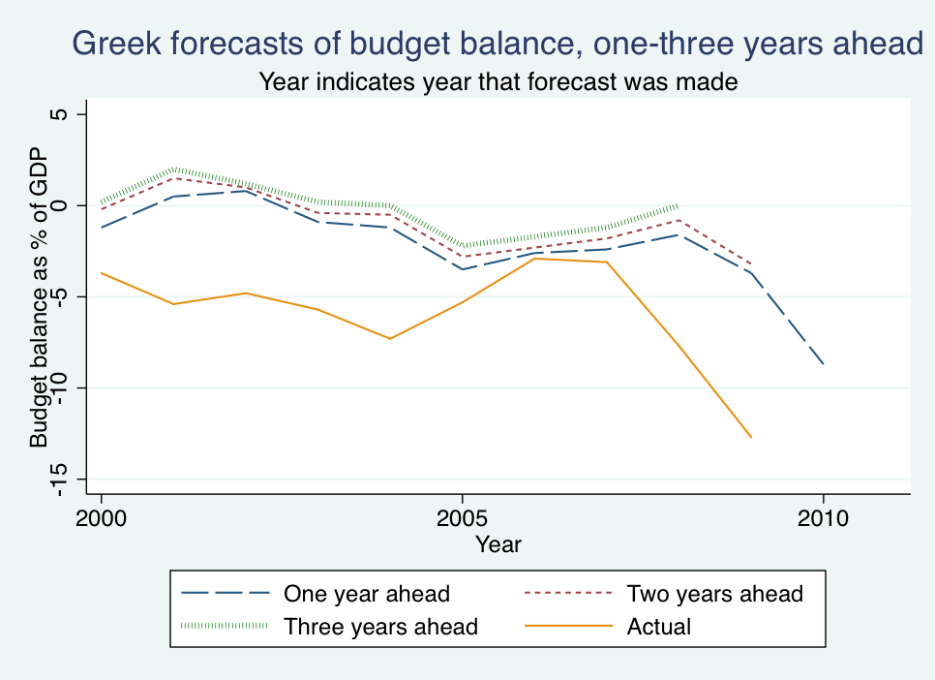
Notes: Data from Greece’s Stability and Convergence Programs.

Figure 2: Italian Budget Balance Forecasts

One-Year Ahead
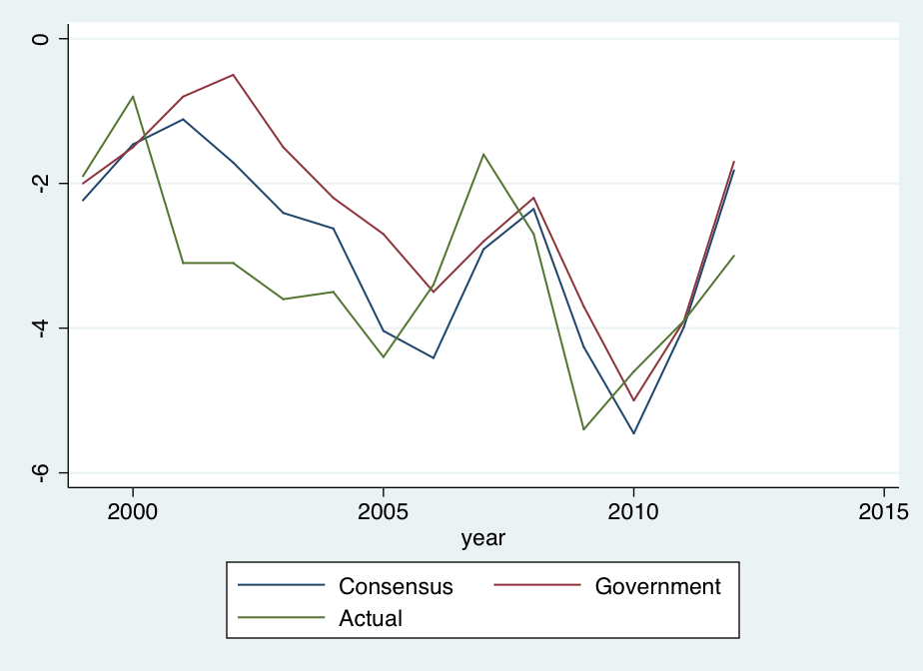

Two-Years Ahead

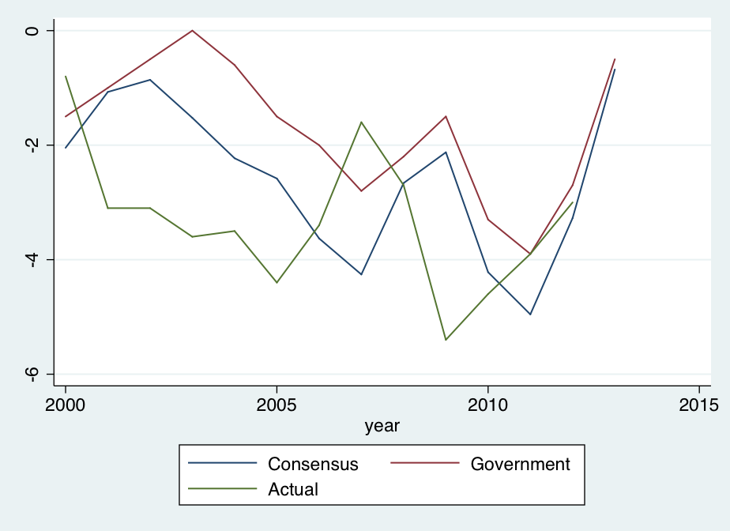
Notes: Year is year being forecast.
Figure 3: Italian Real GDP Growth Forecasts

One-Year Ahead
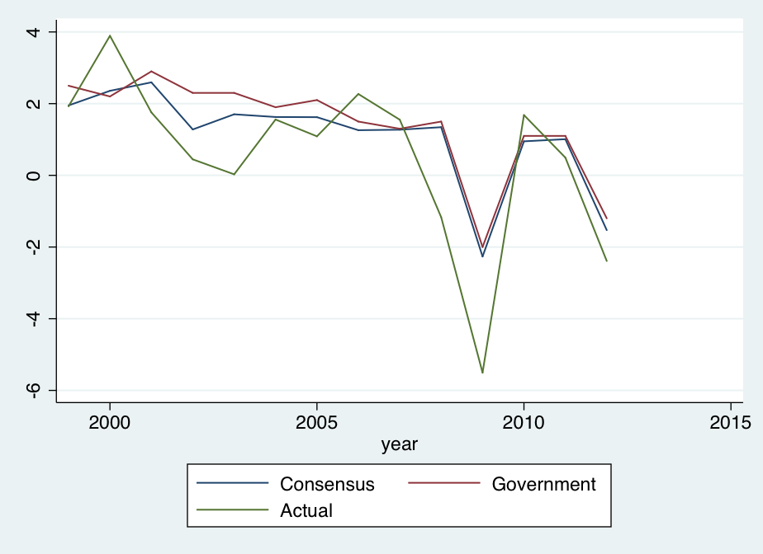

Two-Years Ahead

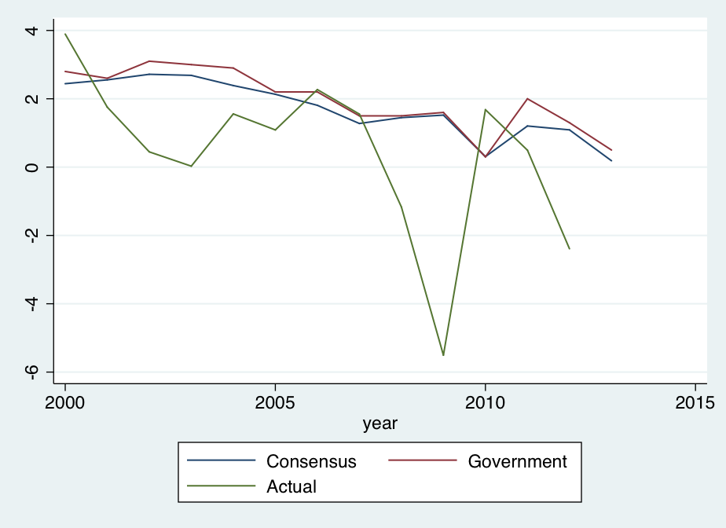
Notes: Year is year being forecast.
Figure 4: Budget Balance forecasts, One-Year Ahead

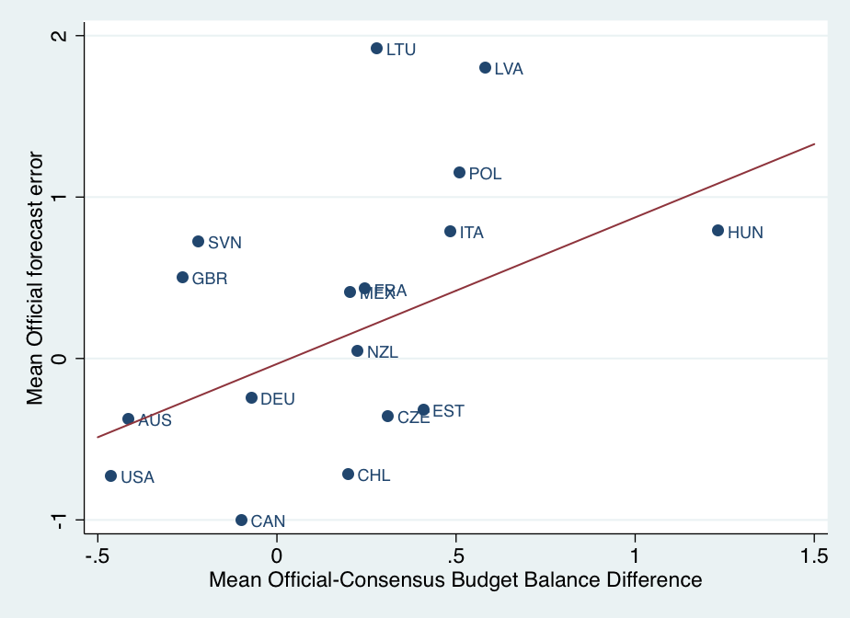

Figure 5: Budget Balance forecasts, Two-Years Ahead

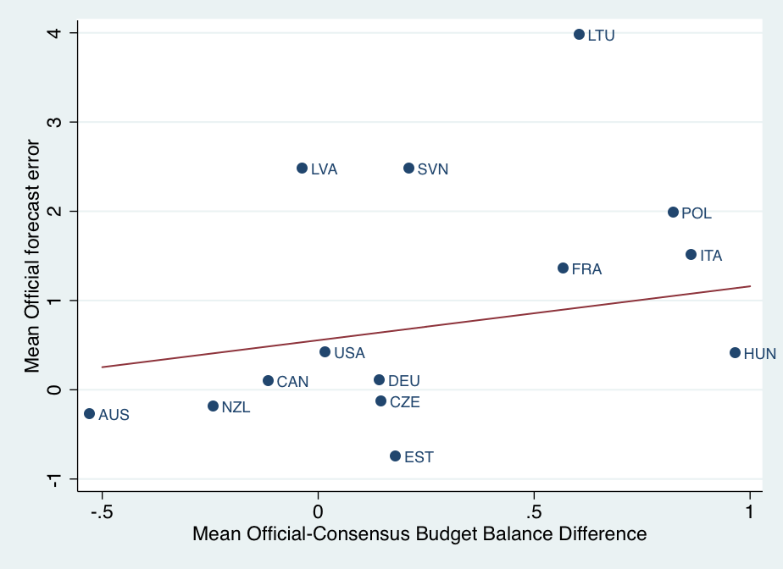
Notes: Only countries with more than 4 observations are included.
Figure 6: Real GDP Growth forecasts, One-Year Ahead

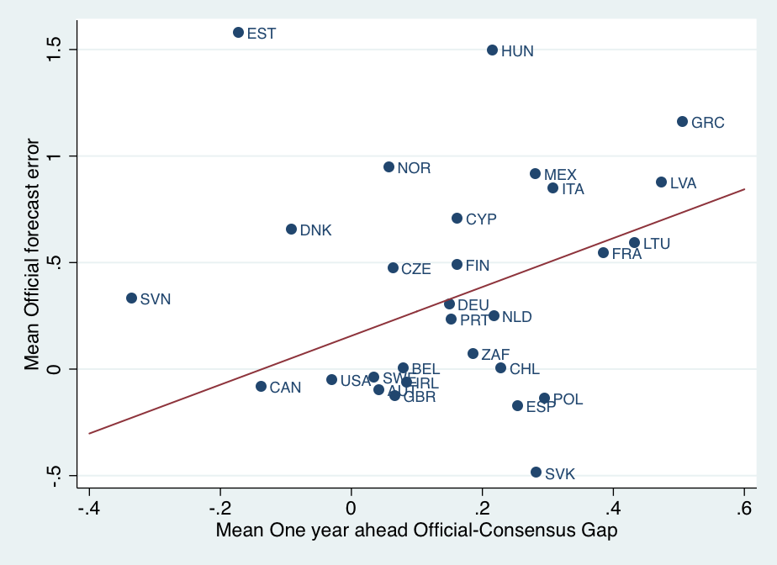

Figure 7: Real GDP Growth forecasts, Two-Years Ahead

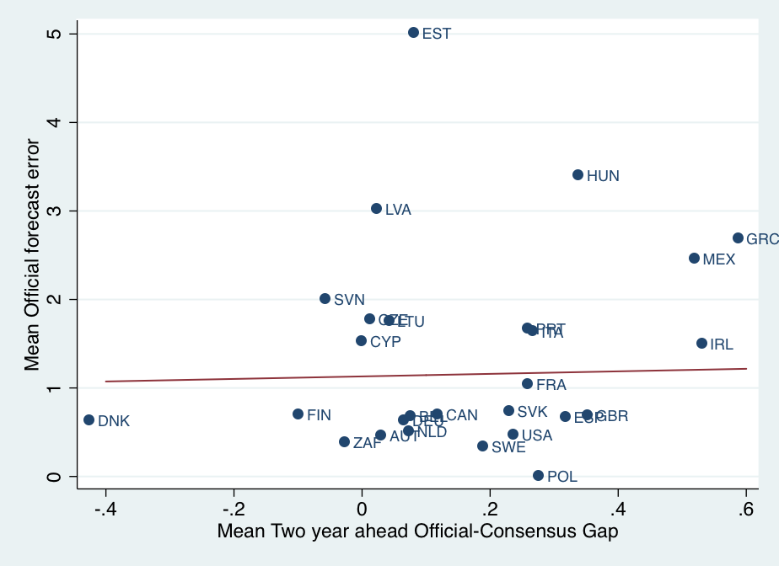
Notes: Only countries with more than 4 observations are included.
Figure 8: Budget Balance Forecasts and Realizations in the Eurozone, Two-Years ahead, Through 2009
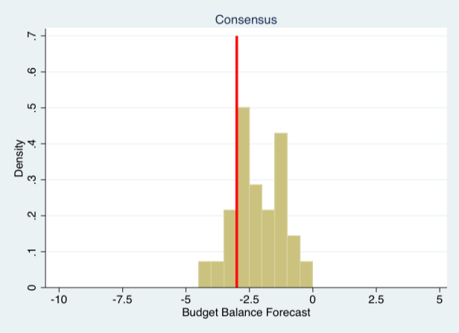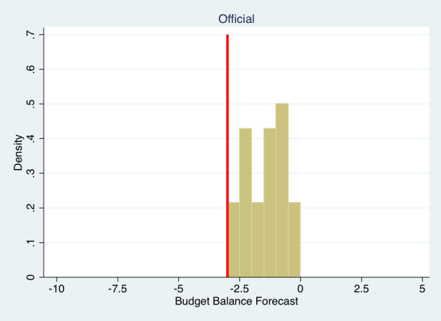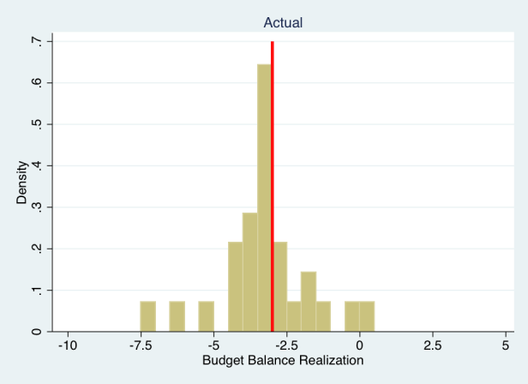
Figure 9: Budget Balance Forecasts and Realizations in the Eurozone, One-Year ahead, Through 2008
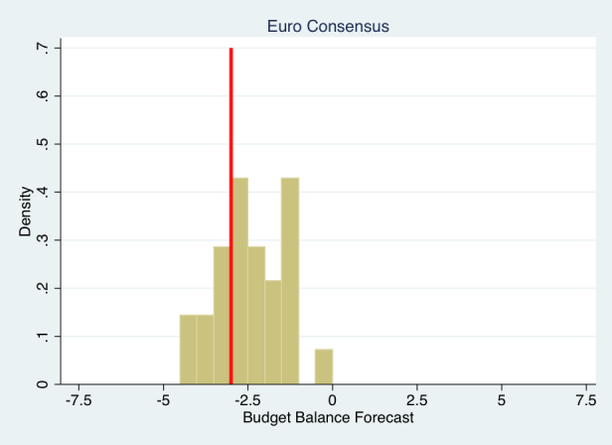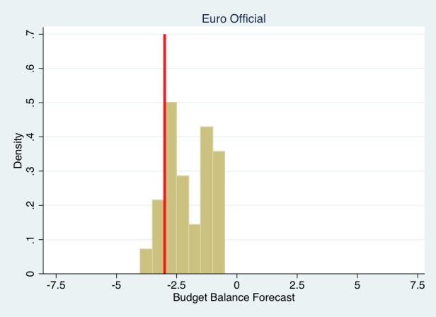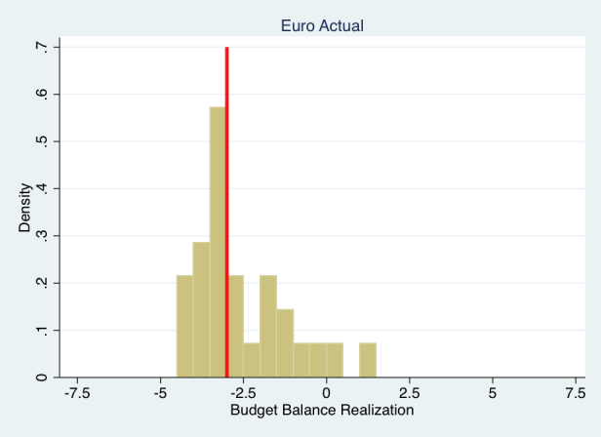

For example, Alesina and Tabellini (1990a, b), Grilli, Masciandaro, and Tabellini (1991) and Roubini and Sachs (1989a,b).
Lane (2003). Other explanations for budget deficits abound as well. Surveys include Alesina, Perotti and Tavares (1998) and Persson and Tabellini (2002).
Canada too has avoided optimism bias (and in fact has been too pessimistic on average), perhaps because it too uses independent forecasts. With the years 2010 and 2011 added to the sample, several countries as well are no longer over-optimistic on average at the one-year horizon, though they still are at the two-year horizon.
Realizations for budget balances come from Eurostat for European countries and the IMF or World Bank for the others. Additional details on data sources can be found in the appendix.
By only including forecasts made through 2007, the two-year ahead figure covers forecasts of budget deficits through 2009 and the one-year ahead figure covers forecasts through 2008. After the start of the financial crisis, budget balances became much larger and European countries began deficits in excess of the 3% threshold.

