Jan. 5, 2018
“The Case for (and Drawbacks of) Nominal GDP Targets”
Jeffrey Frankel, Harpel Professor of Capital Formation and Growth,
Harvard Kennedy School, Harvard University
Detailed outline, prepared for Brookings Institution conference,
Should the Fed stick with the 2 percent inflation target or rethink it?
Hutchins Center on Fiscal & Monetary Policy
Monday, January 8, 2018.
To start
Basic principle: The point of announcing a target is credibility; therefore the target is not very useful if the authorities are chronically unable to achieve it.

- The main point of promising to raise inflation to 2% was to get the economy back to full employment. The 2% inflation goal no longer serves the purpose as envisioned
  - since it hasn‘t been achieved and clearly lacks credibility;
  - and also since US unemployment is nevertheless back down to the natural rate.
  - Raising the inflation target to 3 or 4%, or setting a price level target, would be even less credible.
  - I agree that it isn’t a bad idea for the central bank to be transparent about what it sees as the long-run inflation rate, along with the long-run rates of GDP growth and unemployment. If this is all that is meant by Flexible Inflation Targeting, then fine.
- More important question: if the central bank wants to communicate its intentions [not just at the long-term horizon, but also] at a 1- or2-year horizon, how should it express the signal?
  - Obvious choices for a nominal anchor: Inflation? M1? Exchange rate?
  - Other candidate variables? “Forward guidance” has generally been phrased in terms of future short interest rates. China has long set real GDP targets (at least until very recently). The FRB & BoE phrased thresholds in terms of the unemployment rate a few years back (though unanticipated labor market shocks soon forced an end to that approach)?
  - [The question will become important when the time comes where the desired short-run stance of monetary policy once again deviates from the long-run stance.]
    - [E.g., because an unwanted rise in inflation requires the central bank to tighten monetary policy and gradually bring the inflation rate back down
    - Or because a recession requires the reverse.
    - This is less a live question for the US recently than it is for some other countries that need monetary policy either to tighten (because inflation is currently too high) or to loosen (because of a downturn). ]

The proposal
- I will defend the proposition that if central banks want to communicate their intentions at a 1-2 year horizon, it would be more effective to do so phrased in terms of nominal GDP than in terms of CPI inflation (or M1 or other possible variables).
  - I am not talking about staking a lot of credibility on a particular target for nominal GDP growth
    - just as the Fed does not currently stake a lot of credibility on hitting its inflation target in the short term.
  - My proposal could be as mild as adding a row for Nominal GDP to the FOMC’s Summary of Economic Projections,
    - I would want to do this even if the Governors and district presidents who fill out the SEP table simply got their projected NGDP growth numbers by taking the sum of the real growth row and the (CPI) inflation rate row of table.
    - But I would prefer that NGDP be reported in the first row of the SEP table
      - before the rows for real growth, unemployment, CPI inflation, and fed funds rate,
      - and that the public be allowed to infer that the Fed was now paying some attention to NGDP.
      - The governors and district presidents might shift from an initial instinct of projecting growth and inflation separately and then adding the two together to get their projection of nominal GDP, to a habit of doing it in the other order.
      - After all, they probably have (even) less control over the two components than they do over nominal GDP.
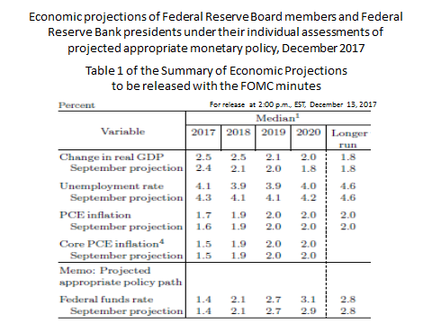
What is the case for NGDPT?
- NGDPT dominates a money target
  - It arose in the 1980s, when the alternative was Milton Friedman’s M1 target.
  - After monetarist rules broke down, a number of monetary economists pointed out the robustness of nominal GDP targeting.
    - The original proposal was from Meade (1978, 1982) and Tobin (1980, 83),
    - followed by analysis from Bean (1983), Taylor (1985), West (1986), Feldstein & Stock (1994), Hall & Mankiw (1994), Frankel (1995), Bernanke and Mishkin (1997), McCallum (1998), among others.
  - “Robustness” refers to the target’s ability to hold up in the long term under various shocks.
    - Relative to the money growth rule, the advantage of nominal GDP targeting was robustness with respect to velocity shocks in particular.
    - [If Volcker had rigidly stuck with the M1 target after the big increase in the demand for money that occurred around 1982, monetary policy would have been way too tight and the 1981-82 recession would have lasted another four years.]
- NGDPT underwent a revival around 2011-12, under quite different circumstances. The alternative to beat was no longer an M1 target, which had crashed-and-burned in the early 1980s, but an inflation target.
  - The new proponents showed up across a wide spectrum of analysts: Romer (2011) and Krugman (2011); Hatzius (2011) and Woodford (2012); David Beckworth (2016 and at Macro Market Musings), Scott Sumner (2014, and at Money Illusion), Lars Christensen (at Market Monetarist), and Marcus Nunes (at Historinhas).
  - The case in favor of a nominal GDP target is still its robustness with respect to shocks. But relative to a CPI inflation target, the advantage of nominal GDP targeting is robustness with respect to Aggregate Supply shocks
    - such as productivity shocks or commodity shocks...
    - [Bhandari and Frankel (2017) argue that weather shocks, natural disasters, and terms of trade shocks make NGDPT particularly relevant for developing countries.]
  - In the presence of an adverse supply shock, an inflation target implies a needlessly tight monetary policy and a needlessly large recession.
    - NGDP targeting allows the impact of the shift to be automatically divided between some loss of price stability and some loss on the output objective…
    - …whereas an ex ante inflation target, if it has any influence on ex post monetary policy, can push the authorities to tighten in the face of an adverse shock, thereby needlessly worsening the fall in output. See graph. E.g., this can explain the ECB’s decision in July 2008 to raise interest rates just as the world was sliding into the great recession. [That move was hard to explain, other than as an IT-induced reaction to spiking oil prices.]
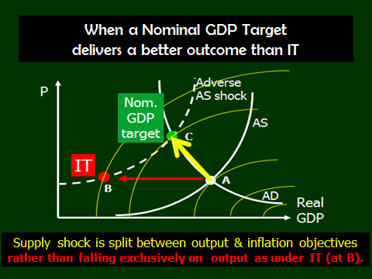

  - NGDPT proponents have also come up with a relatively new argument, concerning risk-sharing and financial stability:
    - by allowing inflation in response to adverse supply shocks, NGDPT would alleviate the real burden of recessions on debtors.
    - I.e., counter-cyclical inflation improves the financial distribution of risk.
    - Koenig (2013), Sheedy (2014), and Bullard et al. (2015).

- What are the drawbacks of NGDPT?
  - One common argument against Nominal GDP targets is that the authority cannot hit them. But the same point applies to inflation targets. Either way, nobody proposes to stake all credibility on hitting the target.
  - A second common argument is that the person in the street does not understand what nominal GDP is, nor how it breaks down into real GDP versus the price level. Central bankers fear the public would hold them responsible for hitting a real GDP target which might be rendered impossible by an adverse supply shock. This could well be true. All the more reason to avoid choosing an ex ante target like inflation that in the event of an adverse supply shock must be abandoned ex post amid feeble explanations about the unforeseen shock.
  - Nominal GDP numbers are always revised ex post. CPI numbers usually are not. This does seem to me a valid drawback of NGDPT, but not in itself a fatal one [since, again, we are not promising to hit the target exactly anyway].

Appendix
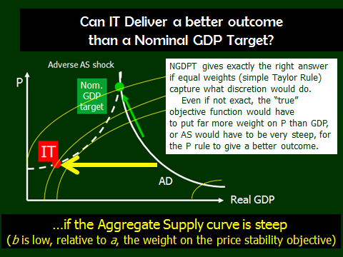
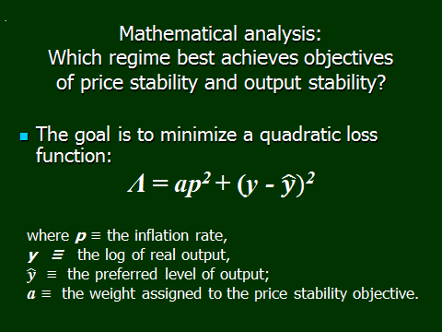
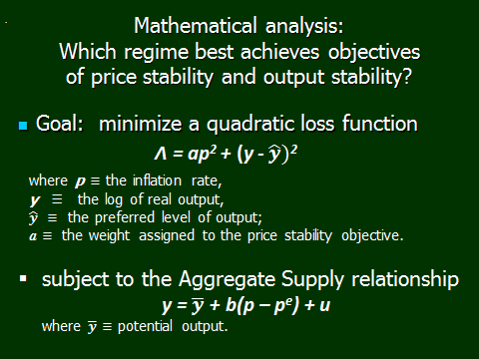

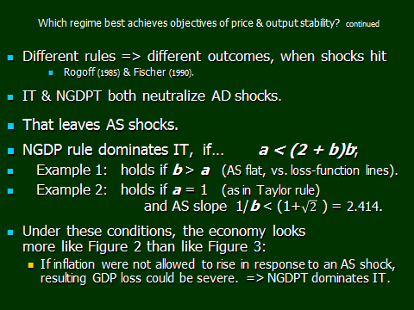

References
Azariadis, C, J Bullard, Aarti Singh and Jacek Suda, 2015 “Optimal Monetary Policy at the Zero Lower Bound,” Federal Reserve Bank of St. Louis.
Bean, C (1983), “Targeting Nominal Income: An Appraisal”, The Economic Journal, 93, 806-819.
Beckworth, D and J Hendrickson (2016) “Nominal GDP Targeting and the Taylor Rule on an Even Playing Field” Mercatus Working Paper, Oct.
Bernanke, B and F Mishkin (1997) "Inflation Targeting: A New Framework For Monetary Policy?," Journal of Economic Perspectives, v11(2,Spring), 97-116.

Bhandari, P and J Frankel, 2017, “Nominal GDP Targeting for Developing Countries,” [word] Research in Economics (Elsevier), vol.71, issue 3 (Elsevier), September, pp. 491-506. NBER WP 20898.
Feldstein, M and J Stock (1994), “The Use of a Monetary Aggregate to Target Nominal GDP” in N Gregory Mankiw (ed.) Monetary Policy, NBER, University of Chicago Press).
Frankel, J (1995), "The Stabilizing Properties of a Nominal GNP Rule," Journal of Money, Credit and Banking 27, 2, May, 318-334.
-- (2012a), “Inflation Targeting is Dead. Long Live Nominal GDP Targeting,” VoxEU, June 19.
-- (2012b) “Central banks can phase in nominal GDP targets without damaging the inflation anchor” VoxEU, Dec. 19.

-- (2014) "Nominal GDP Targeting for Middle-Income Countries," Central Bank Review, vol.14, no.3, September (Central Bank of the Republic of Turkey), pp.1-14. HKS RWP 14-033.
Hall, R E and N G Mankiw (1994), “Nominal Income Targeting”, in N Gregory Mankiw, ed., Monetary Policy, (University of Chicago Press), 71-93.
Hatzius, J (2011), “The Case for a Nominal GDP Level Target,” US Economics Analyst, issue 11/41, Goldman Sachs, Oct.
Koenig, E, 2013,“Like a Good Neighbor: Monetary Policy, Financial Stability, and the Distribution of Risk,” International Journal of Central Banking, June, 57-82.
Krugman, P (2011), “A Volcker Moment Indeed (Slightly Wonkish),” blog, 30 October.
McCallum, B T and E Nelson (1998), “Nominal Income Targeting in an Open-Economy Optimizing Model,” Journal of Monetary Economics, 43(3), 553-578.
Meade, J (1978), “The Meaning of Internal Balance”, The Economic Journal, 88, 423-435.
Romer, C (2011), “Dear Ben: It’s Time for Your Volcker Moment,” The New York Times, 29 October.

Sheedy, Kevin (2014), “Debt and Incomplete Financial Markets: A Case for Nominal GDP Targeting,” Brookings Papers on Economic Activity, Spring.
Sumner, S (2014) “Nominal GDP Targeting: A Simple Rule to Improve Fed Performance,” Cato Journal.
Taylor, J (1985). “What would nominal GNP targeting do to the business cycle?” Carnegie-Rochester Conference Series on Public Policy 22: 61-84

Tobin, J (1980), “Stabilization Policy Ten Years After,” Brookings Papers on Economic Activity, no.1, pp. 19-72.
Vines, D., J. Maciejowski, and J.E. Meade (1983), Demand Management (George Allen: London).
West, K (1986), “Targeting Nominal Income: A Note”, Economic Journal, 96, Dec., 1077-1083.
Woodford, M (2012): “Policy Methods of Accommodation at the Interest-Rate Lower Bound”, presented at the Jackson Hole Symposium (Federal Reserve Bank of Kansas City), August.

