Jeffrey Frankel, Feb. 10, 2020
Council on Foreign Relations, Boston, Economic Outlook, 2020
- The forecasts for 2019 had been quite gloomy.
  - Lots of recession talk.
  - The trade war was the most widely cited cause.
  - Fears of a weakening US economy and below-target inflation were sufficient to persuade the Fed to switch from raising interest rates in 2018 to lowering them in 2019.
  - As recently as 4 months ago, Germany was said to be already in recession.
  - The ECB too gave up plans to begin normalizing interest rates;
it went back to cutting them and renewed QE (September; before Draghi left).
Three points:
- The 2019 recession didn’t happen,
- why the next recession could be bad,
- and the Wuhan coronavirus
- The 2019 recession did not materialize, either in the U.S. or internationally.
  - GDP grew 2.3 % in 2019.
    - To be sure, this was the slowest of Trump's presidency,
      - down from 2.9% in 2018 (the year the tax cut kicked in)
      - and far below Trump forecasts.
      - Manufacturing, in particular, has been contracting.
      - And world growth was weak: 2.9% in 2019 (IMF WEO Jan.2020)
< IMF forecast [had been 3.7% as of Oct 2018; 3.5% as of Jan. 2019].
    - But better than many had expected.
    - And US employment growth has been remarkable.
  - One standard story: “the reason behind recession fears was the trade war launched by Trump in 2018. But significant progress has recently been made (USMCA, China Phase 1); ergo no recession.”
  - I don’t buy this story.
    - For one thing, although trade wars are very damaging, their big costs may lie in the long run, in the loss of global integration, more than in short-run recessions.
[Tariffs did not imply loss in net demand for US goods, even when foreign retaliation factored in. Did imply loss of net demand for RoW.]
    - To be sure, a trade war is an adverse supply shock.
[But, incidentally, I’m not sure it is appropriate for monetary policy to respond to an adverse supply shock like this by easing.]
    - Also the big uncertainty it created for many firms must have hurt investment.
  - The main reason I don’t buy the story:
    - the agreements with China & Mexico are only improvements relative to the alarming path that Trump had said he had embarked on.
      - Including his threat to withdraw from NAFTA
      - and his plans to put tariffs on the remaining imports from China.
    - No improvement relative to where we were two years ago. The contrary.
      - The USMCA made quite a few changes relative to NAFTA. But
        - They are generally small
        - I see them as negative on net,
          - Esp. the uncertainty about the longer-term future of the FTA
          - + also the domestic content provisions, which reduce the competiveness of the N.American auto industry on world markets.
      - The China “Phase I” deal leaves high tariffs in place and is a fragile creature with low credibility. Claims that the Chinese will buy an extra $200 billion of US exports are unlikely actually to translate into higher US exports, for a variety of reasons [(i) they may not do it, (ii) if so, would divert from other customers].

- Although I avoid predictions of a recession in any specific year, I have made the prediction that the next recession will be worse than usual. The reason is that we (esp. one party) have been following pro-cyclical policy.
  - Pro-cyclical fiscal policy: our trillion-$ deficit, the legacy of the fiscal expansion enacted in December 2017 at the peak of the business cycle,
    - will leave us without the fiscal space to respond to a recession
    - or at least that will be the perception
      - Romer & Romer (2019)
      - Especially on the part of the Republicans if the Dems are back in the WH, in a replay of 2009-16.

  - Pro-cyclical monetary policy: Trump has of course been criticizing the Fed for high interest rates even though unemployment < 4%.
    - Remember, he joined other Republicans in criticizing the Fed for low interest rates when unemployment exceeded 9.0% in 2010-11.
    - With the effective Fed funds rate barely at 1 ½ % now, there won’t be room for the usual 500+ basis-pt cut when the next recession hits.
    - I don’t know why the Fed (& other central banks) has failed to reach its 2% inflation target. But I think they should now de-emphasize it, rather than doubling down
as “Average Inflation Targeting” would seem to do.
  - Procyclical financial regulation: The US has been loosening financial regulation at the cyclical peak, when it should be tightening it. (Some EM governments actually manage counter-cyclical macroprudential policy.)
    - Should have raised required capital buffers (as under Basel III)
    - Keep the supplementary leverage ratio on the largest banks
    - Include some non-banks in SIFI designation
    - Don’t weaken stress tests
    - Protect consumers by restoring (1) a vigorous CFPB & (2) the fiduciary rule.

- What could cause a global recession in 2020? The Wuhan coronavirus could.
  - An epidemic like this is a classic black swan tail-risk we knew could happen.
  - Even if deaths turn out to remain in a range like the 2003 SARS epidemic, economic effects are disproportionate: much of the population stays home, either voluntarily out of fear or by state order.
  - Ec effect of SARS, as with most natural disasters, was localized in time & geography (in PRC 2% GDP in QII, largely made up subsequently on net for 2003 [0-1-2%]; negligible globally). That could happen again (SJWei 1/27/2020).
  - The economic effect may be bigger this time,
    - even if a global pandemic is avoided.
    - Partly because the quarantining in China is unprecedented.
    - Partly because the world economy is more dependent on PRC than 2003.

      - This point is being made regularly, but often with the claim that the big change between 2003 and 2020 is the supply-chain phenomenon, the switch in the composition from trade in final goods to trade in intermediate products.
      - There is, however, some reason to believe that, although the lengthening of supply chains has been a hugely important phenomenon (esp. in China’s trade), much of it had been completed by 2003.*
        - [The levelling off of the ratio of foreign value added to gross trade is a possible explanation for the ending around 2008 of the previously impervious global trend of rising trade/GDP.
          - This end-of-trend had become plain during 2008-2016.
          - It has presumably gotten much worse under Trump’s trade war.]
        - But China is a far bigger share of world economy than in 2003
          - 17% in 2020 [IMF, at current exchange rates] vs. 4% in 2003.
        - So bottom line is the same: coronavirus could, for the first time (since the 1918 “Spanish flu”), have a major global economic impact.
          - Esp. for EMs, who would lose commodity X to Chinese downturn & lose financial flows to “risk off.”
          - Could even attain an IMF criterion for global recessn: gr. < 2 ½-3%.
          - From pre-virus forecast of 3.3% 2020 global (& 2.0% US)
        - Another possible implication of the virus for the longer term, along with the higher tariffs, could be a reinforcement of the post-2008 reversal in global integration – previously almost unthinkable.

* JF, “Globalization and Chinese Growth: Ends of Trends?” 2017, Il Grande Sconvolgimento, edited by Paolo Onofri (Il Mulino: Bologna). HKS RWP 16-029: Some available evidence suggests that the expansion of global supply chains has slowed, supporting the hypothesis that vertical specialization may have largely run its course. The ratio of foreign value added to domestic value added in world gross exports rose by 8 ½ percentage points during 1995-2005, but only by 2 ½ percentage points during 2005-2012. In China in particular, where parts and components are imported and assembled into final goods which are then exported to the US and elsewhere, the share of imports of parts and components in China’s exports peaked at a high level in 1993. The subsequent diminishing importance of such trade is reflected as a declining share in the two decades since then. Because China by now constitutes a significant share of world trade, its patterns affect the total. Consistent with these numbers, figures for parts and components as a share of US imports have reversed as well.
Shang-Jin Wei and Xinding Yu The importance of domestic value added (vs. foreign value added) in Chna’s trade and GDP bottomed out in 2004-07 and has been rising since then:
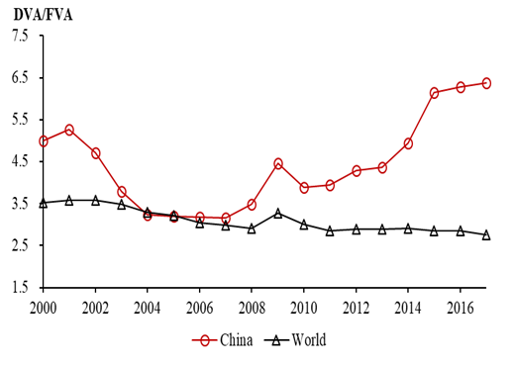
On the other hand, that leaves out role of Chinese output as intermediate inputs to other countries.
A direct measure of the length of production chains shows them continuing to rise:
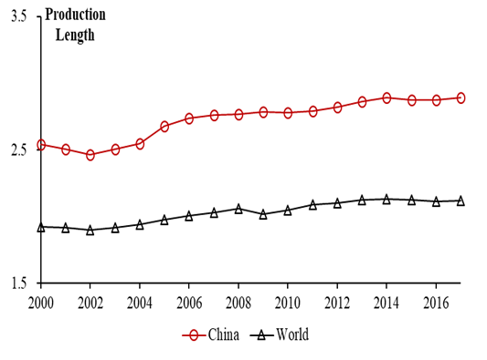

Feb. 2, 2020
Council on Foreign Relations, Boston, Economic Outlook, 2020
- Outlook
IMF [update at Davos] Global growth 2020 3.3%,,
- Uncertainty
Biggest: presidential election.
Continuing unpredictability to Trump policies.
Also: Brexit
[Tail risk/black swans
  - Corporate debt
  - Market crash, triggered e.g. by unexpected uptick in inflation.]
  - Pandemic (always on my list): now the coronavirus from Wuhan.
    - Natural disasters tend not to show up in annual GDP numbers
    - If this turns out to be like SARS , killed 74 in China in 2003:
      - Vs. 35,000 US deaths from regular flu every year.
    - Major pandemic could be different.
      - Millions stay home rather than working/shopping.
      - One of these times, there will be a pandemic with a high infection rate per sick person, and hard to protect against. We all need to improve public health systems, including early and credible govt.info.
- Recession fears of a year ago didn’t materialize [not even in Germany]
  - U.S. grew 2.3 % in 2019 (the slowest of Trump's presidency, down from 2.9% in 2018 (the year when the tax cut kicked in < 3% admin forecast < 4% he campaigned on) but better than many had expected.
  - One standard story: trade war threatened recession, but now progress has been made (NAFTA2=USMCA, China “Phase 1)
  - Another: By reversing course after Dec. 2018, cutting interest rates, Fed and other CBs (ECB) prevented recession
  - Alternative: Bandwagon forecasting. The easing by Fed and ECB were not necessary. Perhaps feeding excess froth in asset markets, as in 2006 (BIS…)

- Trade war
  - Trump pattern:
    - take a real problem (NK nuclear pgrm, China IPR)
    - make the situation far worse (threatening war against NK, ripping up JCPA with Iran; raising tariffs against China and most others far more aggressively than anytime since Smoot-Hawley 1930.)
    - reach an “agreement” that leaves things worse off than before he started (Singapore summit, NAFTA 0.9, China Phase I), but that steps back from the brink, a huge relief, so that the reduction in uncertainty is received positively.
    - Business uncertainty remains far higher than three years ago. Even where there is an agreement written, signed and ratified (USMCA), (i) it has a sunset provision, (ii) Trump has made clear that his word has little value (as when he threatened tariffs against Mexico as a weapon for immigration policy, in violation of the agreement he had just reached).
  - By far the biggest cost is long-term undermining of the 1945-2001 open rules-based multilateral system. And of fact-based governance.
  - Can trade war also cause recession?
- Monetary policy
  - Fed, other major CBs, and most independent monetary economists are obsessed with on getting inflation up to 2% (or higher, under inflation-averaging), convinced that the public is hanging on the edge of ever monthly CPI number and that their all-important credibility depends on achieving 2%.

Appendix
IMF, Jan. 28 https://blogs.imf.org/2020/01/28/a-call-for-vigilance-after-a-strong-year-for-risky-assets/
…risky asset markets around the world had a spectacular year in 2019. Equity market indices were up just over 30 percent in the United States, close to 25 percent in Europe and China, and over 15 percent in emerging markets and Japan. Emerging-market sovereign debt, U.S. high-yield debt, and emerging-market corporate debt all had returns in excess of 12 percent.

Constantinescu, Cristina, Aaditya Mattoo, and Michele Ruta (2015) “The Global Trade Slowdown: Cyclical or Structural?”, IMF WP 15/6 (International Monetary Fund, Washington DC), January.
Koopman, Wang, and Wei (2008).
Feenstra and Wei (2010).

