July 8, 2017
German Ordoliberals Vs. American Pragmatists:
What Did They Get Right or Wrong in the Euro Crisis?
Jeffrey Frankel, Harvard University
For German Ordoliberalism vs. Anglo-Saxon Pragmatism,
an e-book edited by Thorsten Beck and Hans-Helmut Kotz.

I leave it to other contributors to elucidate the concepts of German Ordoliberalism and “American pragmatism” (or Anglo-Saxon pragmatism). I will assume that we have a general idea to what each of these terms refers. I will focus, rather, on what the two approaches had to say about the euro crisis, including the policy issues that led up to it and the measures taken after the crisis arose. Neither party had it all figured out. What did they get right and what did they get wrong? We begin with the origins of the euro and the roots of the crisis, before turning to attempts to deal with it in 2010 and thereafter.
What German ordoliberalism got right at the birth of the euro
German ordoliberals got some things right when the terms of European Economic Monetary Union were agreed at Maastricht in December 1991. They recognized that the danger of excessive national budget deficits – to which they are by nature always acutely sensitive – would be exacerbated by moral hazard from the anticipated likelihood of bailouts in the event of difficulty. Ordinary German citizens were wary of monetary union on the grounds that they would eventually be asked to bail out some profligate Mediterranean country. The leaders sought explicitly to address these concerns with a set of rules to bind euro members, which were agreed at the level of the European Union. These rules included:
- The Maastricht fiscal criteria, which specified that among the pre-conditions for a country to join the euro, it had first to achieve a budget deficit under 3% of GDP and a public debt under 60% of GDP or at least a path approaching that level.
- The Stability and Growth Pact of 1997 (SGP), which took the fiscal criteria required to join the euro and extended them as requirements for members thereafter, supposedly to be enforced by fines.
- The feature of the 1991 Maastricht treaty (reaffirmed in the 2007 Lisbon Treaty) that is popularly known as the “No bail-out clause,” which prevents member governments from being responsible for the debts of other member governments.
The importance of fiscal moral hazard in a monetary union was not as obvious as it may seem in retrospect. North American economists had long kept a list of criteria that were thought to qualify nations to join in an “optimum currency area” but fiscal constraints did not even appear on their list. If anything, the loss of independent monetary tools at the national level suggested the need for an increase in the counter-cyclical use of the fiscal policy tool. This would have meant allowing more fiscal latitude at the national levels or, as in the US, creating fiscal buffers at the federal level. Or both. But the German “ordo” view was correct to identify the fiscal problem, as subsequent experience has borne out.
Versus what U.S. “Pragmatism” had right
American economists tended to be skeptical of the euro project from the beginning. Many of their concerns have been borne out, particularly concerns that European countries did not constitute an optimum currency area, certainly not to the extent that American states do. They correctly predicted the importance of asymmetric or asynchronous shocks and the difficulty of dealing with them once countries had lost monetary independence. Ireland, for example, in 2004-06 needed a tighter monetary policy than the ECB (European Central Bank) was prepared to set, because it was experiencing a housing bubble and economic overheating; during 2009-2013 it needed an easier monetary policy than the ECB was prepared to set because it was in steep recession.
What German ordo had wrong, when fiscal rules were violated
Although the architects of the euro had correctly identified the problem of fiscal moral hazard and tried to address it in advance by fiscal rules, these rules did not work in practice. As American pragmatists had suspected, the SGP fiscal rules were un-enforceable. Virtually all euro members except Luxembourg soon violated the 3% budget deficit rule, including Germany.
The response of the ordoliberals was continuation and escalation of language insisting on rules and the sanctity of debt, with little reason to think that the rules could be enforced. This included:
- Repeated unrealistic assertion that fiscal targets would be met in the future, assertions that could only be maintained via consistently over-optimistic forecasts. Governments never forecast that they would have a budget deficit in excess of 3% 1999-2008, even though they did, often in successive years. [See Figures 1 and 2.] Rules that are too stringent to be credible can be worse than no rules at all.
- Refusal to write-down Greek debt in 2010, despite Debt Sustainability Analysis that showed the debt/GDP path to be explosive even with stringent fiscal austerity.
- Other forms of head-in-the-sand procrastination, notably a series of European summits that tended to “kick the can down the road.”
- Vast underestimation by the troika (ECB, EU Commission and the IMF) in 2010 and thereafter of the fall in income that would follow from austerity in the periphery countries. [See Figure 3.] Even leaving aside the economic cost of the recession and the political cost of associated populist anger, fiscal austerity did not achieve its financial goal of putting Greece and other periphery countries onto sustainable debt paths. To the contrary, the fall in GDP was greater than any fall in debt with the result that debt/GDP ratios rose at accelerated rates. [See Figure 4.]
- Successive attempts to revise the SGP rules (such as the “Fiscal Compact” of 2012).

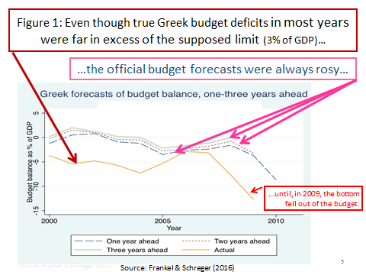

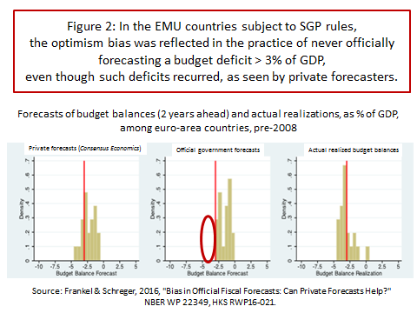
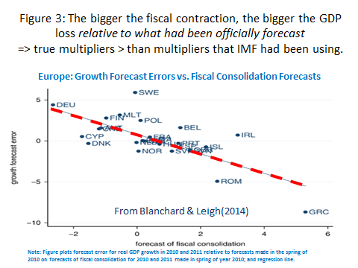
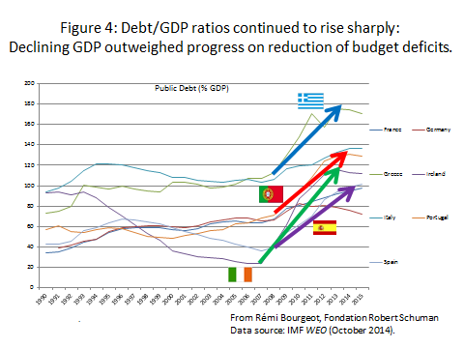

What everyone got wrong
After EMU went into effect in 1999, the periphery countries experienced large current account deficits, financed by large net capital inflows. This was perceived as evidence that cross-border financial integration was working well. It seemed that the lifting of financial and monetary barriers had allowed capital to flow efficiently to countries that had a higher return to capital because of relatively lower capital/labor ratios, as in the days of the gold standard before World War I.
Before 1999, it had been expected that more highly indebted euro members would have to pay higher interest rate spreads on their debt, as do states in the US, and that this would furnish a market-based incentive to avoid excessive debt levels. Instead, interest rates among all member countries fell almost to the level of the interest rate on German debt. This absence of meaningful spreads should have been seen as a signal that the problem of moral hazard from perceived guarantees was alive and well. But the convergence of interest rates was instead seen as another sign that financial integration was working well.
Most observers also made the mistake all along of failing even to think about banking regulation at a pan-euro level let alone to go all the way and create a banking union. It was only Greece that ran egregiously excessive budget deficits before 2008. Budget deficits and debt/GDP ratios were much more moderate in other countries like Ireland. There the problem was instead in the banking sector. To make a government debt problem out of a financial crisis that in turn had originated in a housing bubble, it took the euro crisis and a decision that the government of Ireland should bail out its banks (including large creditors).
What the pragmatists’ view still has right
Greek debt is still not sustainable. The target for the primary fiscal surplus should not be 3.9 % while Greek unemployment still exceeds 23%. Even if the fiscal target is achieved, a sustainable path for the Debt/GDP ratio will not be achieved. Rather, the debt should be further written down.
What ordoliberalism still has right
Structural conditionality is in order. This especially applies to labor market reforms. Employers should feel able to hire new employees without fearing that the result will necessarily be expensive lifetime commitments. Shopkeepers should be allowed to sell aspirin without a pharmacist’s license. Needless to say, there are serious domestic political obstacles to such reforms in each country. But the same is true of fiscal austerity. Structural conditionality is more likely than fiscal contraction to deliver economic growth. Economic growth is the key both to debt sustainability and political sustainability. Only by combining the points that the ordos have right with the points that the pragmatists have right can the crisis be laid to rest and prosperity restored.

References
Blanchard, Olivier, and Daniel Leigh, 2013,"Growth forecast errors and fiscal multipliers," American Economic Review 103.3, pp. 117-120.
Buiter, Willem, Giancarlo Corsetti, and Nouriel Roubini, 1993, "Excessive deficits: sense and nonsense in the Treaty of Maastricht." Economic Policy 8.16, pp. 57-100.
Eichengreen, Barry, 1992, “Is Europe an Optimum Currency Area?’ in: Silvio Borner and Herbert Grubel (eds.) The European Community after 1992 (Palgrave Macmillan, London).
Fatás, Antonio, and Lawrence Summers, 2016, “The permanent effects of fiscal consolidations,” National Bureau of Economic Research working paper no. 22374. Presented at NBER International Seminar on Macroeconomics, Vilnius, June 2017.
Frankel, Jeffrey, and Jesse Schreger, 2013, “Over-optimistic official forecasts in the Eurozone and fiscal rules,” Review of World Economics, June, Volume 149, Issue 2, pp 247-272.
Jonung, Lars, and Eoin Drea, 2009, “The euro: It can't happen, It's a bad idea, It won't last. US economists on the EMU, 1989-2002,” No. 395. Directorate General Economic and Financial Affairs (DG ECFIN), European Commission.
Mundell, Robert, 1961, “A theory of optimum currency areas,” American Economic Review, 51(4), pp.657-665.
Reinhart, Carmen, and Kenneth Rogoff, 2009, This Time is Different: Eight Centuries of Financial Folly. (Princeton University Press).

Endnotes

But, briefly: German ordoliberals believe in classical liberalism, supported by a democratic constitution, including (i) emphasis on the rules under which economic agents play the game; (ii) government intervention to enforce the rules, including to enforce competition; (iii) an aversion to counter-cyclical macroeconomic policies, and especially discretionary fiscal or monetary policies, as inconsistent with rules.
The optimum currency area literature began with Mundell (1961), a Canadian.
E.g., Buiter, Corsetti, and Roubini (1993).
As catalogued in the ill-timed paper by Jonung and Drea (2009),
Eichengreen (1992).
Frankel and Schreger (2013).
Greek indiscipline and German discipline interacted in such a way as to produce the worst of both worlds: Greece went from running a counter-cyclical fiscal policy on average during 1960-2000 to one of the world’s most pro-cyclical fiscal policies under the euro.
Blanchard and Leigh (2013) argue convincingly that the underestimation of the severity of the recessions took the form of underestimation of fiscal multiplier.
Fatás and Summers (2017) argue that fiscal austerity may have exacerbated debt/GDP paths not just in the short run but even in the long run.
One of the foresighted lessons in the celebrated book by Reinhart and Rogoff (2009) is that a banking crisis is often followed by a fiscal crisis in this way.

