Estimation of Nonlinear Exchange Rate Dynamics
in Evolving Regimes
Jeffrey Frankel Yao Hou Danxia Xie
Revised, June 22, 2024
Abstract
This paper develops a new econometric framework to estimate and classify exchange rate regimes. They are classified into four distinct categories: fixed exchange rates, BBC (band, basket and crawl), managed floating, and freely floating. The procedure captures the patterns of exchange rate dynamics and the interventions by authorities under each of the regimes. We pay particular attention to the BBC and offer a new approach to parameter estimation by utilizing a three-regime Threshold Auto Regressive (TAR) model to reveal the nonlinear nature of exchange rate dynamics. We further extend our benchmark framework to allow the evolution of exchange rate regimes over time by adopting the minimum description length (MDL) principle, to overcome the challenge of simultaneous two-dimensional inference of nonlinearity in the state dimension and structural breaks in the time dimension. We apply our framework to 26 countries. The results suggest that exchange rate dynamics under different regimes are well captured by our new framework.
JEL Classification Numbers: F31, F33
- Introduction
It has been well-known that there is a big difference between de jure exchange rate regimes, which monetary authorities officially claim to follow, and de facto exchange rate regime, which they maintain in practice (Calvo and Reinhart, 2002; Shambaugh, 2004; Frankel et al., 2001). Motivated by this discrepancy, a group of studies attempt to develop de facto methods for classifying exchange rate regimes. Important examples include Ghosh et al., 2000, Levy-Yeyati and Sturzenegger (2003), Reinhart and Rogoff (2004), Shambaugh (2004), Frankel and Wei (2008), and Frankel and Xie (2010). However, a new consensus on exchange rate regime classification has not been reached by this strand of literature. As Frankel (2004), Bénassy-Quéré et al (2006) and Rose (2011) point out, the classification results of these methods are inconsistent. The debate regarding an appropriate classification procedure continues.
The existing literature on de facto classification include two groups. The first group, such as Reinhart and Rogoff (2004) and Shambaugh (2004), infers the exchange rate regime from the variability of the exchange rate alone. Reinhart and Rogoff (2004), for instance, categorize exchange rate regimes into four groups (namely, peg, band, managed floating, and freely floating) , according to the variation of the exchange rate within a rolling window. The authors further roughly estimate band width under the band regime by taking values from two discrete levels, namely, ±2% and ±5%. These estimations give a hint of exchange rate dynamics and rules concerning the interventions by monetary authorities under band regimes. Nevertheless, as Frankel and Xie (2010) point out, these methods ignore that the shocks that some countries face are greater than those faced by other countries. Faced with large external shocks, the exchange rate may vary greatly even if the monetary authority has intervened substantially.
A second group of statistical studies, such as Levy-Yeyati and Sturzenegger (2003) and Frankel and Wei (2008), addresses the problem by comparing the changes in the exchange rate with the total exchange market pressure the country suffers; this pressure is measured by the variation in changes in foreign reserves combined with changes in value of the local currency. These studies propose overall estimates of exchange rate flexibility. However, their procedure does not provide information on how the exchange rate is managed or how interventions are performed by the monetary authority.
In this paper, we extend the existing literature by precisely characterizing the patterns of exchange rate changes under different regimes. We consider four broad groups of exchange rate regimes: fixed rate regimes; band, basket and crawl regimes; managed floating regimes; and freely floating. Moreover, we propose clearer definitions of these regimes from the perspective of econometrics to make it easier to distinguish them from each other. Our explicit definitions enable us to estimate subtle patterns of exchange rate dynamics and the monetary authority’s interventions under different regimes, going beyond existing studies. In particular, we develop a two-step econometric framework base on our definitions of exchange rate regimes, to allow regime classification and the estimation of associated parameters under various regimes.
In the first step, we infer the basket of currencies with respect to which a country stabilizes its exchange rate by using the Frankel-Wei method. In the second step, we extract the residual series from the Frankel-Wei model as a measure of the deviation of the exchange rate from its central parity and classify regimes by analyzing the characteristics of the residual series. The classification results are determined by several criteria including exchange rate volatility, the correlation between volatility and deviation from the central parity, and the unit root test. After determining regimes, we estimate the related parameters of each regime by using time series models. Different time series models are used to fit various patterns of exchange rate dynamics under distinct regimes. The width of the target band and the intensity of the monetary authority’s interventions under the BBC regime can be well captured in our procedure. which adopts a three-regime Threshold AutoRegressive (TAR) model and thereby allows intervention to become more intense when the exchange rate begins to go outside the band. These groups of parameters estimated by time series models describe comprehensibly the patterns of exchange rate changes under different regimes.
One potential limitation of our econometric framework is that the evolution of a country’s exchange rate regime over time is not considered because the econometric models we adopt in the previous framework are time-invariant. As Frankel and Xie (2010) note, considering these regime changes is important because, in practice, a majority of countries do not maintain a consistent regime for more than a few years and instead adjust their regimes from time to time. (This includes adjustment in parameters of a given arrangement, such as the width of a band, basket weights, trend, and level.) To deal with the drawback, a time-varying statistical inference is needed. The motivation is similar to the motivation for extending Frankel and Wei (2008). Frankel and Xie (2010) adopted the Bai-Perron break point test to augment the Frankel-Wei method of regime classification, by allowing changes in exchange rate regimes over time.
However, this paper does not simply imitate the extension in Frankel and Xie. The Bai-Perron test cannot be applied to our procedure because nonlinear time series models are used here to capture nonlinear dynamics of the exchange rate, while the application of the Bai-Perron test is restricted to linear models. The non-smoothness and nonlinearity of models such as TAR models make it technically highly challenging to derive the asymptotic distribution of estimators of structural breaks (Gao and Ling, 2019). Confronted by these challenges, an econometric procedure of inferring structural breaks in nonlinear models by using traditional statistical estimation methods has not been sufficiently developed, though there have been some attempts.
To address this challenge, we utilize the estimation method developed by Yau et al. (2015). This method uses the minimum description length (MDL) principle, instead of the ordinary least squares (OLS) method or maximum likelihood estimation (MLE), which are more familiar. The MDL principle was first proposed by Rissanen (1989), a computer scientist, to solve model selection problems in computer science and has recently been widely accepted by statisticians to serve as an important method of model selection in statistical problems. As Yau et al. (2015) prove, the consistency of the estimators of parameters in the TAR model with structural breaks estimated by MDL principle is ensured. The MDL principle enables us to describe precisely how the nonlinear dynamics of the exchange rate are determined when structural changes in exchange rate regimes are considered.
We apply this new econometric framework to investigate empirically whether it is suitable for describing various exchange rate regimes, using daily data from 26 countries. Our sample includes widely known floaters (such as Australia and Canada), firm peggers (such as Middle Eastern oil exporters), and economies maintaining an intermediate regime (mostly in Asia and Latin America). The estimation results depict several interesting patterns. As we expect, floaters float -- most of the time. However, they don’t fully abandon their ability to intervene in the foreign exchange market. Instead, floaters respond strongly to dramatic exchange rate fluctuations to stabilize the value of the local currency. The BBC regime gains popularity among economies pursuing an intermediate regime. These economies allow the exchange rate to wander within the target band they set, but outside the band intensively intervene in foreign exchange markets to correct the deviation from the central parity. In contrast, only a small fraction of economies are identified as maintaining a managed floating regime and the periods these economies follow such a regime are usually short. The evolution of exchange rate regimes over time is also captured. Our results well document how many emerging market economies, including China, India, and Russia, have shifted from a fixed regime to floating in the past two decades.
To recap, the contribution of this paper is threefold. First, we offer a new econometric framework of exchange rate regime classification. In our explicit procedure, which benefit from clear definitions, criteria for determining which group a country’s regime belongs to are fully statistically based. Second, our framework offers new insights into the patterns of exchange rate dynamics and the authority’s interventions under different regimes. We pay particular attention to the BBC regime and estimate its target band and the intensity of out-of-band interventions by utilizing a three-regime TAR model to reveal the nonlinear nature of exchange rate dynamics. Finally, methodologically, our framework overcomes the challenge of simultaneous two-dimensional inference of nonlinearity in the state dimension and nonstationarity in the time dimension, thereby enabling us to identify structural changes.
The remainder of this paper is organized as follows. Section 2 proposes the econometric framework of exchange rate regime estimation. Section 3 presents the data extraction and empirical results. Finally, Section 4 draws conclusions.

- Econometric Model
In this section, we will develop an econometric framework to classify a country’s exchange rate regime. Our classification scheme includes four categories: fixed regimes; basket, band and crawl (BBC) regimes; managed floating regimes with no target band; and freely floating regimes. Our framework infers the exchange rate regime by a two-step procedure. We first estimate the implicit basket of currencies that the monetary authority may target and use this estimation to determine the central parity and deviations of the exchange rate from the central parity over time. Then, we classify the exchange rate regime of the country into one of the four categories by analyzing the monetary authority’s intervention rule that is revealed by the dynamics of the deviations of the exchange rate.
A country maintaining a fixed regime pegs its exchange rate tightly to one or more currencies in a basket and controls the deviations from the central parity in a small range. Countries that maintain a BBC regime typically allow a degree of deviation from a central parity when the exchange rate lies within a target band, and intervene in the foreign exchange market when the exchange rate goes outside the band. If a country pursues an intermediate regime but does not set an explicit target band, the monetary authority may occasionally intervene in the foreign exchange market. When the exchange rate is floating, its dynamics can be roughly captured by a random walk process. The details of this procedure will be discussed in the following sections.
2.1 Currency Basket Inference, Central Parity Determination, and Deviation from the Central Parity
To analyze the deviations of the exchange rate from the central parity, we first determine how the monetary authority sets the central parity. Most existing studies of bands (target zones) focus on countries where the central parity that is set is explicitly known. These countries include those participating in the EMS (1979–90) and Scandinavian countries (1985–92). However, many countries maintaining an intermediate exchange rate regime do not announce the basket of currencies which they target (i.e., the parity to which the home currency is pegged or around which the home currency orients its target band or other pattern of foreign exchange intervention). We follow Frankel and Wei (1994, 2008) in that we infer the implicit basket weights in the central parity by performing a regression of the change in the foreign exchange value of the local currency against changes in the values of a set of major currencies, including the dollar, euro, pound, and yen.
We estimate the implicit de facto basket weights by using the following equation:
$∆logH_{t}=c+ \sum_{k=1}^{n}{w_{k}∆logX_{k,t}+ ε_{t}}$ (1)
where $H_{t}$ denotes the value of the home currency at time t, $X_{k,t}$ represents the value of currency k at time t (one of the major currencies thought to be in the basket), $w_{k}$ denotes the weight of currency k in the basket, and $c$ determines the trend of exchange rate appreciation or depreciation against the central parity.
Although the Frankel-Wei method enables us to infer implicit weights from actual data, it cannot capture the changes in the weight parameters over time. To identify changes in the currency weights, following Frankel and Xie (2010), we adopt econometric techniques developed by Bai and Perron (1998, 2003) to discern structural changes in the exchange rate regime and to estimate time-varying weight parameters. The identification procedure is implemented in two steps. In the first step, given the number of breaks $m$, we infer the optimal partition $(T_{0}^{*},T_{1}^{*},...,T_{m+1}^{*})$ of the full sample by using the regression model described by Equation (2):
$$∆logH_{t}=c_{i}+ \sum_{k=1}^{n}{w_{i,k}∆logX_{k,t}}+ ε_{t}$$
$t=T_{i-1}+1,...,T_{i};T_{0}=0;T_{m+1}=T;i=1,...,m+1$ (2)
The model allows the weights of the currencies in the basket to vary across different time segments, split by break points $T_{i}$ when the regime switches, thus relaxing the constraint that the coefficients in Equation (1) must be constant over time. Algebraically, Bai and Perron (1998) identify structural breaks by minimizing the sum of the squared residuals of Equation (2), as represented by Expression (3):
$\sum_{i=1}^{m+1}{\sum_{t=T_{i-1}+1}^{T_{i}}{{[∆logH_{t}-c_{i}-\sum_{k=1}^{n}{w_{i,k}{∆logX}_{k,t} }]}^{2}}}$ (3)
For any given partition $(T_{0},T_{1},...,T_{m+1})$, we determine a set of parameters $(c_{i}^{*},w_{i,k}^{*})$ that minimize the sum of squared residuals, as shown by Equation (4):
$(c_{i}^{*},w_{i,k}^{*})=\underset{c_{i},w_{i,k}}{argmin}{\sum_{i=1}^{m+1}{\sum_{t=T_{i-1}+1}^{T_{i}}{{[∆logH_{t}-c_{i}-\sum_{k=1}^{n}{w_{i,k}{∆logX}_{k,t} }]}^{2}}}}$ (4)
Then, the optimal partition $(T_{0}^{*},T_{1}^{*},...,T_{m+1}^{*})$ is inferred by comparing the goodness of fit of the different partitions and globally minimizing the sum of squared residuals, as represented by equation (5):
$(T_{0}^{*},T_{1}^{*},...,T_{m+1}^{*})=\underset{T_{0},T_{2},...,T_{m+1}}{argmin}{\sum_{i=1}^{m+1}{\sum_{t=T_{i-1}+1}^{T_{i}}{{[∆logH_{t}-c_{i}^{*}-\sum_{k=1}^{n}{w_{i,k}^{*}{∆logX}_{k,t} }]}^{2}}}}$ (5)
Thus, we have determined the optimal partition $(T_{0}^{*},T_{1}^{*},...,T_{m+1}^{*})$ and the corresponding parameters of the basket weights and intercept $(c_{i}^{*},w_{i,k}^{*})$, if the number of structural breaks $m$ is given. In practice, however, it is impossible to accurately know the number of breaks in advance. Thus, the number of structural breaks, $m$, is estimated in the second step. Following Bai and Perron (1998, 2003), we sequentially infer the number of breaks by testing the null hypothesis of $l$ breaks against the alternative of $l+1$ breaks; finally, we estimate the number of breaks,$m$.
Through such a two-step procedure, we detect the switches in a country’s exchange rate regime and the corresponding weights of the basket of currencies within each time segment. Thus, following this procedure enables us to define the central parity that the monetary authority sets, thereby helping to identify the rule that the monetary authority follows to manage the exchange rate.
The value of the central parity changes from month to month along with changes in the values of major currencies in the basket, as shown by Equation (2). To calculate the fitted value of Equation (2), we multiply the estimated weight of each major currency by its percent change in value, and add up all the terms, including the intercept term, to obtain the change in the central parity. The difference between the actual percent change in the local exchange rate and the fitted value of Equation (2), namely the residual of the model, captures the percentage deviation from the central parity on this trading day. By adding up the series of residuals of Equation (2) within the period from the start of the exchange rate regime to the present trading day, we obtain the cumulative percentage deviation of the exchange rate; this deviation serves as a criterion for the monetary authority to decide whether to intervene. The series of cumulative percentage deviations obtained by this procedure serves as the input for the exchange rate classification algorithm that we will present in the next section.

2.2 Exchange Rate Regime Classification
Section 2.1 explained how we obtain the series of deviations from the central parity. In this section, we show how the series can be used to infer the exchange rate regime. It is relatively straightforward to distinguish the fixed and floating regimes from the two types of intermediate regimes, i.e. the BBC regime and the managed floating regime with no target band. The exchange rate regime should be classified as fixed when the volatility of deviations remains low. A unit root test can be used to decide whether the exchange rate regime should be categorized as floating. However, it is challenging to subdivide intermediate regimes into various subgroups of intermediate regimes, such as BBC and managed floating regimes, due to the diversity of the monetary authority’s intervention rule under these regimes.
Before we discuss how to identify exchange rate regimes empirically, we first specifically define the two categories of intermediate exchange rate regimes, namely, the BBC and managed floating regimes, which we adopt throughout this paper.
Definition 1—BBC Regime: A regime is categorized as a BBC when the authority sets a target band for the exchange rate’s deviation from the central parity, allows the deviation series to follow a random walk process within the band, and intervenes in the foreign market if the rate goes outside the band. Algebraically, the deviation of the exchange rate at time $t$ under a BBC regime can be modeled as
$X_{t}=\left\{\begin{aligned}ρχ_{1}+(1-ρ)(X_{t-1}+ ε_{t})=ρχ_{1}+(1-ρ)X_{t-1}+(1-ρ)ε_{t}, if X_{t-1}>θ_{1} \\ X_{t-1}+ ε_{t}, if θ_{2}≤X_{t-1}≤θ_{1} \\ ρχ_{2}+(1-ρ)(X_{t-1}+ ε_{t})=ρχ_{2}+(1-ρ)X_{t-1}+(1-ρ)ε_{t}, if X_{t-1}<θ_{2}\end{aligned}\right., ε_{t}\sim IID(0,σ^{2})$(6)
where $X_{t}$ denotes the percentage deviation of the exchange rate from its central parity at time t, $ε_{t}$ denotes white noise with variance $σ^{2}$, [$θ_{2}$, $θ_{1}$] specifies the target band, $ρ$ denotes the intensity of the authority’s intervention outside the band, and $χ_{1}$, $χ_{2}$ are the positions that the authority targets when it intervenes in the foreign exchange rate market. In this paper, we assume the target band is symmetric, i.e. $θ_{2}=-θ_{1}$, for simplicity. This assumption is consistent with the practice of many monetary authorities.
That is, we model the deviation of the exchange rate outside the band as a weighted average of the authority’s target and the exchange rate’s own trend, where the weights depend on the authority’s intervention intensity. This modeling is similar to “systematic managed floating”, proposed by Frankel (2019). In systematic managed floating, the authority responds to the exchange market pressure by allowing some fraction to be reflected as exchange rate change and absorbing the remaining fraction through foreign exchange intervention. This modeling is intuitive and highly tractable econometrically. Here we give a broad definition of the BBC regime: several intermediate regimes that have been previously discussed in the literature can be categorized into this definition. When $χ_{1}$, $χ_{2}$ are set as $θ_{1}$, $θ_{2}$, respectively, and $ρ$ is set as 1, for instance, the regime will degenerate into the target zone characterized by Krugman (1991). When the exchange rate begins to wander outside the band, the authority intervenes to keep the level of deviation at $θ_{1}$ or $θ_{2}$, the bound of the target zone, until the exchange rate returns to the band. Let the targets of intervention $χ_{1}$, $χ_{2}$ be kept unchanged and the intensity $ρ$ be reduced; then, the regime will switch to a loosely managed target band regime where a degree of departure from the band is allowed. The authority has flexibility on setting intervention targets $χ_{1}$, $χ_{2}$, which are not necessarily set as the bounds of the band. The target can be determined to be a constant within the band or even 0 if the authority desires to reduce the deviation from the central parity to a lower level.
Definition 2—Managed Floating Regime: A regime is categorized as a managed floating regime when the authority does not set a target band and, instead, continuously intervenes in the foreign market. Algebraically, the deviation of the exchange rate at time $t$ under a managed floating regime can be modeled as
$X_{t}=ρχ+(1-ρ)(X_{t-1}+ ε_{t})=ρχ+(1-ρ)X_{t-1}+(1-ρ)ε_{t}, ε_{t}\sim IID(0,σ^{2})$ (7)
where $ρ$ denotes the intensity of the authority’s intervention, and $χ$ denotes the position of the deviation that the authority targets when the authority intervenes.
Similar to that under the BBC regime, the deviation of the exchange rate under managed floating is also determined by a weighted average of the authority’s target and the exchange rate’s own trend. When $ρ$ is close to 1, then the volatility of the exchange rate will be kept at a rather low level, and the managed floating regime is similar to a fixed regime. Alternatively, if $ρ$ is set as 0, then the exchange rate floats. It is expected that most countries maintaining a managed floating regime set $ρ$ as a moderate value somewhere between 0 and 1.
The above definitions give us clear guidance for empirically classifying exchange rate regimes. When a country follows a BBC, the monetary authority lets the exchange rate wander within the band, and intervenes when the exchange rate goes outside the upper bound or the lower bound of the band. The regime switches lead to two distinct changes in parameters of the autoregressive process that can be econometrically estimated--the decrease in the coefficient of the lagged term and the variance of the error term. The estimated percentage decrease in the deviation series volatility can then be used to measure the intensity of out-of-band intervention $ρ$. In contrast, under a managed floating regime with no target band, it is less likely to detect such clear regime switches induced by the current deviation from the central parity. We thus utilize these nuances between BBC and managed floating without target band to subdivide observations that are classified in the group of intermediate regimes.
Technically, a three-regime Threshold Autoregressive (TAR) model is adopted to infer whether the exchange rate within a segment shows the above-mentioned nonlinearity. If a country follows a BBC regime, it is expected that the middle regime of the TAR model is close to a unit root process sketching how the exchange rate wanders within the band, while the upper regime and the lower regime show a clear trend of a decrease in exchange rate volatility and a reversion to the band. When managed floating with no band is pursued, on the other hand, we may detect intramarginal interventions, thereby leading to the rejection of the null hypothesis of a unit root within the middle regime. We can further utilize the TAR model to infer related parameters capturing the pattern of the monetary authority’s intervention under the BBC regime, including the width of target band and the intensity of out-of-band intervention. These statistically based inferences give a nuanced portrait of patterns of how the exchange rate is managed under various intermediate regimes, which has not been investigated in existing studies.
Throughout the analysis so far, we have assumed the monetary authority follows the same exchange rate regime during the whole time segment delineated by the procedure of breakpoint identification presented in Section 2.1. That is, the exchange rate regime is supposed to remain fully constant if a country does not change the basket of currencies to which the rate is pegged. Under this assumption, we simply run the above-mentioned procedure to infer the exchange rate regime a country follows within the segment and estimate related parameters. However, as Bertola and Caballero (1992) note, central parity realignments frequently take place. Moreover, related parameters representing rules of exchange rate management (including band width, intensity of out-of-band intervention and coefficients of autoregressive models) may also change over time. The strong assumptions we made in the previous analysis may therefore lead to misspecification.
To consider these realignments and other changes in exchange rate regimes, we need to develop a time-varying econometric framework similar to Frankel and Xie (2010), which allows for simultaneous inference of structural changes in regimes in the time dimension and the exchange rate regime a country follows within a time segment. Though the economic motivation is straightforward, it is technically difficult to implement such a simultaneous two-dimensional statistical inference due to the nonlinearity of exchange rate dynamics within a segment we aim to capture in this paper. When regime switches in the state dimension (i.e., how the intervention pattern varies along with the current position of deviation from the central parity) are considered, the Bai-Perron test used by Frankel and Xie (2010) to detect structural breaks is no longer applicable, as it applies only to linear models. As Gao and Ling (2019) discuss, the non-smooth and nonlinear function forms of nonlinear models such as TAR models make it hard to detect structural breaks in TAR models by means of the traditional estimation methods used in statistical inference of structural changes in linear time series models.
To overcome the technical challenge, we utilize the estimation method developed by Yau et al. (2015). This procedure allows us to address the nonlinearity and the nonstationarity of a time series simultaneously; these characteristics match exactly the characteristics of exchange rate dynamics under intermediate regimes. The spirit of the method developed by Yau et al. is similar to Bai and Perron’s method (1998, 2003), which also detects structural changes. Both define an objective function measuring the goodness of fit and infer structural breaks by minimizing the objective function. Instead of minimizing the sum of squared residuals, as Bai and Perron do, Yau et al. (2015) identify structural changes by using the MDL principle. Proposed by Rissanen (1989), the MDL principle has served as a general technique for model selection. Following the MDL principle, the best fitting model is defined as the best compression of the observed time series. In other words, the MDL principle selects the model that uses the shortest code to compress the information contained in the observed time series.
The econometric model that Yau et al. (2015) adopt to capture the nonlinearity and nonstationarity of a time series is a piecewise TAR model, which is defined by
$$X_{t}=\sum_{j=1}^{3}{(ϕ_{i,j,0}+ϕ_{i,j,1}X_{t-1}+σ_{i,j}e_{t})I(θ_{i,j-1}<X_{t-1}≤θ_{i,j})}, e_{t}\sim IID(0,1),$$
$$-∞=θ_{i,0}<θ_{i,1}<θ_{i,2}<θ_{i,3}=∞,$$
$τ_{i-1}≤t<τ_{i} (i=1,2,...,m)$ (8)
where $X_{t}$ denotes the percentage deviation of the exchange rate from its central parity at time t. A set of structural breaks $(τ_{1},...,τ_{m})$ splits the whole time series into $m+1$ segments, and the two thresholds $(θ_{i,1},θ_{i,2})$ further partition each segment into three regimes by the value of $X_{t-1}$, in which the $j$-th regime follows an AR(1) model with coefficient parameters $(ϕ_{i,j,0}, ϕ_{i,j,1})$ and white noise variance $σ_{i,j}^{2}$.
The estimation methodology can be described as follows. Given the number of structural breaks $m$, their locations $(τ_{1},...,τ_{m})$, and the series of cumulative percentage deviation from the central parity $\{X_{t}\}$, the total code length compressing the information of time series $CL(\{X_{t}\})$ consists of three terms, as shown in Equation (9):
$CL(\{X_{t}\})=CL(m)+CL(τ_{1},...,τ_{m})+\sum_{i=1}^{m+1}{CL({\{X_{t}\}}_{τ_{i-1}≤t<τ_{i}})}$ (9)
Noticing that approximately $\log_{2}(I)$ bits are required to encode an integer $I$, we adopt $CL(m)=\log_{2}(m)$ to measure the code length required to store the information of the number of breaks, and we adopt $CL(τ_{1},...,τ_{m})=\sum_{i=1}^{m}{\log_{2}(τ_{i})}$ to denote the code length recording the locations of the breaks. $CL({\{X_{t}\}}_{τ_{i-1}≤t<τ_{i}})$ represents the code length used to encode the TAR model within a segment split by structural breaks, $τ_{i-1}$ and $τ_{i}$. Let ${\hat{F}}_{i}$ denote the fitted TAR model of the $i$-th segment and ${\hat{e}}_{i}$ denote the corresponding series of residuals. Then, $CL({\{X_{t}\}}_{τ_{i-1}≤t<τ_{i}})$ can be expressed in two terms, as presented by Equation (10):
$CL({\{X_{t}\}}_{τ_{i-1}≤t<τ_{i}})=CL({\hat{F}}_{i})+CL({\hat{e}}_{i}|{\hat{F}}_{i})$ (10)
The first term, $CL({\hat{F}}_{i})$, captures the code length of the fitted model. A three-regime TAR model within the $i$-th segment is completely determined by two thresholds (i.e., $θ_{i,j} (j=1,2)$) and a set of parameters ($Ψ_{i,j}=(ϕ_{i,j,0},ϕ_{i,j,1},σ_{i,j}^{2}) (j=1,2,3)$) for each regime. The set contains the intercept $ϕ_{i,j,0}$, coefficient of the lagged term $ϕ_{i,j,1}$, and white noise variance $σ_{j}^{2}$. Thus, $CL({\hat{F}}_{i})$ can be decomposed into
$CL({\hat{F}}_{i})=CL(θ_{i,1},θ_{i,2})+CL(Ψ_{i,1})+CL(Ψ_{i,2})+CL(Ψ_{i,3})$ (11)
As proved by Rissanen (1989), ${\frac{1}{2}log}_{2}(N)$ bits are required to encode a maximum likelihood estimate of a parameter estimated by $N$ observations. Therefore, let $n_{i,j}$ denote the number of observations of the $j$-th regime within the $i$-th segment; then, Equation (11) can be rewritten as
$CL({\hat{F}}_{i})=\sum_{j=1}^{2}{{\frac{1}{2}log}_{2}(n_{i,j})}+\sum_{j=1}^{3}{{\frac{3}{2}log}_{2}(n_{i,j})}$ (12)
The second part of Equation (10), $CL({\hat{e}}_{i}|{\hat{F}}_{i})$, measures the code length of the series of residuals within the $i$-th segment. As shown by Rissanen (1989), the code length can be approximated by the negative log-likelihood of the fitted model ${\hat{F}}_{i}$; this negative log-likelihood is obtained by maximizing the log-likelihood of the data $l(θ_{i,1},θ_{i,2}; Ψ_{i,1}, Ψ_{i,2}, Ψ_{i,3})$. Given the observations within the $i$-th segment ${\{X_{t}\}}_{τ_{i-1}≤t<τ_{i}}$, $l(θ_{i,1},θ_{i,2}; Ψ_{i,1}, Ψ_{i,2}, Ψ_{i,3})$can be approximated by the conditional log-likelihood $l(θ_{i,1},θ_{i,2}; Ψ_{i,1}, Ψ_{i,2}, Ψ_{i,3} | {\{X_{t}\}}_{τ_{i-1}≤t<τ_{i}})$, which is specified as
$l(θ_{i,1},θ_{i,2}; Ψ_{i,1}, Ψ_{i,2}, Ψ_{i,3} | {\left\{X_{t}\right\}}_{τ_{i-1}≤t<τ_{i}})$
$=-\frac{1}{2}\sum_{t=1}^{n_{i}}{\sum_{j=1}^{3}{(\log\left(2πσ_{i,j}^{2}\right)+\frac{{\left(X_{t}-ϕ_{i,j,0}-ϕ_{i,j,1}X_{t-1}\right)}^{2}}{σ_{i,j}^{2}})×I(θ_{i,j-1}<X_{t-1}≤θ_{i,j})}}$
$=-\frac{1}{2}\sum_{j=1}^{3}{(n_{i,j}\log\left(2πσ_{i,j}^{2}\right)+\frac{\sum_{t=1}^{n_{i,j}}{{\left(Y_{i,j,t}-ϕ_{i,j,0}-ϕ_{i,j,1}Y_{i,j,t-1}\right)}^{2}}}{σ_{i,j}^{2}})}$ (13)
where $\{Y_{i,j,t}\}$ denote observations contained in the $j$-th regime of the $i$-th segment sorted in ascending order of $X_{t-1}$. Minimizing the function inside the summation in Equation (13) gives $n_{i,j}(\log\left(2π{\hat{σ}}_{i,j}^{2}\right)+1)$, where ${\hat{σ}}_{i,j}^{2}$ is given by the least-squares estimation of the multiple-regime TAR model proposed by Li and Ling (2012). Thus, the code length of the residuals can be written as
$CL({\hat{e}}_{i}|{\hat{F}}_{i})=\frac{n_{i}}{2}+\frac{1}{2}\sum_{j=1}^{3}{{n_{i,j}log}_{2}(2π{\hat{σ}}_{i,j}^{2})}$ (14)
Having specified the three components of the MDL given by Equation (9), we estimate the piecewise three-regime model by minimizing the MDL. Given the complexity of the TAR model, it is difficult to minimize the MDL in practice. To estimate the model efficiently, we adopt the genetic algorithm suggested by Yau et al. (2015) to solve the optimization problem. As proved by Yau et al. (2015), this estimation procedure ensures large-sample consistency of parameter estimates, including the number and locations of structural breaks and the corresponding parameters in each TAR model.
The piecewise TAR estimation procedure enables us to model an exchange rate regime that allows a certain degree of flexibility around the central parity. Moreover, exchange rate realignments and potential changes in the target band over time can be detected by this procedure. When a jump in the central parity occurs, the procedure may detect a sudden change in the level of the central parity and the target band around it and discern the change as a structural break point. Additionally, if the monetary authority adjusts the width of the target band or the intensity of out-of-band interventions, the procedure will split the whole series into two separate segments and infer the target band of each segment individually. However, a potential limitation is that the procedure is suitable only for estimating the exchange rate regime of a country following a pattern of foreign exchange intervention that resembles a BBC regime.
To address this matter, a more general estimation algorithm is developed; this algorithm is represented in Figure 1. In the first step, we use the piecewise TAR model to fit the series of cumulative percentage deviation from the central parity. Then, to consider potential jumps in the central parity, we realign the central parity back to 0 at the start of each segment that is marked out by the piecewise estimation procedure, and adjust the series of deviations accordingly. After the adjustment for exchange rate realignment, the standard deviation of the actual data within each segment is calculated to infer whether the country follows a fixed regime within the segment. We set the threshold of the standard deviation at 1%, which distinguishes a fixed regime from a managed floating regime. If the standard deviation is less than 1%, the regime will be determined to be a fixed regime.
Next, we propose a test of whether the country maintains a managed floating regime without a predetermined band. Typically, foreign exchange intervention will not take place and the dynamics of the exchange rate can be approximated by a random walk process in the middle regime within a segment if the authority follows a floating regime or a BBC regime. In contrast, the null hypothesis of the unit root test will be rejected if inframarginal interventions under a managed floating regime with no target band exists. Relying on these two facts, we define the exchange rate regime as a managed floating regime without a target band when the augmented Dickey-Fuller (ADF) unit root test on the deviation series in the middle regime rejects the null hypothesis. To distinguish floating regimes from BBC regimes, we examine whether the volatility of the deviation series is reduced when the exchange rate goes out of the band. If a country floats its exchange rate, the volatility of the exchange rate will not be affected by its current position. Instead, the exchange rate follows a random walk process similar to how the rate behaves in the band. For BBC regime, the monetary authority’s intervention will counteract the trend of continuous appreciation or depreciation, and decrease the volatility of value changes in local currency to keep the exchange rate at a stable level or even return the exchange rate to the band. Therefore, we categorize the regime as a floating regime when the ratio of the variance of changes in the deviation outside the band to that in the band is not less than 1. Otherwise, the regime is classified as a BBC regime.
We can further estimate related parameters revealing how the monetary authority intervenes, including when it intervenes and how intensive its intervention is. The intensity of out-of-band intervention is measured by the standard deviation of the difference between the exchange rate in the current period and the lagged one, when the exchange rate goes outside the band, taking values between 0% and 100%. An intensity of 0% shows no intervention, while that of 100% indicates that the exogenous trend of changes in the exchange rate is fully offset by the monetary authority.
The band width of this segment is estimated by the maximum absolute values of the two thresholds estimated by the piecewise TAR model procedure. The intuition to estimate the band width in this way can be explained as follows. As the time span of each segment is relatively short, the actual exchange rate often does not approach both the upper and lower bounds of the target band within a single observation period. In this case, our procedure can only accurately detect the threshold that the exchange rate has reached during the period, while the threshold on the side where the actual exchange rate does not reach the limit cannot be correctly identified from the data. Under this circumstance, a natural alternative is to estimate the threshold on the side that the actual exchange rate does not reach by the opposite of the threshold on the other side, as the upper and lower bounds of the target band are usually symmetric around the central parity. The band width is approximated by the maximum of the absolute values of the two estimated thresholds.

- Estimation Results
  - Data
We obtained the data from the PACIFIC Exchange Rate Service database. The sample consists of daily exchange rates from January 1999, when the euro was launched, to December 2020.To demonstrate how our framework works, we include in the sample economies with diverse exchange rate regimes, including the fixed regime, intermediate regime with a target band, managed floating regime, and freely floating regime. Twenty-six countries are covered, a full list of which is shown in Table 1.
  - Results
Table 2 reports the estimates of the currency basket that each country targets, the width of the band set by the monetary authority, the exchange rate regime categorized by our procedure, and the parameters in the piecewise three-regime TAR model portraying the dynamics of the exchange rate. Figure 2 further plots the time series of the actual exchange rate’s cumulative deviation from the exchange rate’s central parity and the structural breaks and the exchange rate regime within each segment inferred by our procedure.
The estimation results show that our framework is suitable for describing the behavior of the exchange rate under various exchange rate regimes. We can roughly divide countries covered in our sample into several groups according to the estimation results shown in Table 2. The first group comprises countries, such as oil exporters in the Middle East, that firmly peg their exchange rate to one or more of a basket of currencies. The volatility of their exchange rates remains at rather low most of the time, except for some unusual periods such as the 2008 global financial crisis.
The second group comprises economies with a high degree of exchange rate flexibility. Many developed countries, including Australia, Canada, Iceland, New Zealand, Norway, South Korea and Sweden, belong to this group. The group also includes some developing countries, such as India, Indonesia, Peru and Philippines. It is noteworthy that none of these countries floats its exchange rate during the full period from 1999 to 2020, thereby showing that the monetary authorities in these countries do not totally refrain from intervening in foreign exchange markets though these monetary authorities follow a freely floating regime policy in normal periods. Instead, these monetary authorities intervene occasionally when the exchange rate fluctuates considerably to stabilize the relative price. For example, many of these monetary authorities switch their exchange rate regime from freely floating to a BBC when faced with high external uncertainty during the 2008 global financial crisis. We further see that though these countries’ monetary authorities only occasionally intervene in the foreign market, their responses to dramatic exchange rate fluctuations are intensive. Our estimation shows that most of these interventions reduce the volatility of the exchange rate by over 40% when the exchange rate reaches an extreme level. The intensity of some of these interventions, such as those by Australia during 2010-2015 and South Korea during 1999-2002 and during 2009-2010 is up to approximately 90%, thus almost fully counteracting the trend of depreciation or appreciation.
The last group comprises economies pursuing an intermediate regime, including a BBC or a managed float with no target band. Table 2 shows that BBC regimes or similar regimes that can be parameterized by the TAR model are prevalent among many countries we cover, particularly emerging market economies in Asia and Latin America. The table further indicates that the estimates of the coefficients of the lagged term under the BBC regime are generally close to or equal to 1, thus supporting the hypothesis that a random walk is a proper approximation for the dynamics of the exchange rate when inside the band. This finding further indicates that the monetary authority allows a certain degree of deviation from the central parity and refrains from intervening in the foreign exchange market while within the target band. However, as shown in Figure 2, when the exchange rate occasionally strays outside the band, the exchange rate will be returned to the band soon after; this finding is probably attributable to the monetary authority’s intervention in response to an excessive deviation.
The estimates reported in Table 2 further support our observation from Figure 2. As Table 2 reports, most of the estimates of the coefficient of the AR(1) model’s lagged term in the high and low regimes under the BBC regime are considerably less than 1, thus reflecting a tendency to regress toward the central parity. The table also shows that target band widths vary significantly among these countries. Some countries (e.g., China and Singapore) maintain a narrow band, with a width lower than ±10%, while others (e.g., Latin American countries) follow a more flexible regime. Though the width of their target bands diverges, the intensities of these countries’ out-of-band interventions are similar. All of these countries take drastic measures to maintain the stability of the exchange rate when it wanders outside the band. Our estimation results seem to show that among countries we cover, managed floating regimes with no target band are much less popular than BBC regimes. Only a small proportion of these countries chose a managed floating regime even for short periods, and few countries maintained the regime for long periods.
The exchange rate regime’s evolution, including changes in the currency basket and the exchange rate regime, is well captured by our piecewise estimation procedure. Many economies have shifted from a firm peg to a single anchor (such as the dollar) to an intermediate regime that can be modeled as managing the exchange rate against a basket of currencies and tries to keep the exchange rate within a certain band. This hypothesis is supported by our estimation results.
Take China for instance. As Table 2 shows, before 2005, the People’s Bank of China de facto firmly pegged China’s exchange rate to the dollar. Then, China shifted to a managed floating regime in 2005, allowing a moderate degree of flexibility and diversifying the basket of currencies that China takes as reference. As Panel E in Table 2 presents, the width of the target band increased from nearly 0 before 2005 to approximately 3% after the shift. Additionally, the weight of the dollar decreased from almost 100% before 2005 to approximately 70% after 2016, and the weights of the euro and pound increased to 20% and 6%, respectively, after 2016. These estimates accord with the official declarations of China’s monetary authority (Das 2019; Jermann et al. 2019; Lei et al. 2020). Notably, though the monetary authority gradually widened the target band to allow higher exchange rate flexibility, the out-of-band intensity of interventions was kept at a pretty high level, showing the authority’s emphasis on the stability of its exchange rate. We see from Panel E that during the periods when China pursued a BBC regime, the intensity of interventions was at least 85%. During 2005 to 2007 when China had just switched from a fixed regime to an intermediate regime, the intensity even reached over 96%. These results show that the monetary authority’s interventions almost fully counteracted the exchange rate fluctuations when it wandered outside the band, which is close to the target zone scenario modeled by Krugman (1991).
As Panels J and S in Table 2 show, India and Russia experienced a similar evolution, in that both countries increased the flexibility of their exchange rates and shifted from a sole dollar target to a diversified basket of currencies. The estimates indicate that the shift from a fixed regime to a floating regime in India occurred in June 1999; this shift is exactly in keeping with the enforcement of India’s new Foreign Exchange Management Act. Russia underwent two significant adjustments in 2005 and 2011. As Panel S shows, from 1999 to 2005, Russia’s monetary authority fully targeted the dollar, and kept the exchange rate inside a zone whose one-side width was lower than 10%. Subsequently, the authority turned to target a basket of currencies where the weight of the dollar reduced to 60% and the euro took up the rest of the basket. The zone, meanwhile, was expanded to around ±20% and reached ±30% after the 2008 global financial crisis. The BBC regime was finally abandoned, and the exchange rate regime was switched to a regime close to a freely floating regime after 2011. These findings are consistent with the evolution of the exchange rate regime officially announced by the Central Bank of the Russian Federation (2013).
The dramatic regime changes in Eastern European countries (e.g., the Czech Republic, Hungary, Poland and Romania) are also revealed by our reported results, which further validate how our econometric framework can be used to classify exchange rate regimes when frequent and subtle regime changes have to be considered.
In contrast to these countries, where over the past two decades the parameters of exchange rate regimes have undergone significant evolution, some other countries covered in our sample, including Singapore, South Africa, Mexico, Colombia, and Thailand, consistently tended to maintain a single intermediate regime for a relatively long period. Colombia, for instance, maintains a wide target band with one-side width of around 25% to 30% most of the past 20 years, and keeps a moderate intensity of out-of-band interventions between 55% and 70%.

- Conclusion
This paper develops a new econometric framework to classify and estimate exchange rate regimes. Under this new framework, the exchange rate regime a country follows is identified through a two-step procedure. In the first step, we infer the basket of currencies to which the country pegs the exchange rate by using the Frankel-Wei model. Then, by multiple statistically based criteria, we classify the regime into one of the following four groups: fixed, BBC, managed floating and freely floating. After the regime is determined, the related parameters that precisely capture the dynamics of the exchange rate under this regime are estimated by utilizing appropriate times series models. These parameters include, for instance, the width of the target band and the intensity of out-of-band interventions under the BBC regime. Following Yau et al. (2015), the evolution of exchange rate regimes over time is allowed in this framework by simultaneous inference of nonlinearity of exchange rate variation in the state dimension and structural changes over time.
We apply our framework to 26 countries. The results show that exchange rate dynamics under different regimes are well captured by our framework. Several interesting patterns are revealed. Though, naturally, the floaters float most of the time, they don’t fully abandon their ability to intervene in the foreign exchange market. Instead, they respond strongly to drastic exchange rate fluctuations to stabilize the exchange rate. The BBC regime is widely adopted among economies pursuing an intermediate regime. Some of them, including Singapore, South Africa, Mexico, Colombia, and Thailand, maintain a rather stable target band and a consistent rule of out-of-band interventions over a long period of time. In contrast, only a small group of economies maintain a managed floating regime and the periods these economies follow such a regime are usually short.
The evolution of exchange rate regimes inferred by our procedure also validates how our econometric framework is enhanced by allowing time-varying statistical inference. We pay particular attention to three important emerging market economies, China, India, and Russia, that experienced significant shifts in exchange rate regime in the past two decades. Our results clearly document China’s exchange rate regime reform in 2005 and its subsequent efforts to gradually increase its exchange rate flexibility. Nevertheless, China’s monetary authority did not lessen its interventions correspondingly, when the exchange rate wandered outside the band. Instead, the intensity of out-of-band interventions was kept high throughout the whole period. Similarly, India and Russia also shifted from a fixed regime to a managed floating regime. But they took bigger steps. Both of them now allow a high degree of exchange rate volatility, though still intervening in the foreign exchange market from time to time.
References
Anthony, M., and MacDonald, R. (1998) On the Mean-Reverting Properties of Target Zone Exchange Rates: Some Evidence from the ERM. European Economic Review 42: 1493-1523.
Bai, J., and Perron, P. (1998) Estimating and Testing Linear Models with Multiple Structural Changes. Econometrica 66(1): 47-78.
Bai, J., and Perron, P. (2003) Computation and Analysis of Multiple Structural Change Models. Journal of Applied Econometrics 18(1): 1-22.
Bénassy-Quéré, A., Coeuré B., and Mignon V. (2006) On the Identification of De Facto Currency Pegs. Journal of the Japanese and International Economies 20(1): 112-127.
Bertola, G., and Caballero, R. (1992) Target Zones and Realignments. American Economic Review 82: 520-536.
Brooks, C., and Revéiz, A. H. (2002) A Model for Exchange Rates with Crawling Bands: An Application to the Colombian Peso. Journal of Economics and Business 54: 483-503.
Calvo, G., and Reinhart, C. (2002) Fear of Floating. Quarterly Journal of Economics 117(2): 379-408.
Central Bank of the Russian Federation. (2013) The History of the Bank of Russia's Exchange Rate Policy. In Sovereign Risk: A World without Risk-Free Assets? edited by Bank for International Settlements, 293-299. Basel, Switzerland: Bank for International Settlements.
Das, S. (2019) China’ s Evolving Exchange Rate Regime. Washington, DC: International Monetary Fund.
Flood, R., and Garber, P. (1991) The Linkage between Speculative Attack and Target Zone Models of Exchange Rates. Quarterly Journal of Economics 106: 1367-1372.
Frankel, J. (2004) Experience of and Lessons from Exchange Rate Regimes in Emerging Economies. In Monetary and Financial Integration in East Asia: The Way Ahead, edited by the Asian Development Bank, 91-138. New York, NY: Palgrave Macmillan Press.
Frankel, J. (2019) Systematic Managed Floating. Open Economies Review 30: 255-295.
Frankel, J., Fajnzylber, E., Schmukler, S., and Serven, L. (2001) Verifying Exchange Rate Regimes. Journal of Development Economics 66(809): 351-386.
Frankel, J., and Wei, S-J. (1994) Yen Bloc or Dollar Bloc? Exchange Rate Policies of the East Asian Economies. In Macroeconomic Linkages, edited by Takatoshi Ito and Anne Krueger, 295-329. Chicago, IL: University of Chicago Press.
Frankel, J., and Wei, S-J. (2008) Estimation of De Facto Exchange Rate Regimes: Synthesis of The Techniques for Inferring Flexibility and Basket Weights, IMF Staff Papers 55: 384-416. NBER WP No. 14016.
Frankel, J., and Xie, D. (2010) Estimation of De Facto Flexibility Parameter and Basket Weights in Evolving Exchange Rate Regimes. American Economic Review 100: 568-572.
Gao, Z., and Ling, S. (2019) Statistical inference for structurally changed threshold autoregressive models. Statistica Sinica 29(4): 1803-1829.
Ghosh, A., Guide, A.-M., Ostry, J., and Wolf, H. (2000) Currency Boards: More than a Quick Fix? Economic Policy 31 (October): 270-335.
Jermann, U., Wei, B., and Yue, V. (2019) The Two-Pillar Policy for the RMB. No. 2019-8, Federal Reserve Bank of Atlanta, Atlanta, GA.
Krugman, P. (1991) Target Zones and Exchange Rate Dynamics. Quarterly Journal of Economics 106: 669-682.
Lei, X., Lu, D., and Kasa, K. (2020) "Wait and See" or "Fear of Floating"? Macroeconomic Dynamics 1-52.
Levy-Yeyati, E. L., and Sturzenegger, F. (2003) To Float or to Fix: Evidence on the Impact of Exchange Rate Regimes on Growth. American Economic Review 93(4): 1173-1193.
Li, D., and Ling, S. (2012) On the Least Squares Estimation of Multiple-Regime Threshold Autoregressive Models. Journal of Econometrics 167: 240-253.
Lundbergh, S., and Terasvirta, T. (2006) A Time Series Model for an Exchange Rate in a Target Zone with Applications. Journal of Econometrics 131: 579-609.
Rajan, R. S. (2010) The Evolution and Impact of Asian Exchange Rate Regimes. Economics Working Paper Series No. 208, Asian Development Bank, Manila, Philippines.
Reinhart, C., and Rogoff, K. (2004) The Modern History of Exchange Rate Arrangements: A Reinterpretation. Quarterly Journal of Economics 119(1): 1-48.
Rissanen, J. (1989) Stochastic Complexity in Statistical Inquiry. Singapore: World Scientific.
Rose, A. K. (2011) Exchange Rate Regimes in the Modern Era: Fixed, Floating, and Flaky. Journal of Economic Literature 49(3): 652-72.
Shambaugh, J. C. (2004) The Effect of Fixed Exchange Rates on Monetary Policy. Quarterly Journal of Economics 119(1):300-351.
Williamson, J. (2001) The case for a basket, band and crawl (BBC) regime for East Asia. In Future directions for monetary policies in East Asia, edited by David Gruen and John Simon, 96-111. Sydney, AU: Reserve Bank of Australia.
Yau, C. Y., Tang, C. M., and Lee, T. C. M. (2015) Estimation of Multiple-Regime Threshold Autoregressive Models with Structural Breaks. Journal of the American Statistical Association 110: 1175-1186.
Zhu, K., and Ling, S. (2012) Likelihood ratio tests for the structural change of an AR (p) model to a threshold AR (p) model. Journal of Time Series Analysis 33(2): 223-232.
Tables
Table 1 Countries Covered in the Study
Region | Countries
Asia | China, India, Indonesia, Philippines, Saudi Arabia, Singapore, South Korea, Thailand, United Arab Emirates
Africa | South Africa
Europe | Czech Republic, Hungary, Iceland, Norway, Poland, Romania, Russia, Sweden
North America | Canada, Mexico
Oceania | Australia, New Zealand
South America | Brazil, Chile, Colombia, Peru

Table 2 Estimation Results of the Currency Basket and Exchange Rate Regime
Panel A: Australia
Time period |  | 1999/01/01-  2003/04/04 | 2003/04/05-  2007/05/22 | 2007/05/23-  2010/09/01 | 2010/09/02-  2015/07/15 | 2015/07/16-  2017/05/03 | 2017/05/04-  2020/12/31
Basket weight | $$w_{i,USD}$$ | 59.07% | -1.50% | 35.90% | 1.20% | 31.58% | 31.58%
Basket weight | $$w_{i,EUR}$$ | 32.31% | 45.92% | 84.97% | 41.67% | 38.05% | 38.05%
Basket weight | $$w_{i,JPY}$$ | 7.03% | 22.26% | -56.66% | 14.47% | -0.23% | -0.23%
Basket weight | $$w_{i,GBP}$$ | 1.58% | 33.31% | 35.79% | 42.66% | 30.59% | 30.59%
Exchange rate regime |  | Freely Floating | Freely Floating | BBC | BBC | BBC | BBC
Target band (±max{$|θ_{i,1}|$, $|θ_{i,2}|$}) |  | -/- | -/- | ±18.78% | ±19.25% | ±2.14% | ±14.02%
AR coefficients | High regime ($ϕ_{i,h,0}$/$ϕ_{i,h,1}$) | -/- | -/- | -/- | 0.068/0.661 | 0.000/0.997 | -/-
AR coefficients | Middle regime ($ϕ_{i,m,0}$/$ϕ_{i,m,1}$) | -/- | -/- | 0.000/0.998 | 0.001/0.994 | 0.000/0.985 | 0.000/0.997
AR coefficients | Low regime ($ϕ_{i,l,0}$/$ϕ_{i,l,1}$) | -/- | -/- | -0.079/0.575 | -/- | -/- | 0.000/0.993
Intensity of out-of-band intervention |  | - | - | 66.22% | 89.33% | 35.24% | 36.41%

Panel B: Brazil
Time period |  | 1999/01/01-  1999/10/27 | 1999/10/28-  2001/03/14 | 2001/03/15-  2002/04/02 | 2002/04/03-  2002/10/22 | 2002/10/23-  2003/05/30 | 2003/05/31-  2007/02/20
Basket weight | $$w_{i,USD}$$ | 106.02% | 106.02% | 106.02% | 106.02% | 73.25% | 73.25%
Basket weight | $$w_{i,EUR}$$ | -12.76% | -12.76% | -12.76% | -12.76% | 8.89% | 8.89%
Basket weight | $$w_{i,JPY}$$ | 9.01% | 9.01% | 9.01% | 9.01% | 15.34% | 15.34%
Basket weight | $$w_{i,GBP}$$ | -2.28% | -2.28% | -2.28% | -2.28% | 2.53% | 2.53%
Exchange rate regime |  | Managed floating | BBC | Freely Floating | Freely Floating | BBC | BBC
Target band (±max{$|θ_{i,1}|$, $|θ_{i,2}|$}) |  | -/- | ±36.20% | -/- | -/- | ±14.02% | ±15.73%
AR coefficients | High regime ($ϕ_{i,h,0}$/$ϕ_{i,h,1}$) | -/- | 0.087/0.777 | -/- | -/- | 0.052/0.685 | -/-
AR coefficients | Middle regime ($ϕ_{i,m,0}$/$ϕ_{i,m,1}$) | -/- | 0.004/0.989 | -/- | -/- | 0.004/0.963 | -0.001/0.994
AR coefficients | Low regime ($ϕ_{i,l,0}$/$ϕ_{i,l,1}$) | -/- | -/- | -/- | -/- | -/- | -0.002/0.984
Intensity of out-of-band intervention |  | - | 90.66% | - | - | 45.14% | 65.30%
Time period |  | 2007/02/21-  2009/02/23 | 2009/02/24-  2010/07/07 | 2010/07/08-  2014/09/03 | 2014/09/04-  2016/05/10 | 2016/05/11-  2020/12/31
Basket weight | $$w_{i,USD}$$ | 71.08% | 71.08% | 35.87% | 35.87% | 50.05%
Basket weight | $$w_{i,EUR}$$ | 70.12% | 70.12% | 28.24% | 28.24% | 46.67%
Basket weight | $$w_{i,JPY}$$ | -65.72% | -65.72% | -8.05% | -8.05% | -7.06%
Basket weight | $$w_{i,GBP}$$ | 24.52% | 24.52% | 43.94% | 43.94% | 10.34%
Exchange rate regime |  | BBC | Freely Floating | BBC | BBC | BBC
Target band (±max{$|θ_{i,1}|$, $|θ_{i,2}|$}) |  | ±12.48% | -/- | ±17.64% | ±36.87% | ±22.41%
AR coefficients | High regime ($ϕ_{i,h,0}$/$ϕ_{i,h,1}$) | -/- | -/- | 0.015/0.909 | -/- | 0.025/0.881
AR coefficients | Middle regime ($ϕ_{i,m,0}$/$ϕ_{i,m,1}$) | -0.001/1.003 | -/- | 0.001/0.987 | -0.003/0.990 | 0.001/0.997
AR coefficients | Low regime ($ϕ_{i,l,0}$/$ϕ_{i,l,1}$) | -0.066/0.510 | -/- | -/- | -0.137/0.647 | -/-
Intensity of out-of-band intervention |  | 51.83% | - | 90.39% | 80.50% | 93.29%

Panel C: Canada
Time period |  | 1999/01/01-  2003/01/02 | 2003/01/03-  2007/02/20 | 2007/02/21-  2012/06/29 | 2012/06/30-  2016/05/10 | 2016/05/11-  2020/12/31
Basket weight | $$w_{i,USD}$$ | 94.14% | 47.41% | 53.08% | 46.23% | 50.61%
Basket weight | $$w_{i,EUR}$$ | 5.73% | 41.22% | 47.81% | 11.66% | 33.55%
Basket weight | $$w_{i,JPY}$$ | 3.89% | 7.82% | -26.48% | 3.75% | -2.42%
Basket weight | $$w_{i,GBP}$$ | -3.77% | 3.55% | 25.59% | 38.35% | 18.26%
Exchange rate regime |  | Managed floating | BBC | BBC | Freely floating | Managed floating
Target band (±max{$|θ_{i,1}|$, $|θ_{i,2}|$}) |  | -/- | ±6.58% | ±10.50% | -/- | -/-
AR coefficients | High regime ($ϕ_{i,h,0}$/$ϕ_{i,h,1}$) | -/- | 0.003/0.960 | 0.008/0.917 | -/- | -/-
AR coefficients | Middle regime ($ϕ_{i,m,0}$/$ϕ_{i,m,1}$) | -/- | 0.000/0.995 | 0.000/0.990 | -/- | -/-
AR coefficients | Low regime ($ϕ_{i,l,0}$/$ϕ_{i,l,1}$) | -/- | -/- | -/- | -/- | -/-
Intensity of out-of-band intervention |  | - | 47.92% | 70.36% | - | -

Panel D: Chile
Time period |  | 1999/01/01-  2003/12/17 | 2003/12/18-  2008/03/10 | 2008/03/11-  2008/11/04 | 2008/11/05-  2013/01/24 | 2013/01/25-  2020/12/31
Basket weight | $$w_{i,USD}$$ | 111.05% | 64.89% | 64.89% | 64.95% | 64.95%
Basket weight | $$w_{i,EUR}$$ | -5.62% | 43.51% | 43.51% | 26.54% | 26.54%
Basket weight | $$w_{i,JPY}$$ | -4.96% | -22.94% | -22.94% | -9.26% | -9.26%
Basket weight | $$w_{i,GBP}$$ | -0.47% | 14.54% | 14.54% | 17.76% | 17.76%
Exchange rate regime |  | Freely floating | BBC | BBC | BBC | BBC
Target band (±max{$|θ_{i,1}|$, $|θ_{i,2}|$}) |  | -/- | ±9.60% | ±16.33% | ±29.14% | ±33.26%
AR coefficients | High regime ($ϕ_{i,h,0}$/$ϕ_{i,h,1}$) | -/- | 0.008/0.939 | -/- | 0.027/0.912 | -/-
AR coefficients | Middle regime ($ϕ_{i,m,0}$/$ϕ_{i,m,1}$) | -/- | 0.000/0.998 | -0.003/0.991 | 0.001/0.996 | -0.001/0.997
AR coefficients | Low regime ($ϕ_{i,l,0}$/$ϕ_{i,l,1}$) | -/- | -/- | -0.011/0.957 | -/- | -0.007/0.982
Intensity of out-of-band intervention |  | - | 37.72% | 20.29% | 83.56% | 55.35%

Panel E: China
Time period |  | 1999/01/01-  2000/01/06 | 2000/01/07-  2005/07/20 | 2005/07/21-  2007/02/28 | 2007/03/01-  2008/11/14 | 2008/11/15-  2010/06/01 | 2010/06/02-  2015/04/29
Basket weight | $$w_{i,USD}$$ | 99.88% | 99.88% | 94.70% | 94.70% | 98.28% | 98.28%
Basket weight | $$w_{i,EUR}$$ | 0.23% | 0.23% | 1.44% | 1.44% | 0.21% | 0.21%
Basket weight | $$w_{i,JPY}$$ | -0.11% | -0.11% | 2.17% | 2.17% | 0.00% | 0.00%
Basket weight | $$w_{i,GBP}$$ | 0.00% | 0.00% | 1.69% | 1.69% | 1.51% | 1.51%
Exchange rate regime |  | Fixed | Fixed | BBC | Freely floating | Fixed | BBC
Target band (±max{$|θ_{i,1}|$, $|θ_{i,2}|$}) |  | -/- | -/- | ±2.64% | -/- | -/- | ±8.48%
AR coefficients | High regime ($ϕ_{i,h,0}$/$ϕ_{i,h,1}$) | -/- | -/- | -/- | -/- | -/- | 0.001/0.993
AR coefficients | Middle regime ($ϕ_{i,m,0}$/$ϕ_{i,m,1}$) | -/- | -/- | 0.000/0.997 | -/- | -/- | 0.000/0.996
AR coefficients | Low regime ($ϕ_{i,l,0}$/$ϕ_{i,l,1}$) | -/- | -/- | -0.023/0.100 | -/- | -/- | -/-
Intensity of out-of-band intervention |  | - | - | 96.46% | - | - | 85.21%
Time period |  | 2015/04/30-  2016/02/22 | 2016/02/23-  2017/08/03 | 2017/08/04-  2020/12/31
Basket weight | $$w_{i,USD}$$ | 98.28% | 72.76% | 72.76%
Basket weight | $$w_{i,EUR}$$ | 0.21% | 19.52% | 19.52%
Basket weight | $$w_{i,JPY}$$ | 0.00% | 1.72% | 1.72%
Basket weight | $$w_{i,GBP}$$ | 1.51% | 6.01% | 6.01%
Exchange rate regime |  | Freely floating | BBC | BBC
Target band (±max{$|θ_{i,1}|$, $|θ_{i,2}|$}) |  | -/- | ±4.14% | ±5.44%
AR coefficients | High regime ($ϕ_{i,h,0}$/$ϕ_{i,h,1}$) | -/- | -/- | 0.041/0.255
AR coefficients | Middle regime ($ϕ_{i,m,0}$/$ϕ_{i,m,1}$) | -/- | 0.000/0.989 | 0.000/0.998
AR coefficients | Low regime ($ϕ_{i,l,0}$/$ϕ_{i,l,1}$) | -/- | 0.006/1.122 | -/-
Intensity of out-of-band intervention |  | - | 87.69% | 94.77%

Panel F: Colombia
Time period |  | 1999/01/01-  2003/06/03 | 2003/06/04-  2006/03/15 | 2006/03/16-  2006/11/27 | 2006/11/28-  2008/06/18 | 2008/06/19-  2009/11/19 | 2009/11/20-  2014/11/27 | 2014/11/28-2017/03/09 | 2017/03/10-2020/12/31
Basket weight | $$w_{i,USD}$$ | 91.45% | 91.45% | 91.45% | 84.37% | 84.37% | 65.68% | 65.68% | 69.92%
Basket weight | $$w_{i,EUR}$$ | -1.51% | -1.51% | -1.51% | 45.48% | 45.48% | 18.28% | 18.28% | 46.95%
Basket weight | $$w_{i,JPY}$$ | 5.99% | 5.99% | 5.99% | -36.38% | -36.38% | -8.22% | -8.22% | -47.25%
Basket weight | $$w_{i,GBP}$$ | 4.07% | 4.07% | 4.07% | 6.53% | 6.53% | 24.26% | 24.26% | 30.38%
Exchange rate regime |  | BBC | BBC | Freely floating | Managed floating | Freely floating | BBC | BBC | Managed floating
Target band (±max{$|θ_{i,1}|$, $|θ_{i,2}|$}) |  | ±29.79% | ±27.50% | -/- | -/- | -/- | ±24.50% | ±29.04% | -/-
AR coefficients | High regime ($ϕ_{i,h,0}$/$ϕ_{i,h,1}$) | -/- | -0.001/1.004 | -/- | -/- | -/- | 0.010/0.960 | -/- | -/-
AR coefficients | Middle regime ($ϕ_{i,m,0}$/$ϕ_{i,m,1}$) | -0.001/0.996 | 0.000/1.002 | -/- | -/- | -/- | 0.001/0.997 | -0.002/0.987 | -/-
AR coefficients | Low regime ($ϕ_{i,l,0}$/$ϕ_{i,l,1}$) | -0.002/0.991 | -/- | -/- | -/- | -/- | -/- | -0.045/0.862 | -/-
Intensity of out-of-band intervention |  | 56.11% | 67.89% | - | - | - | 87.61% | 65.89% | -

Panel G: Czech Republic
Time period |  | 1999/01/01-  2000/07/19 | 2000/07/20-  2000/12/11 | 2000/12/12-  2003/01/22 | 2003/01/23-  2008/09/04 | 2008/09/05-  2009/04/02 | 2009/04/03-  2012/10/19
Basket weight | $$w_{i,USD}$$ | 21.28% | 21.28% | 21.28% | -6.09% | -11.13% | -11.13%
Basket weight | $$w_{i,EUR}$$ | 75.82% | 75.82% | 75.82% | 97.23% | 112.73% | 112.73%
Basket weight | $$w_{i,JPY}$$ | 3.21% | 3.21% | 3.21% | 5.28% | -14.49% | -14.49%
Basket weight | $$w_{i,GBP}$$ | -0.31% | -0.31% | -0.31% | 3.58% | 12.88% | 12.88%
Exchange rate regime |  | BBC | Managed floating | Freely Floating | Freely Floating | Freely Floating | BBC
Target band (±max{$|θ_{i,1}|$, $|θ_{i,2}|$}) |  | ±10.56% | -/- | -/- | -/- | -/- | ±5.94%
AR coefficients | High regime ($ϕ_{i,h,0}$/$ϕ_{i,h,1}$) | -/- | -/- | -/- | -/- | -/- | 0.005/0.927
AR coefficients | Middle regime ($ϕ_{i,m,0}$/$ϕ_{i,m,1}$) | -0.007/0.911 | -/- | -/- | -/- | -/- | 0.001/0.985
AR coefficients | Low regime ($ϕ_{i,l,0}$/$ϕ_{i,l,1}$) | -0.004/0.967 | -/- | -/- | -/- | -/- | -/-
Intensity of out-of-band intervention |  | 40.97% | - | - | - | - | 71.71%
Time period |  | 2012/10/20-  2014/12/22 | 2014/12/23-  2016/12/13 | 2016/12/14-  2017/06/09 | 2017/06/10-  2020/12/31
Basket weight | $$w_{i,USD}$$ | -1.44% | -1.44% | -1.44% | -5.52%
Basket weight | $$w_{i,EUR}$$ | 101.37% | 101.37% | 101.37% | 95.33%
Basket weight | $$w_{i,JPY}$$ | -0.50% | -0.50% | -0.50% | -8.74%
Basket weight | $$w_{i,GBP}$$ | 0.57% | 0.57% | 0.57% | 18.93%
Exchange rate regime |  | BBC | BBC | Freely Floating | BBC
Target band (±max{$|θ_{i,1}|$, $|θ_{i,2}|$}) |  | ±4.64% | ±2.61% | -/- | ±4.42%
AR coefficients | High regime ($ϕ_{i,h,0}$/$ϕ_{i,h,1}$) | -/- | 0.000/0.992 | -/- | 0.005/0.891
AR coefficients | Middle regime ($ϕ_{i,m,0}$/$ϕ_{i,m,1}$) | -0.002/0.924 | 0.000/0.977 | -/- | 0.000/0.980
AR coefficients | Low regime ($ϕ_{i,l,0}$/$ϕ_{i,l,1}$) | -0.003/0.959 | -/- | -/- | -/-
Intensity of out-of-band intervention |  | 49.33% | 37.98% | - | 0.06%
Panel H: Hungary
Time period |  | 1999/01/01-  2000/07/17 | 2000/07/18-  2003/06/04 | 2003/06/05-  2006/10/05 | 2006/10/06-  2008/05/28 | 2008/05/29-  2009/06/24 | 2009/06/25-  2012/11/29
Basket weight | $$w_{i,USD}$$ | 26.63% | 26.63% | -10.86% | -17.51% | -17.51% | -17.51%
Basket weight | $$w_{i,EUR}$$ | 79.71% | 79.71% | 90.00% | 137.85% | 137.85% | 137.85%
Basket weight | $$w_{i,JPY}$$ | -0.51% | -0.51% | 10.94% | -31.98% | -31.98% | -31.98%
Basket weight | $$w_{i,GBP}$$ | -5.82% | -5.82% | 9.92% | 11.64% | 11.64% | 11.64%
Exchange rate regime |  | Freely Floating | BBC | BBC | Freely Floating | Freely Floating | Freely Floating
Target band (±max{$|θ_{i,1}|$, $|θ_{i,2}|$}) |  | -/- | ±13.74% | ±8.40% | -/- | -/- | -/-
AR coefficients | High regime ($ϕ_{i,h,0}$/$ϕ_{i,h,1}$) | -/- | 0.037/0.734 | 0.01/0.889 | -/- | -/- | -/-
AR coefficients | Middle regime ($ϕ_{i,m,0}$/$ϕ_{i,m,1}$) | -/- | 0.000/0.995 | 0.000/0.990 | -/- | -/- | -/-
AR coefficients | Low regime ($ϕ_{i,l,0}$/$ϕ_{i,l,1}$) | -/- | -/- | -/- | -/- | -/- | -/-
Intensity of out-of-band intervention |  | - | 92.31% | 88.00% | - | - | -
Time period |  | 2012/11/30-  2013/07/23 | 2013/07/24-  2017/09/01 | 2017/09/02-  2020/12/31
Basket weight | $$w_{i,USD}$$ | -0.06% | -0.06% | -16.26%
Basket weight | $$w_{i,EUR}$$ | 95.54% | 95.54% | 111.71%
Basket weight | $$w_{i,JPY}$$ | -2.63% | -2.63% | -11.49%
Basket weight | $$w_{i,GBP}$$ | 7.15% | 7.15% | 16.04%
Exchange rate regime |  | Freely Floating | Freely Floating | BBC
Target band (±max{$|θ_{i,1}|$, $|θ_{i,2}|$}) |  | -/- | -/- | ±5.37%
AR coefficients | High regime ($ϕ_{i,h,0}$/$ϕ_{i,h,1}$) | -/- | -/- | 0.007/0.887
AR coefficients | Middle regime ($ϕ_{i,m,0}$/$ϕ_{i,m,1}$) | -/- | -/- | 0.000/0.983
AR coefficients | Low regime ($ϕ_{i,l,0}$/$ϕ_{i,l,1}$) | -/- | -/- | -/-
Intensity of out-of-band intervention |  | - | - | 69.49%

Panel I: Iceland
Time period |  | 1999/01/01-  2001/06/26 | 2001/06/27-  2005/06/17 | 2005/06/18-  2008/10/07 | 2008/10/08-  2009/06/11 | 2009/06/12-  2016/12/07 | 2016/12/08-  2020/12/31
Basket weight | $$w_{i,USD}$$ | 32.92% | 32.92% | 24.14% | 9.68% | 9.68% | 9.68%
Basket weight | $$w_{i,EUR}$$ | 51.22% | 51.22% | 110.00% | 71.41% | 71.41% | 71.41%
Basket weight | $$w_{i,JPY}$$ | 3.77% | 3.77% | -67.36% | 10.60% | 10.60% | 10.60%
Basket weight | $$w_{i,GBP}$$ | 12.10% | 12.10% | 33.21% | 8.32% | 8.32% | 8.32%
Exchange rate regime |  | BBC | BBC | Freely Floating | Freely Floating | Freely Floating | BBC
Target band (±max{$|θ_{i,1}|$, $|θ_{i,2}|$}) |  | ±16.20% | ±18.11% | -/- | -/- | -/- | ±24.04%
AR coefficients | High regime ($ϕ_{i,h,0}$/$ϕ_{i,h,1}$) | -/- | 0.014/0.940 | -/- | -/- | -/- | -/-
AR coefficients | Middle regime ($ϕ_{i,m,0}$/$ϕ_{i,m,1}$) | 0.000/1.009 | 0.000/0.997 | -/- | -/- | -/- | 0.000/1.001
AR coefficients | Low regime ($ϕ_{i,l,0}$/$ϕ_{i,l,1}$) | -0.108/0.486 | -/- | -/- | -/- | -/- | 0.004/1.011
Intensity of out-of-band intervention |  | 52.51% | 64.64% | - | - | - | 79.47%

Panel J: India
Time period |  | 1999/01/01-  1999/06/24 | 1999/06/25-  2001/02/01 | 2001/02/02-  2003/09/19 | 2003/09/20-  2006/05/08 | 2006/05/09-  2007/05/23 | 2007/05/24-  2011/09/08
Basket weight | $$w_{i,USD}$$ | 99.24% | 99.24% | 99.24% | 84.88% | 84.88% | 75.04%
Basket weight | $$w_{i,EUR}$$ | -0.66% | -0.66% | -0.66% | -2.46% | -2.46% | 26.32%
Basket weight | $$w_{i,JPY}$$ | -0.88% | -0.88% | -0.88% | 10.96% | 10.96% | -10.71%
Basket weight | $$w_{i,GBP}$$ | 2.30% | 2.30% | 2.30% | 6.62% | 6.62% | 9.35%
Exchange rate regime |  | Fixed | Freely Floating | Freely Floating | Freely Floating | Freely Floating | Freely Floating
Target band (±max{$|θ_{i,1}|$, $|θ_{i,2}|$}) |  | -/- | -/- | -/- | -/- | -/- | -/-
AR coefficients | High regime ($ϕ_{i,h,0}$/$ϕ_{i,h,1}$) | -/- | -/- | -/- | -/- | -/- | -/-
AR coefficients | Middle regime ($ϕ_{i,m,0}$/$ϕ_{i,m,1}$) | -/- | -/- | -/- | -/- | -/- | -/-
AR coefficients | Low regime ($ϕ_{i,l,0}$/$ϕ_{i,l,1}$) | -/- | -/- | -/- | -/- | -/- | -/-
Intensity of out-of-band intervention |  | - | - | - | - | - | -
Time period |  | 2011/09/09-  2013/11/05 | 2013/11/06-  2017/04/07 | 2017/04/08-  2020/12/31
Basket weight | $$w_{i,USD}$$ | 75.04% | 85.66% | 85.66%
Basket weight | $$w_{i,EUR}$$ | 26.32% | -2.87% | -2.87%
Basket weight | $$w_{i,JPY}$$ | -10.71% | 1.19% | 1.19%
Basket weight | $$w_{i,GBP}$$ | 9.35% | 16.01% | 16.01%
Exchange rate regime |  | BBC | BBC | Managed Floating
Target band (±max{$|θ_{i,1}|$, $|θ_{i,2}|$}) |  | ±20.09% | ±5.48% | -/-
AR coefficients | High regime ($ϕ_{i,h,0}$/$ϕ_{i,h,1}$) | -/- | -/- | -/-
AR coefficients | Middle regime ($ϕ_{i,m,0}$/$ϕ_{i,m,1}$) | -0.001/0.994 | 0.000/0.998 | -/-
AR coefficients | Low regime ($ϕ_{i,l,0}$/$ϕ_{i,l,1}$) | -0.050/0.777 | -0.003/0.949 | -/-
Intensity of out-of-band intervention |  | 41.39% | 71.36% | -
Panel K: Indonesia
Time period |  | 1999/01/01-  2001/01/05 | 2001/01/06-  2020/12/31
Basket weight | $$w_{i,USD}$$ | 84.55% | 84.55%
Basket weight | $$w_{i,EUR}$$ | 4.20% | 4.20%
Basket weight | $$w_{i,JPY}$$ | 1.15% | 1.15%
Basket weight | $$w_{i,GBP}$$ | 10.10% | 10.10%
Exchange rate regime |  | BBC | Managed Floating
Target band (±max{$|θ_{i,1}|$, $|θ_{i,2}|$}) |  | ±29.97% | -/-
AR coefficients | High regime ($ϕ_{i,h,0}$/$ϕ_{i,h,1}$) | -/- | -/-
AR coefficients | Middle regime ($ϕ_{i,m,0}$/$ϕ_{i,m,1}$) | -0.001/0.989 | -/-
AR coefficients | Low regime ($ϕ_{i,l,0}$/$ϕ_{i,l,1}$) | -0.030/0.895 | -/-
Intensity of out-of-band intervention |  | 82.32% | -

Panel L: Mexico
Time period |  | 1999/01/01-  2004/01/23 | 2004/01/24-  2008/08/06 | 2008/08/07-  2009/05/04 | 2009/05/05-  2012/11/09 | 2012/11/10-  2017/09/13 | 2017/09/14-  2020/12/31
Basket weight | $$w_{i,USD}$$ | 122.87% | 86.36% | 68.06% | 68.06% | 62.07% | 55.76%
Basket weight | $$w_{i,EUR}$$ | -12.65% | 10.73% | 41.70% | 41.70% | 21.16% | 41.23%
Basket weight | $$w_{i,JPY}$$ | -6.80% | -8.07% | -34.76% | -34.76% | -8.59% | -39.74%
Basket weight | $$w_{i,GBP}$$ | -3.42% | 10.98% | 24.99% | 24.99% | 25.36% | 42.75%
Exchange rate regime |  | Managed floating | BBC | BBC | BBC | Managed floating | BBC
Target band (±max{$|θ_{i,1}|$, $|θ_{i,2}|$}) |  | -/- | ±8.07% | ±18.14% | ±8.44% | -/- | ±12.28%
AR coefficients | High regime ($ϕ_{i,h,0}$/$ϕ_{i,h,1}$) | -/- | -/- | -/- | 0.001/0.994 | -/- | -/-
AR coefficients | Middle regime ($ϕ_{i,m,0}$/$ϕ_{i,m,1}$) | -/- | 0.000/0.990 | -0.004/0.957 | 0.001/1.007 | -/- | 0.000/0.995
AR coefficients | Low regime ($ϕ_{i,l,0}$/$ϕ_{i,l,1}$) | -/- | -0.023/0.718 | 0.022/1.095 | -/- | -/- | -0.050/0.637
Intensity of out-of-band intervention |  | - | 87.43% | 72.41% | 42.99% | - | 71.12%

Panel M: New Zealand
Time period |  | 1999/01/01-  2003/12/18 | 2003/12/19-  2007/05/08 | 2007/05/09-  2010/09/03 | 2010/09/04-  2016/05/06 | 2016/05/07-  2020/12/31
Basket weight | $$w_{i,USD}$$ | 52.29% | 0.39% | 25.97% | 4.63% | 8.76%
Basket weight | $$w_{i,EUR}$$ | 36.04% | 30.63% | 80.48% | 37.02% | 48.51%
Basket weight | $$w_{i,JPY}$$ | 7.64% | 11.47% | -44.34% | 10.77% | 17.95%
Basket weight | $$w_{i,GBP}$$ | 4.02% | 57.52% | 37.89% | 47.59% | 24.78%
Exchange rate regime |  | Freely floating | Freely floating | Freely floating | BBC | Managed floating
Target band (±max{$|θ_{i,1}|$, $|θ_{i,2}|$}) |  | -/- | -/- | -/- | ±9.42% | -/-
AR coefficients | High regime ($ϕ_{i,h,0}$/$ϕ_{i,h,1}$) | -/- | -/- | -/- | 0.000/0.996 | -/-
AR coefficients | Middle regime ($ϕ_{i,m,0}$/$ϕ_{i,m,1}$) | -/- | -/- | -/- | 0.000/0.996 | -/-
AR coefficients | Low regime ($ϕ_{i,l,0}$/$ϕ_{i,l,1}$) | -/- | -/- | -/- | -/- | -/-
Intensity of out-of-band intervention |  | - | - | - | 59.56% | -

Panel N: Norway
Time period |  | 1999/01/01-  2004/07/05 | 2004/07/06-  2010/03/23 | 2010/03/24-  2014/05/06 | 2014/05/07-  2017/09/12 | 2017/09/13-  2020/12/31
Basket weight | $$w_{i,USD}$$ | 13.15% | -9.48% | -11.41% | 11.03% | -4.48%
Basket weight | $$w_{i,EUR}$$ | 73.82% | 108.87% | 85.64% | 66.96% | 92.93%
Basket weight | $$w_{i,JPY}$$ | 4.18% | -11.54% | 0.37% | -4.62% | -24.02%
Basket weight | $$w_{i,GBP}$$ | 8.85% | 12.15% | 25.39% | 26.63% | 35.57%
Exchange rate regime |  | Freely floating | BBC | Freely floating | Freely floating | Freely floating
Target band (±max{$|θ_{i,1}|$, $|θ_{i,2}|$}) |  | -/- | ±10.44% | -/- | -/- | -/-
AR coefficients | High regime ($ϕ_{i,h,0}$/$ϕ_{i,h,1}$) | -/- | -/- | -/- | -/- | -/-
AR coefficients | Middle regime ($ϕ_{i,m,0}$/$ϕ_{i,m,1}$) | -/- | 0.000/0.998 | -/- | -/- | -/-
AR coefficients | Low regime ($ϕ_{i,l,0}$/$ϕ_{i,l,1}$) | -/- | 0.000/0.987 | -/- | -/- | -/-
Intensity of out-of-band intervention |  | - | 42.41% | - | - | -

Panel O: Peru
Time period |  | 1999/01/01-  2003/01/13 | 2003/01/14-  2005/02/22 | 2005/02/23-  2006/06/13 | 2006/06/14-  2008/08/05 | 2008/08/06-  2011/02/18 | 2011/02/19-  2012/04/30 | 2012/05/01-  2020/12/31
Basket weight | $$w_{i,USD}$$ | 102.41% | 102.41% | 102.41% | 102.41% | 87.97% | 87.97% | 87.97%
Basket weight | $$w_{i,EUR}$$ | 0.30% | 0.30% | 0.30% | 0.30% | 8.37% | 8.37% | 8.37%
Basket weight | $$w_{i,JPY}$$ | -0.22% | -0.22% | -0.22% | -0.22% | -4.32% | -4.32% | -4.32%
Basket weight | $$w_{i,GBP}$$ | -2.49% | -2.49% | -2.49% | -2.49% | 7.98% | 7.98% | 7.98%
Exchange rate regime |  | BBC | BBC | Freely floating | Freely floating | Freely floating | BBC | BBC
Target band (±max{$|θ_{i,1}|$, $|θ_{i,2}|$}) |  | ±15.40% | ±3.66% | -/- | -/- | -/- | ±5.02% | ±11.71%
AR coefficients | High regime ($ϕ_{i,h,0}$/$ϕ_{i,h,1}$) | -/- | 0.015/0.653 | -/- | -/- | -/- | -0.001/1.016 | -/-
AR coefficients | Middle regime ($ϕ_{i,m,0}$/$ϕ_{i,m,1}$) | -0.002/0.982 | 0.000/1.007 | -/- | -/- | -/- | 0.000/1.000 | 0.000/0.999
AR coefficients | Low regime ($ϕ_{i,l,0}$/$ϕ_{i,l,1}$) | -0.004/0.974 | -/- | -/- | -/- | -/- | -/- | -0.002/0.988
Intensity of out-of-band intervention |  | 60.35% | 87.04% | - | - | - | 73.74% | 55.00%

Panel P: Philippines
Time period |  | 1999/01/01-  2001/08/22 | 2001/08/23-  2005/09/20 | 2005/09/21-  2007/05/15 | 2007/05/16-  2010/07/29 | 2010/07/30-  2020/12/31
Basket weight | $$w_{i,USD}$$ | 94.95% | 94.95% | 90.54% | 90.54% | 77.39%
Basket weight | $$w_{i,EUR}$$ | 2.78% | 2.78% | 15.22% | 15.22% | 12.30%
Basket weight | $$w_{i,JPY}$$ | 10.06% | 10.06% | -10.02% | -10.02% | -0.27%
Basket weight | $$w_{i,GBP}$$ | -7.79% | -7.79% | 4.26% | 4.26% | 10.59%
Exchange rate regime |  | BBC | Freely floating | BBC | BBC | Freely floating
Target band (±max{$|θ_{i,1}|$, $|θ_{i,2}|$}) |  | ±17.74% | -/- | ±6.81% | ±11.71% | -/-
AR coefficients | High regime ($ϕ_{i,h,0}$/$ϕ_{i,h,1}$) | -/- | -/- | -0.017/1.204 | 0.018/0.837 | -/-
AR coefficients | Middle regime ($ϕ_{i,m,0}$/$ϕ_{i,m,1}$) | 0.000/0.999 | -/- | 0.001/0.987 | 0.000/0.998 | -/-
AR coefficients | Low regime ($ϕ_{i,l,0}$/$ϕ_{i,l,1}$) | -0.087/0.497 | -/- | -/- | -/- | -/-
Intensity of out-of-band intervention |  | 72.52% | - | 88.52% | 95.71% | -

Panel Q: Poland
Time period |  | 1999/01/01-  1999/05/13 | 1999/05/14-  2003/06/12 | 2003/06/13-  2006/08/24 | 2006/08/25-  2008/09/04 | 2008/09/05-  2009/06/01 | 2009/06/02-  2012/10/01 | 2012/10/02-  2020/12/31
Basket weight | $$w_{i,USD}$$ | 66.40% | 66.40% | 1.25% | 1.25% | 1.25% | 1.25% | -5.27%
Basket weight | $$w_{i,EUR}$$ | 28.75% | 28.75% | 84.86% | 84.86% | 84.86% | 84.86% | 95.91%
Basket weight | $$w_{i,JPY}$$ | 0.94% | 0.94% | 1.06% | 1.06% | 1.06% | 1.06% | -5.43%
Basket weight | $$w_{i,GBP}$$ | 3.91% | 3.91% | 12.83% | 12.83% | 12.83% | 12.83% | 14.80%
Exchange rate regime |  | BBC | BBC | Freely floating | BBC | Freely floating | BBC | Managed floating
Target band (±max{$|θ_{i,1}|$, $|θ_{i,2}|$}) |  | ±8.11% | ±9.00% | -/- | ±8.53% | -/- | ±23.72% | -/-
AR coefficients | High regime ($ϕ_{i,h,0}$/$ϕ_{i,h,1}$) | -/- | -0.009/1.080 | -/- | 0.003/0.967 | -/- | 0.165/0.318 | -/-
AR coefficients | Middle regime ($ϕ_{i,m,0}$/$ϕ_{i,m,1}$) | -0.007/0.883 | 0.000/0.996 | -/- | 0.000/0.994 | -/- | 0.002/0.990 | -/-
AR coefficients | Low regime ($ϕ_{i,l,0}$/$ϕ_{i,l,1}$) | -0.031/0.604 | -/- | -/- | -/- | -/- | -/- | -/-
Intensity of out-of-band intervention |  | 85.37% | 55.96% | - | 52.68% | - | 93.86% | -

Panel R: Romania
Time period |  | 1999/01/01-  1999/04/19 | 1999/04/20-  2002/04/09 | 2002/04/10-  2004/10/19 | 2004/10/20-  2005/03/28 | 2005/03/29-  2007/02/21 | 2007/02/22-  2009/05/25
Basket weight | $$w_{i,USD}$$ | 95.79% | 95.79% | 95.79% | 29.81% | 29.81% | 29.81%
Basket weight | $$w_{i,EUR}$$ | 9.40% | 9.40% | 9.40% | 91.62% | 91.62% | 91.62%
Basket weight | $$w_{i,JPY}$$ | -4.84% | -4.84% | -4.84% | -23.40% | -23.40% | -23.40%
Basket weight | $$w_{i,GBP}$$ | -0.35% | -0.35% | -0.35% | 1.97% | 1.97% | 1.97%
Exchange rate regime |  | Managed floating | BBC | Freely floating | BBC | Freely floating | BBC
Target band (±max{$|θ_{i,1}|$, $|θ_{i,2}|$}) |  | -/- | ±21.13% | -/- | ±11.87% | -/- | ±10.81%
AR coefficients | High regime ($ϕ_{i,h,0}$/$ϕ_{i,h,1}$) | -/- | -/- | -/- | 0.018/0.829 | -/- | -/-
AR coefficients | Middle regime ($ϕ_{i,m,0}$/$ϕ_{i,m,1}$) | -/- | -0.001/0.996 | -/- | 0.004/0.971 | -/- | 0.000/0.994
AR coefficients | Low regime ($ϕ_{i,l,0}$/$ϕ_{i,l,1}$) | -/- | -0.090/0.602 | -/- | -/- | -/- | -0.029/0.823
Intensity of out-of-band intervention |  | - | 92.18% | - | 70.91% | - | 65.22%
Time period |  | 2009/05/26-  2011/10/25 | 2011/10/26-  2017/04/11 | 2017/04/12-  2020/12/31
Basket weight | $$w_{i,USD}$$ | 4.35% | 4.35% | 4.35%
Basket weight | $$w_{i,EUR}$$ | 97.31% | 97.31% | 97.31%
Basket weight | $$w_{i,JPY}$$ | -3.55% | -3.55% | -3.55%
Basket weight | $$w_{i,GBP}$$ | 1.88% | 1.88% | 1.88%
Exchange rate regime |  | Freely floating | Managed floating | Fixed
Target band (±max{$|θ_{i,1}|$, $|θ_{i,2}|$}) |  | -/- | -/- | -/-
AR coefficients | High regime ($ϕ_{i,h,0}$/$ϕ_{i,h,1}$) | -/- | -/- | -/-
AR coefficients | Middle regime ($ϕ_{i,m,0}$/$ϕ_{i,m,1}$) | -/- | -/- | -/-
AR coefficients | Low regime ($ϕ_{i,l,0}$/$ϕ_{i,l,1}$) | -/- | -/- | -/-
Intensity of out-of-band intervention |  | - | - | -

Panel S: Russia
Time period |  | 1999/01/01-  2000/07/17 | 2000/07/18-  2001/08/17 | 2001/08/18-  2005/01/11 | 2005/01/12-  2008/08/05 | 2008/08/06-  2009/02/12 | 2009/02/13-  2011/07/28
Basket weight | $$w_{i,USD}$$ | 102.26% | 102.26% | 102.26% | 59.58% | 59.58% | 33.84%
Basket weight | $$w_{i,EUR}$$ | 0.99% | 0.99% | 0.99% | 45.80% | 45.80% | 56.13%
Basket weight | $$w_{i,JPY}$$ | 3.82% | 3.82% | 3.82% | -4.72% | -4.72% | -9.68%
Basket weight | $$w_{i,GBP}$$ | -7.08% | -7.08% | -7.08% | -0.66% | -0.66% | 19.71%
Exchange rate regime |  | BBC | BBC | BBC | BBC | Freely floating | BBC
Target band (±max{$|θ_{i,1}|$, $|θ_{i,2}|$}) |  | ±9.50% | ±4.89% | ±9.87% | ±18.09% | -/- | ±29.19%
AR coefficients | High regime ($ϕ_{i,h,0}$/$ϕ_{i,h,1}$) | -/- | -/- | 0.027/0.782 | 0.015/0.932 | -/- | 0.178/0.422
AR coefficients | Middle regime ($ϕ_{i,m,0}$/$ϕ_{i,m,1}$) | -0.008/0.817 | -0.017/0.555 | 0.000/1.002 | 0.000/0.999 | -/- | 0.001/0.998
AR coefficients | Low regime ($ϕ_{i,l,0}$/$ϕ_{i,l,1}$) | -0.019/0.835 | -0.039/0.257 | -/- | -/- | -/- | -/-
Intensity of out-of-band intervention |  | 59.96% | 63.12% | 85.14% | 53.75% | - | 84.32%
Time period |  | 2011/07/29-  2014/12/02 | 2014/12/03-  2015/06/04 | 2015/06/05-  2020/12/31
Basket weight | $$w_{i,USD}$$ | 33.84% | 88.46% | 88.46%
Basket weight | $$w_{i,EUR}$$ | 56.13% | 16.13% | 16.13%
Basket weight | $$w_{i,JPY}$$ | -9.68% | -33.53% | -33.53%
Basket weight | $$w_{i,GBP}$$ | 19.71% | 28.95% | 28.95%
Exchange rate regime |  | Freely floating | Freely floating | Freely floating
Target band (±max{$|θ_{i,1}|$, $|θ_{i,2}|$}) |  | -/- | -/- | -/-
AR coefficients | High regime ($ϕ_{i,h,0}$/$ϕ_{i,h,1}$) | -/- | -/- | -/-
AR coefficients | Middle regime ($ϕ_{i,m,0}$/$ϕ_{i,m,1}$) | -/- | -/- | -/-
AR coefficients | Low regime ($ϕ_{i,l,0}$/$ϕ_{i,l,1}$) | -/- | -/- | -/-
Intensity of out-of-band intervention |  | - | - | -

Panel T: Saudi Arabia
Time period |  | 1999/01/01-  2000/03/08 | 2000/03/09-  2003/01/23 | 2003/01/24-  2003/11/12 | 2003/11/13-  2005/10/06 | 2005/10/07-  2008/03/19 | 2008/03/20-  2009/02/02
Basket weight | $$w_{i,USD}$$ | 95.24% | 95.24% | 95.24% | 95.24% | 91.37% | 91.37%
Basket weight | $$w_{i,EUR}$$ | 3.40% | 3.40% | 3.40% | 3.40% | 22.64% | 22.64%
Basket weight | $$w_{i,JPY}$$ | 1.64% | 1.64% | 1.64% | 1.64% | -6.78% | -6.78%
Basket weight | $$w_{i,GBP}$$ | -0.28% | -0.28% | -0.28% | -0.28% | -7.23% | -7.23%
Exchange rate regime |  | Fixed | Fixed | Fixed | Fixed | Fixed | Freely floating
Target band (±max{$|θ_{i,1}|$, $|θ_{i,2}|$}) |  | -/- | -/- | -/- | -/- | -/- | -/-
AR coefficients | High regime ($ϕ_{i,h,0}$/$ϕ_{i,h,1}$) | -/- | -/- | -/- | -/- | -/- | -/-
AR coefficients | Middle regime ($ϕ_{i,m,0}$/$ϕ_{i,m,1}$) | -/- | -/- | -/- | -/- | -/- | -/-
AR coefficients | Low regime ($ϕ_{i,l,0}$/$ϕ_{i,l,1}$) | -/- | -/- | -/- | -/- | -/- | -/-
Intensity of out-of-band intervention |  | - | - | - | - | - | -
Time period |  | 2009/02/03-  2012/06/25 | 2012/06/26-  2015/04/02 | 2015/04/03-  2018/09/13 | 2018/09/14-  2019/10/23 | 2019/10/24-  2020/12/31
Basket weight | $$w_{i,USD}$$ | 87.94% | 87.94% | 87.94% | 87.94% | 87.94%
Basket weight | $$w_{i,EUR}$$ | 3.78% | 3.78% | 3.78% | 3.78% | 3.78%
Basket weight | $$w_{i,JPY}$$ | 2.36% | 2.36% | 2.36% | 2.36% | 2.36%
Basket weight | $$w_{i,GBP}$$ | 5.91% | 5.91% | 5.91% | 5.91% | 5.91%
Exchange rate regime |  | Fixed | Fixed | Fixed | Fixed | Fixed
Target band (±max{$|θ_{i,1}|$, $|θ_{i,2}|$}) |  | -/- | -/- | -/- | -/- | -/-
AR coefficients | High regime ($ϕ_{i,h,0}$/$ϕ_{i,h,1}$) | -/- | -/- | -/- | -/- | -/-
AR coefficients | Middle regime ($ϕ_{i,m,0}$/$ϕ_{i,m,1}$) | -/- | -/- | -/- | -/- | -/-
AR coefficients | Low regime ($ϕ_{i,l,0}$/$ϕ_{i,l,1}$) | -/- | -/- | -/- | -/- | -/-
Intensity of out-of-band intervention |  | - | - | - | - | -

Panel U: Singapore
Time period |  | 1999/01/01-  2002/04/16 | 2002/04/17-  2006/12/08 | 2006/12/09-  2009/05/25 | 2009/05/26-  2010/11/25 | 2010/11/26-  2016/05/06 | 2016/05/07-  2020/12/31
Basket weight | $$w_{i,USD}$$ | 84.16% | 60.34% | 67.50% | 67.50% | 45.05% | 47.27%
Basket weight | $$w_{i,EUR}$$ | 5.53% | 9.13% | 32.23% | 32.23% | 24.00% | 30.95%
Basket weight | $$w_{i,JPY}$$ | 13.91% | 26.79% | -4.38% | -4.38% | 6.09% | 10.81%
Basket weight | $$w_{i,GBP}$$ | -3.60% | 3.74% | 4.65% | 4.65% | 24.85% | 10.97%
Exchange rate regime |  | Managed floating | BBC | BBC | Freely floating | BBC | Freely floating
Target band (±max{$|θ_{i,1}|$, $|θ_{i,2}|$}) |  | -/- | ±4.35% | ±6.18% | -/- | ±5.78% | -/-
AR coefficients | High regime ($ϕ_{i,h,0}$/$ϕ_{i,h,1}$) | -/- | -/- | -/- | -/- | 0.008/0.869 | -/-
AR coefficients | Middle regime ($ϕ_{i,m,0}$/$ϕ_{i,m,1}$) | -/- | 0.000/0.991 | 0.000/0.988 | -/- | 0.000/0.991 | -/-
AR coefficients | Low regime ($ϕ_{i,l,0}$/$ϕ_{i,l,1}$) | -/- | -0.002/0.960 | -0.052/0.211 | -/- | -/- | -/-
Intensity of out-of-band intervention |  | - | 51.71% | 88.05% | - | 86.41% | -

Panel V: South Africa
Time period |  | 1999/01/01-  2002/09/17 | 2002/09/18-  2003/01/21 | 2003/01/22-  2006/09/11 | 2006/09/12-  2010/08/09 | 2010/08/10-  2017/08/08 | 2017/08/09-  2020/12/31
Basket weight | $$w_{i,USD}$$ | 81.17% | 81.17% | -11.86% | 58.81% | 3.07% | 34.29%
Basket weight | $$w_{i,EUR}$$ | 8.47% | 8.47% | 64.66% | 80.13% | 54.60% | 69.21%
Basket weight | $$w_{i,JPY}$$ | 0.05% | 0.05% | 16.61% | -60.34% | 0.88% | -38.12%
Basket weight | $$w_{i,GBP}$$ | 10.31% | 10.31% | 30.59% | 21.40% | 41.45% | 34.62%
Exchange rate regime |  | BBC | BBC | BBC | BBC | BBC | Freely floating
Target band (±max{$|θ_{i,1}|$, $|θ_{i,2}|$}) |  | ±33.55% | ±19.20% | ±16.12% | ±26.93% | ±24.31% | -/-
AR coefficients | High regime ($ϕ_{i,h,0}$/$ϕ_{i,h,1}$) | -/- | 0.047/0.773 | 0.003/0.983 | -/- | -/- | -/-
AR coefficients | Middle regime ($ϕ_{i,m,0}$/$ϕ_{i,m,1}$) | 0.000/0.998 | 0.002/1.009 | 0.001/0.999 | -0.001/0.996 | 0.000/0.997 | -/-
AR coefficients | Low regime ($ϕ_{i,l,0}$/$ϕ_{i,l,1}$) | -0.074/0.787 | -/- | -/- | -0.031/0.892 | -0.022/0.912 | -/-
Intensity of out-of-band intervention |  | 64.98% | 74.71% | 43.13% | 64.01% | 72.20% | -

Panel W: South Korea
Time period |  | 1999/01/01-  2002/04/16 | 2002/04/17-  2007/02/23 | 2007/02/24-  2009/01/20 | 2009/01/21-  2010/11/25 | 2010/11/26-  2017/07/27 | 2017/07/28-  2020/12/31
Basket weight | $$w_{i,USD}$$ | 95.33% | 68.60% | 76.87% | 76.87% | 44.78% | 69.37%
Basket weight | $$w_{i,EUR}$$ | -8.66% | -2.38% | 35.72% | 35.72% | 20.67% | 37.88%
Basket weight | $$w_{i,JPY}$$ | 13.75% | 26.63% | -32.63% | -32.63% | 7.37% | -26.40%
Basket weight | $$w_{i,GBP}$$ | -0.42% | 7.15% | 20.05% | 20.05% | 27.19% | 19.16%
Exchange rate regime |  | BBC | Freely floating | Freely floating | BBC | Managed floating | Freely floating
Target band (±max{$|θ_{i,1}|$, $|θ_{i,2}|$}) |  | ±8.02% | -/- | -/- | ±18.76% | -/- | -/-
AR coefficients | High regime ($ϕ_{i,h,0}$/$ϕ_{i,h,1}$) | -0.006/1.063 | -/- | -/- | 0.085/0.549 | -/- | -/-
AR coefficients | Middle regime ($ϕ_{i,m,0}$/$ϕ_{i,m,1}$) | 0.000/0.995 | -/- | -/- | 0.001/0.997 | -/- | -/-
AR coefficients | Low regime ($ϕ_{i,l,0}$/$ϕ_{i,l,1}$) | -/- | -/- | -/- | -/- | -/- | -/-
Intensity of out-of-band intervention |  | 91.80% | - | - | 95.08% | - | -

Panel X: Sweden
Time period |  | 1999/01/01-  2003/06/03 | 2003/06/04-  2008/10/24 | 2008/10/25-  2009/07/20 | 2009/07/21-  2012/05/22 | 2012/05/23-  2017/04/20 | 2017/04/21-  2020/12/31
Basket weight | $$w_{i,USD}$$ | 19.76% | -5.28% | -9.73% | -9.73% | 5.22% | 3.82%
Basket weight | $$w_{i,EUR}$$ | 76.67% | 106.96% | 109.56% | 109.56% | 79.43% | 93.63%
Basket weight | $$w_{i,JPY}$$ | 0.42% | -3.03% | -16.70% | -16.70% | 2.05% | -12.12%
Basket weight | $$w_{i,GBP}$$ | 3.16% | 1.35% | 16.86% | 16.86% | 13.30% | 14.67%
Exchange rate regime |  | Freely floating | BBC | BBC | Managed floating | Managed floating | BBC
Target band (±max{$|θ_{i,1}|$, $|θ_{i,2}|$}) |  | -/- | ±3.11% | ±13.86% | -/- | -/- | ±7.18%
AR coefficients | High regime ($ϕ_{i,h,0}$/$ϕ_{i,h,1}$) | -/- | 0.001/0.973 | -/- | -/- | -/- | -/-
AR coefficients | Middle regime ($ϕ_{i,m,0}$/$ϕ_{i,m,1}$) | -/- | 0.000/0.976 | -0.003/0.971 | -/- | -/- | 0.000/0.999
AR coefficients | Low regime ($ϕ_{i,l,0}$/$ϕ_{i,l,1}$) | -/- | -/- | -0.086/0.350 | -/- | -/- | -0.001/0.974
Intensity of out-of-band intervention |  | - | 29.68% | 83.15% | - | - | 70.89%

Panel Y: Thailand
Time period |  | 1999/01/01-  2001/01/11 | 2001/01/12-  2002/05/21 | 2002/05/22-  2006/12/11 | 2006/12/12-  2007/07/23 | 2007/07/24-  2009/06/08 | 2009/06/09-  2011/03/08 | 2011/03/09-  2020/12/31
Basket weight | $$w_{i,USD}$$ | 86.83% | 86.83% | 67.87% | 67.87% | 87.45% | 87.45% | 69.39%
Basket weight | $$w_{i,EUR}$$ | 6.09% | 6.09% | -2.81% | -2.81% | 11.33% | 11.33% | 16.61%
Basket weight | $$w_{i,JPY}$$ | 15.48% | 15.48% | 26.58% | 26.58% | -2.11% | -2.11% | 5.28%
Basket weight | $$w_{i,GBP}$$ | -8.39% | -8.39% | 8.36% | 8.36% | 3.33% | 3.33% | 8.72%
Exchange rate regime |  | BBC | BBC | BBC | BBC | BBC | BBC | Freely floating
Target band (±max{$|θ_{i,1}|$, $|θ_{i,2}|$}) |  | ±8.91% | ±5.22% | ±14.49% | ±6.77% | ±12.26% | ±11.74% | -/-
AR coefficients | High regime ($ϕ_{i,h,0}$/$ϕ_{i,h,1}$) | -/- | 0.001/0.992 | -/- | 0.000/1.004 | -/- | 0.005/0.963 | -/-
AR coefficients | Middle regime ($ϕ_{i,m,0}$/$ϕ_{i,m,1}$) | 0.000/0.989 | 0.000/1.004 | 0.000/0.999 | 0.003/0.938 | -0.003/0.968 | 0.000/1.005 | -/-
AR coefficients | Low regime ($ϕ_{i,l,0}$/$ϕ_{i,l,1}$) | 0.001/1.003 | -/- | 0.004/1.019 | -/- | 0.003/1.019 | -/- | -/-
Intensity of out-of-band intervention |  | 77.17% | 52.65% | 44.88% | 13.89% | 58.61% | 61.80% | -

Panel Z: United Arab Emirates
Time period |  | 1999/01/01-  2006/01/23 | 2006/01/24-  2008/10/09 | 2008/10/10-  2009/02/02 | 2009/02/03-  2012/02/13 | 2012/02/14-  2014/12/23 | 2014/12/24-  2017/06/07 | 2017/06/08-  2019/06/10
Basket weight | $$w_{i,USD}$$ | 95.24% | 91.15% | 91.15% | 86.47% | 86.47% | 86.47% | 86.47%
Basket weight | $$w_{i,EUR}$$ | 3.99% | 23.49% | 23.49% | 3.57% | 3.57% | 3.57% | 3.57%
Basket weight | $$w_{i,JPY}$$ | 1.55% | -7.45% | -7.45% | 2.95% | 2.95% | 2.95% | 2.95%
Basket weight | $$w_{i,GBP}$$ | -0.79% | -7.19% | -7.19% | 7.01% | 7.01% | 7.01% | 7.01%
Exchange rate regime |  | Fixed | BBC | Fixed | Fixed | Fixed | Fixed | Fixed
Target band (±max{$|θ_{i,1}|$, $|θ_{i,2}|$}) |  | -/- | ±3.63% | -/- | -/- | -/- | -/- | -/-
AR coefficients | High regime ($ϕ_{i,h,0}$/$ϕ_{i,h,1}$) | -/- | -/- | -/- | -/- | -/- | -/- | -/-
AR coefficients | Middle regime ($ϕ_{i,m,0}$/$ϕ_{i,m,1}$) | -/- | 0.000/0.978 | -/- | -/- | -/- | -/- | -/-
AR coefficients | Low regime ($ϕ_{i,l,0}$/$ϕ_{i,l,1}$) | -/- | -0.024/0.334 | -/- | -/- | -/- | -/- | -/-
Intensity of out-of-band intervention |  | - | 89.13% | - | - | - | - | -
Notes: This table reports estimation results for the basket of currencies and target zone. The basket weights are estimated by the regression of the form $∆logH_{t}=c_{i}+ \sum_{j=1}^{n}{w_{i,j}∆logX_{j,t}}+ ε_{t}$, where $H_{t}$ denotes the value of the home currency at time t, $X_{k,t}$ represents the value of currency k at time t, $w_{i,k}$ denotes the weight of currency k in the basket within time period i. Specifically, $w_{i,USD}$, $w_{i,EUR}$, $w_{i,GBP}$, and $w_{i,JPY}$ stand for the weights of the dollar, euro, pound, and yen within time period i separately. The target zone is estimated piecewise by the algorithm described in Figure 1. For each segment split by inferred structural breaks, we first classify the exchange rate regime the country follows within the segment. If the country floats or fixes its exchange rate or maintains a managed floating regime, we end the estimation procedure. Otherwise, we further infer the upper and lower limits of the target zone ±max{$|θ_{i,1}|$, $|θ_{i,2}|$}, and estimate the coefficients of the AR(1) model within each regime ($ϕ_{i,j,0}, ϕ_{i,j,1})$ separately through the regression of the form $X_{t}=\sum_{j=1}^{3}{(ϕ_{i,j,0}+ϕ_{i,j,1}X_{t-1}+σ_{i,j}e_{t})I(θ_{i,j-1}<X_{t-1}≤θ_{i,j})}, e_{t}\sim IID(0,1),-∞=θ_{i,0}<θ_{i,1}<θ_{i,2}<θ_{i,3}=∞,τ_{i-1}≤t<τ_{i} (i=1,2,...,m)$, where a set of structural breaks $(τ_{1},...,τ_{m})$ split the series of the percentage deviation of the exchange rate from its central parity $\{X_{t}\}$ into $m+1$ segments, and the two thresholds $(θ_{i,1},θ_{i,2})$ further partition each segment into three regimes by the value of $X_{t-1}$, in which the $j$-th regime follows an AR(1) model with coefficient parameters $(ϕ_{i,j,0}, ϕ_{i,j,1})$ and white noise variance $σ_{i,j}^{2}$. If there is no observation in one regime within a segment, the estimates of the AR(1) model’s coefficients within this regime are not reported. Intensity of out-of-band intervention is defined as the percentage decrease in exchange rate volatility, i.e. the standard deviation of the difference between the exchange rate in current period and the lagged one, when the exchange rate goes outside the band.
Figures
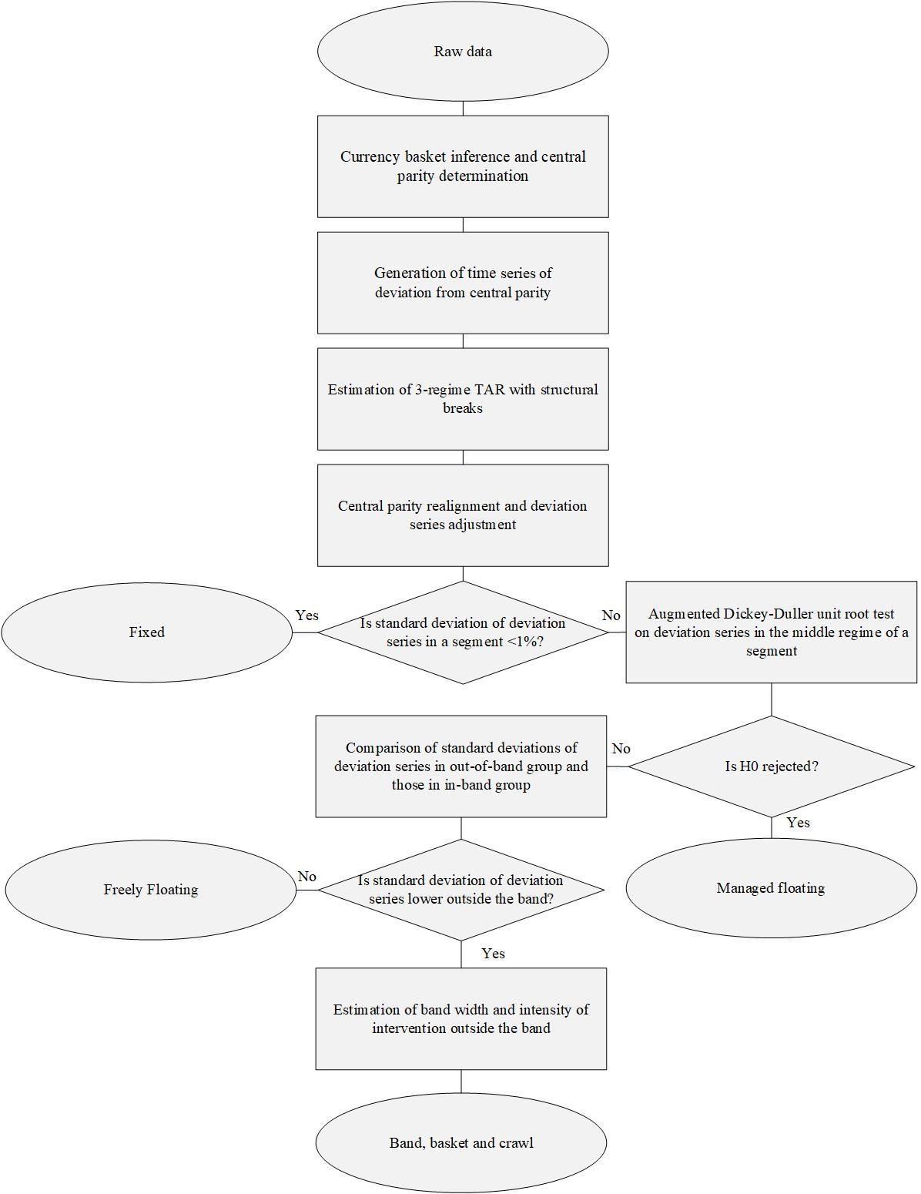
Figure 1 Algorithm for Exchange Rate Regime Estimation

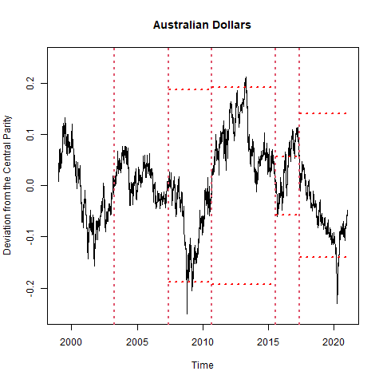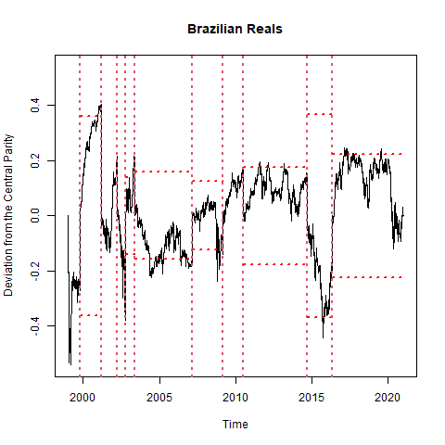
- (b)
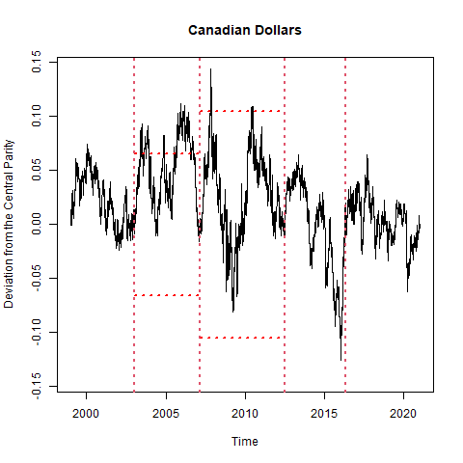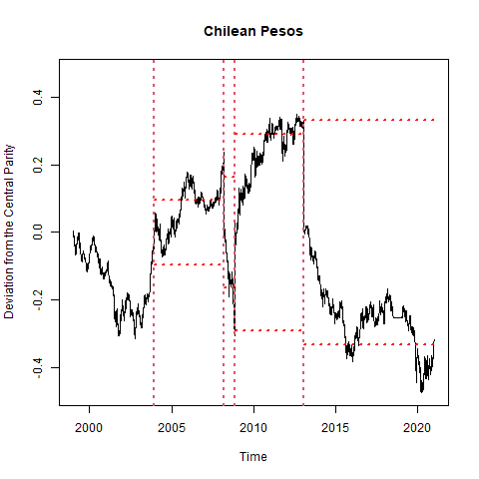
(c) (d)
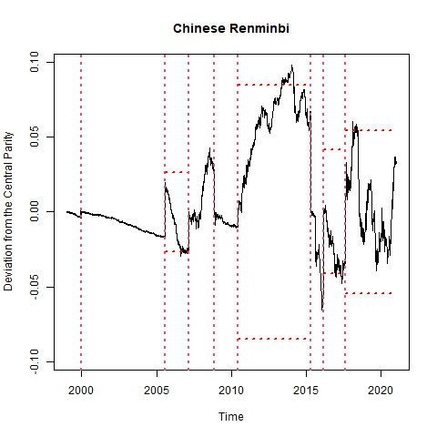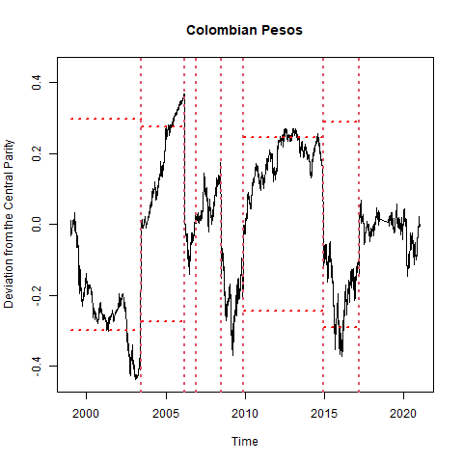
(e) (f)
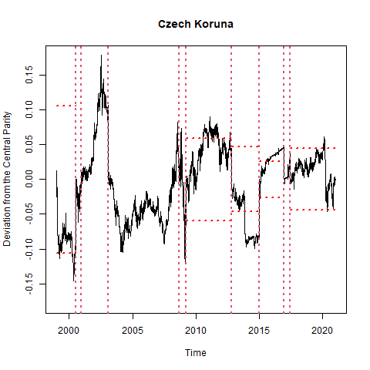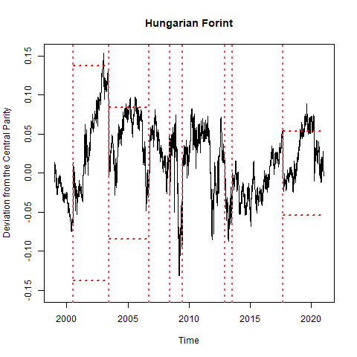
(g) (h)
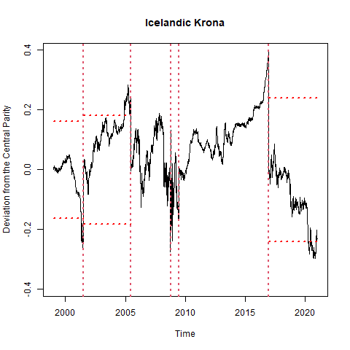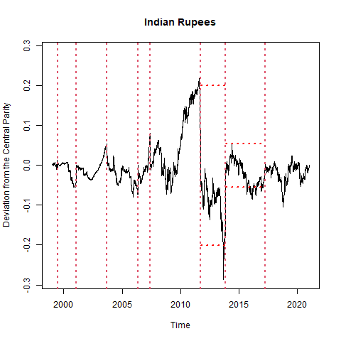
(i) (j)
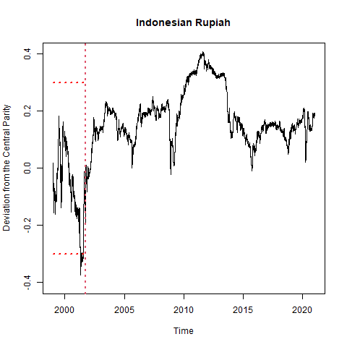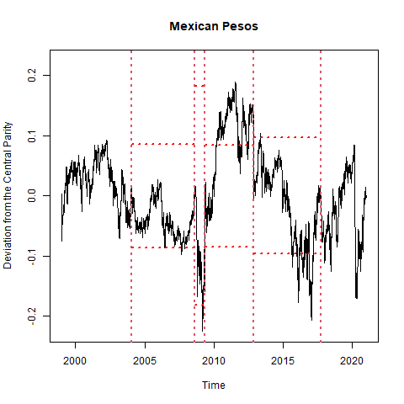
(k) (l)
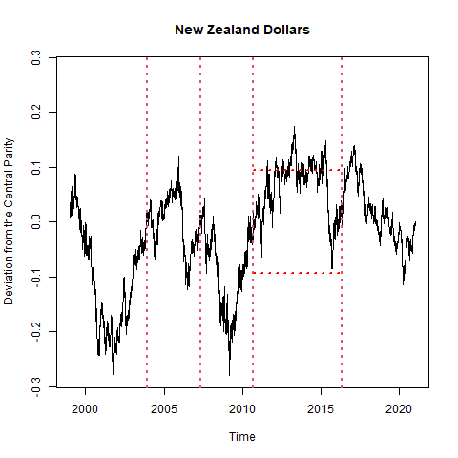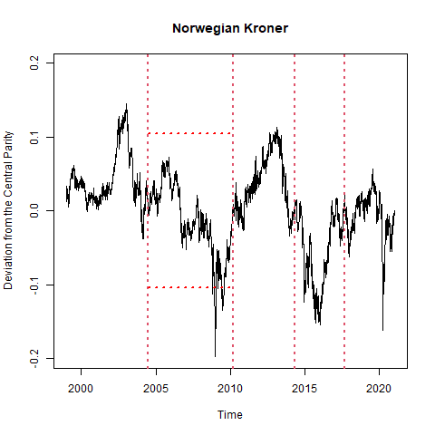
(m) (n)
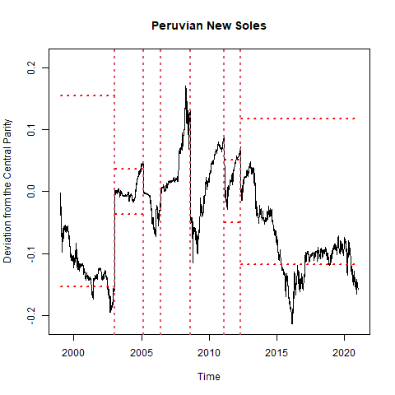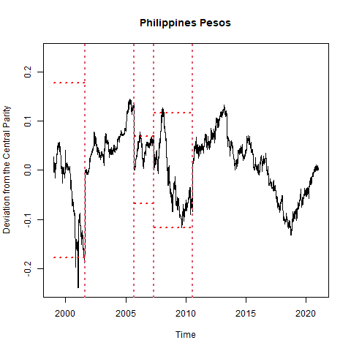
(o) (p)
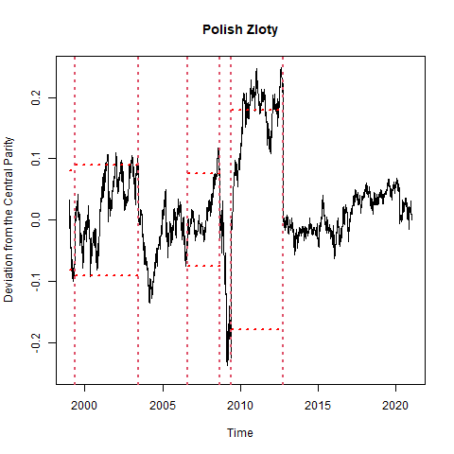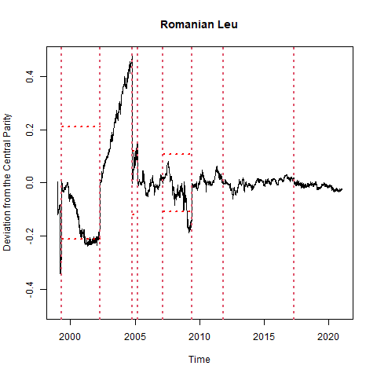
(q) (r)
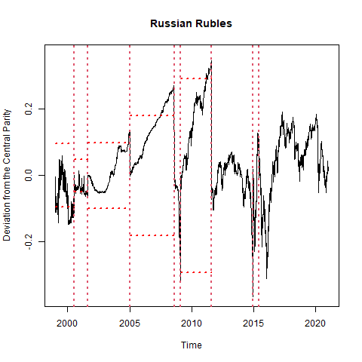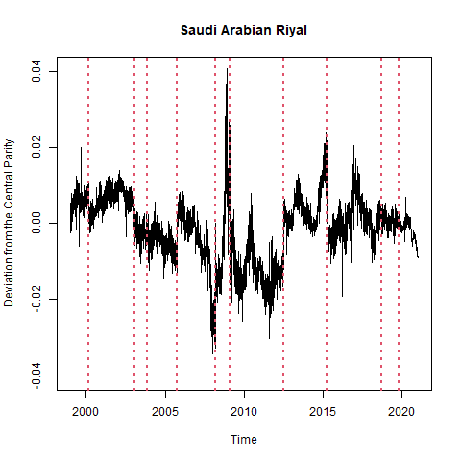
(s) (t)
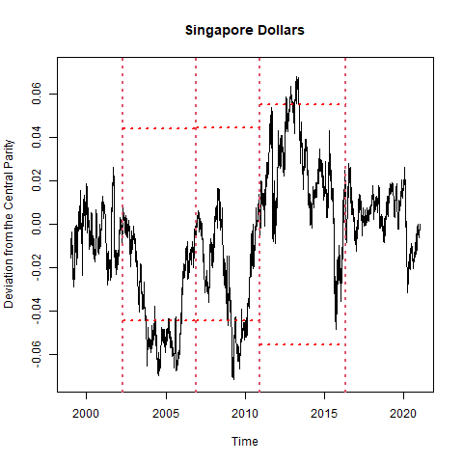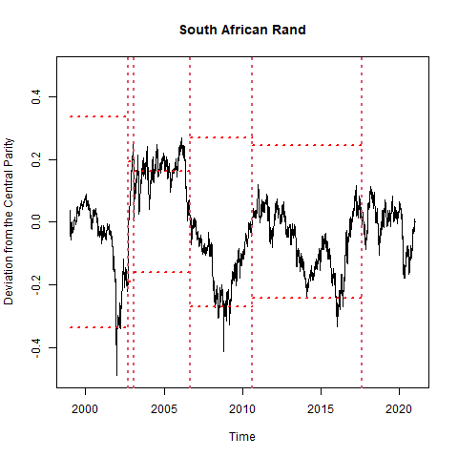
(u) (v)
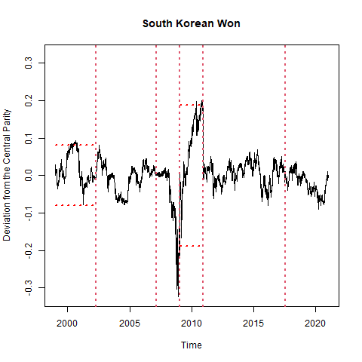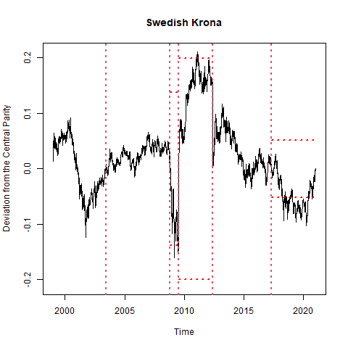
(w) (x)
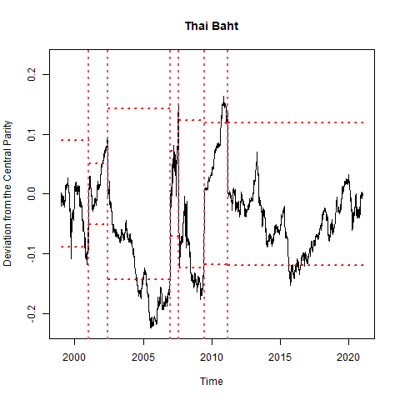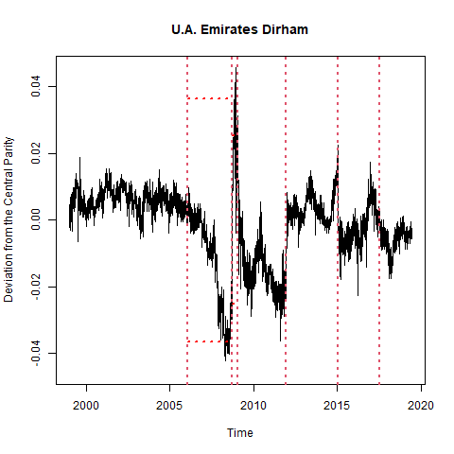
(y) (z)
Figure 2 Cumulative Deviation from Central Parity, Structural Breaks, and Target Zone
Note: The black lines plot the series of the exchange rate’s cumulative deviation from the central parity. The vertical dashed lines correspond to the estimates of structural breaks, and the horizontal dashed lines correspond to the threshold estimates. If a country is fount to follow a fixed regime or a floating regime, the thresholds are not reported.

Jeffrey Frankel, Harvard Kennedy School, Harvard University, Cambridge, MA, USA. Email: jeffrey_frankel@harvard.edu.
Yao Hou, Department of Economics, University of Rochester, Rochester, NY, USA. Email: yhou16@ur.rochester.edu.
Danxia Xie, Institute of Economics, Tsinghua University, Beijing, China, 100084. Email: xiedanxia@tsinghua.edu.cn
Dubbed a BBC regime by Williamson (2001).
These attempts include Zhu and Ling (2012) and Gao and Ling (2019). Their methods apply only to cases where the number of structural breaks is known, whereas we usually have no prior knowledge on the number of exchange rate regime changes a country experienced over a certain period.
See Flood and Garber (1991), Bertola and Caballero (1992), Anthony and MacDonald (1998), and Lundbergh and Terasvirta (2006).
The numeraire for the “value” of currencies is here measured in Special Drawing Rights, following Frankel and Wei (2008). Alternative numeraires are also possible. Under a pure basket peg, the choice of numeraire makes no difference.
In keeping with the practice that, when the monetary authority starts a new exchange rate regime, it typically sets the central parity equal to the actual exchange rate (Brooks and Revéiz 2002; Lundbergh and Terasvirta 2006), we assume that the two are equal at the start. Thus, the sum of the residuals from the start of a regime to the current trading day accurately captures the cumulative percentage deviation from the central parity.
The specification of exchange rate dynamics within a target band we adopt here differs from the Krugman target zone model. In his model, rational expectations imply a distribution that is not a random walk inside the band, because speculators face a one-sided bet as the exchange rate draws close to the margin of the target zone. However, in our definition, the exchange rate can wander outside the margins, and so it is not a one-sided bet, allowing us to model exchange rate changes inside the target band with a random walk.
As Frankel (2019) notes, in addition to the systematic managed floating regime explicitly defined here, there are murky intermediate regimes. Unlike under systematic managed floating regimes, under murky regimes, the authority intervenes in the foreign exchange market without a clear rule. Though this kind of regime can scarcely be parameterized, the authority’s intervention under this regime may still make the dynamics of the exchange rate depart from a random walk and lead to the rejection of the null hypothesis of the unit root test. In the estimation procedure we will discuss later, we utilize this fact to distinguish murky regimes from BBC regimes, just as we similarly do for systematic managed floating, and group together these regimes and systematic managed floating regimes into managed floating regimes.
The intensity of intervention can also be inferred by the estimated coefficient of the lagged term of the autoregressive process outside the band. However, throughout this paper, we choose to use the standard deviation of the error term as an (inverse) proxy for intensity of intervention, because the estimates of the coefficient of the lagged term we obtain are sometimes misleading. The misidentification is particularly evident when the intervention targets $χ_{1}$ and $χ_{2}$ the authority sets are close to the value of the lagged term $X_{t-1}$ outside the band, under which the econometric procedure typically overestimates the coefficient of the lagged term and underestimates the intercept term, as much of the intercept term is now mistaken for a part of the autoregressive term. In the extreme case, the estimated coefficient of the lagged term can be close to 1 though the intensity of intervention is actually substantial. (We will see this scenario in the section describing the estimation results.) However, no matter whether this misspecification emerges, we can always correctly detect higher intensity of intervention by lower volatility of the error term.
One potential solution is to decompose the two-dimensional inference problem into two subproblems of one-dimensional inference. For instance, we may first identify structural breaks of exchange rate regimes in the time dimension by using breakpoint detection techniques like that used by Frankel and Xie (2010), and then estimate a three-regime TAR model within the segment between two adjacent break points in the state dimension. However, the drawback of this solution is notable. The Frankel-Xie method allows us to identify two types of exchange regime changes, changes in the basket of currencies a country pegs its exchange rate to and changes in exchange rate flexibility. Nevertheless, as we show before, there are other types of regime changes, such as changes in the pattern of intervention, that cannot be detected by observing the variation in exchange rate flexibility or the pegged basket. For example, if the monetary authority keeps the pegged basket unchanged and switches between two regimes with similar exchange rate flexibility (e.g., from a managed float to a BBC regime or from a BBC regime with a loosely-managed narrow band to a BBC regime with a strict but wide band), the Frankel-Xie method will not detect a regime change even though it takes place.
Yau et al. (2015) infer the number of regimes and the lagged order of each regime in a TAR model via statistical inference. In contrast, we restricted the number of regimes to three and the lagged order to one, to accord with the practice that a monetary authority running a BBC regime typically follows.
The PACIFIC Exchange Rate Service database provides daily exchange rate data from 79 economies. We report the estimation results of only some of these economies due to space limitations.
Some estimates of the coefficient of the lagged term outside the band are close to 1, thus contradicting the corresponding intensity estimated by our procedure. We attribute the inconsistency to the misidentification we point out in Footnote 11.
E.g., Rajan (2010), Frankel (2019).

