The Virus, Vaccination, and Voting: An Econometric Analysis
Jeffrey Frankel, Harvard Kennedy School
Draft, July 18, 2021
This document is background for a column written for Project Syndicate.
The author would like to thank Randy Kotti for excellent research assistance.

If we can accomplish the scientific miracle of developing vaccines capable of ending the Covid-19 pandemic, why can’t we convince enough people to get vaccinated? In lower-income countries, vaccination is often limited by the availability of the vaccines. But this is not the case in countries as fortunate as the United States, where the problem is primarily vaccine hesitancy, or even outright vaccine hostility.
- Introduction: Two Americas of perceptions
To many, it is crystal clear that the advantages of getting vaccinated far outweigh the disadvantages – not just for society as a whole, but also for the individual. What explains widespread vaccine hesitancy? In the words of Dr. Anthony Fauci, there are two Americas. Their perceptions regarding vaccination are separated by a wall -- socially, epistemologically, and to an extent geographically.
The Food and Drug Administration authorized use of three vaccines, in response to the covid-19 emergency, after appropriate trials. (That is, Moderna, Pfizer and Johnson & Johnson.) Those in the other America, however, are not always persuaded by appeals to the expertise of remote authorities or by the logic of scientific methods. The skeptics need evidence that is more tangible, closer to home.

- The negative correlation between vaccination and virus victims
Recent data across US counties show a strong negative correlation between vaccination rates and rates of infection, hospitalization or death. In the week ending June 22, counties where 30 % or fewer residents had been vaccinated suffered 5.6 covid deaths per 100,000, while counties in which more than 60 % of residents had been vaccinated experienced less than half the deaths, only 2.1 per 100,000. This seems like evidence that is perhaps tangible and closer to home than FDA trials.
The criterion for cause of death in all these studies is whether the doctor or coroner enters covid-19 on the death certificate. This probably understates the true number of deaths caused by covid-19, as international studies of excess mortality rates strongly suggest.
Table 2, below, is based on updated county-level data. A Data Appendix to this paper explains the definitions and sources of the numbers used.
As shown in column 1 of Table 2, a 1 percentage-point increase in a county’s percentage of residents (12 years old and older) who were fully vaccinated as of June 9th was associated with a covid-19 death rate over the subsequent 30 days (to July 9th ) that was lower by a highly significant .057 per 100,000 inhabitants. That represents 2% of the total monthly deaths related to covid. Extrapolating, the apparent statistical effect of going from the current vaccination rate to 100% vaccination would be to bring covid-related deaths to near 0.
But, as they say, correlation need not prove causality.
Perhaps the apparent beneficial effect of vaccination is really the illusory result of an omitted variable, some third factor such as the county’s poverty rate. That is, perhaps low-income people are more likely to live in crowded conditions and for that reason to become covid victims, while at the same time they are less likely to get vaccinated. One can control in the regression equation for third factors such as the poverty rate or local temperature, to isolate the effect of vaccination rates.
Or perhaps the simple observed correlation between vaccination and the death rate understates the true effect of the former on the latter, because of the endogeneity of vaccination. In a place where the coronavirus is a greater danger (say, because it is close to a major airport or other transport hub, or because of other chance spreading), people are more likely to see their neighbors falling victim to the virus and to react by deciding to get vaccinated themselves. This reverse causality could work toward an apparent positive correlation between vaccination and death rates.
This might help explain why earlier studies, one conducted as recently as the beginning of June 2021, did not find a clear negative correlation. Only recently, has the beneficial effect of vaccination been powerful enough to dominate the statistical correlation. The reason for the evolution is probably the rising challenge of the Delta variant to the health of the unvaccinated.

- Voting as an instrumental variable for vaccination
The way to disentangle the causality is to examine the effects of variation in vaccination rates that is due not to variation in the spread of the disease, but rather to some unrelated factor, an exogenous instrument. Party affiliation or voting patterns are obvious choices. (Even before the vaccines were available, for example, red-state governors in 2020 were found less likely to fight the coronavirus by steps such as promulgation of mask mandates.) The idea of this paper is simply to use partisan status as an instrumental variable for the vaccination rate.
As has been extensively reported, Republicans and those who voted for Donald Trump in the 2020 presidential election are less likely to have gotten vaccinated. A PRRI-IFYC survey conducted in March 2021 found that Republicans are less likely than Democrats to accept vaccination, by 45% versus 73%. A New York Times article on April 17 found that the vaccination rate fell below 25% in counties where Trump won by a margin of 50 percentage points or more. The vaccination gap continued to widen in July. Figure 1 illustrates the county-level relationship between the vote in the 2020 election and the vaccination rate as of July 2021.

Figure 1: County-level vaccination rates in 2021 are correlated with presidential vote in 2020
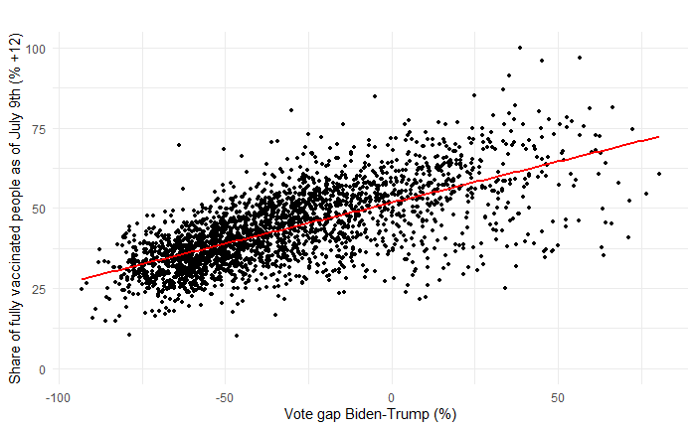

Figure 2: County-level covid-related deaths are negatively correlated with vaccination rates a month earlier (showing counties that reported at least one covid-death in the period)
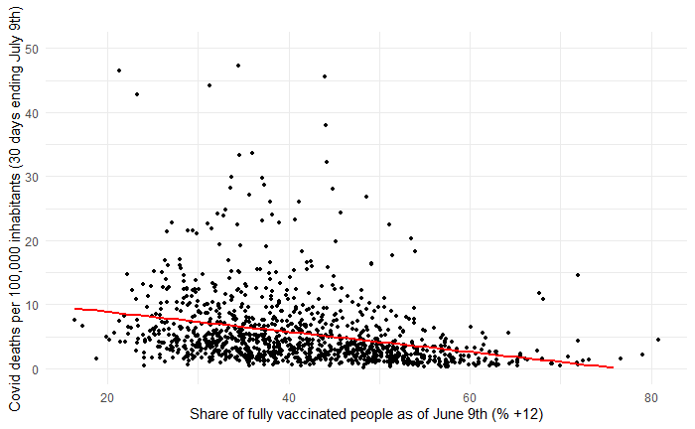

Column 2 of Table 2 controls for the poverty rate, age, and temperature in an equation to determine the covid-19 fatality rate. These variables are statistically significant, with the effect on mortality that one would respect. Low-income people are more likely to die of Covid-19, presumably because they were less healthy to begin with or do not receive as good medical care. Older people are much more vulnerable to the virus physically. And warm temperatures encourage people to spend more time outdoors (though this effect was probably not as strong in June as in earlier colder months).
With the controls, the results in Column 2 of Table 2 show that a 1 percentage-point increase in the number of adults (and teenagers) who were fully vaccinated in a county as of June 9th is associated with a covid-19 death rate during the subsequent 30 days (to July 9th ) that was lower by an estimated .050 per 100,000 inhabitants. The effect is still highly significant statistically. Controlling for poverty and the other variables lowered the estimated coefficient slightly, but not significantly so.
But even with the controls, the estimate is biased if the vaccination decision is influenced by covid-19 prevalence, as noted. Next, we see what difference it makes to use Instrumental Variables to get the causality right.
Table 1 verifies that Trump voters are less likely to have gotten vaccinated than Biden voters, not just as a matter of simple correlation but also when we control for other relevant variables: poverty, age, population density, race and temperature. Use of the controls reveals an even stronger effect of partisan stance on the decision to get vaccinated: If a county supported Trump in the election, that is associated with a vaccination rate up to June 9 that increases by a highly significant 13 percentage points (column 3). For every percentage point in the Biden-Trump vote spread, the vaccination rate goes up by another .302 percentage points (column 4).
Using variation in the vaccination decision attributable solely to Trump-affinity, we find in Column (3) of Table 2 that the IV-estimated coefficient on vaccination rises relative to the OLS estimate. A reasonable interpretation is that Instrumental Variables successfully addresses the reverse causality problem, that covid deaths have an effect on the decision to get vaccinated.
But this is without the controls. Column (4) adds the controls back in: poverty, age and temperature. As in the OLS estimates of Column (2), all three controls are statistically significant. The number of most interest is the instrumented effect of vaccination. It shows that a 1 percentage-point increase in a county’s vaccination rate as of June 9th reduced the covid-19 death rate during the subsequent 30 days (to July 9th) by .042 per 100,000 inhabitants. Controlling for the poverty rate and other variables again lowered the coefficient estimate a bit. But the important finding is that it remains statistically significant.
The reason for looking at the voting pattern was to improve the estimate of the vaccine effectiveness on anyone, regardless of political party. But perhaps some of the skeptics who live in “the other America” will notice a higher casualty rate and will change their minds.

Table 1
First Stage: Vaccination rates by county, determined by Biden vote and other controls
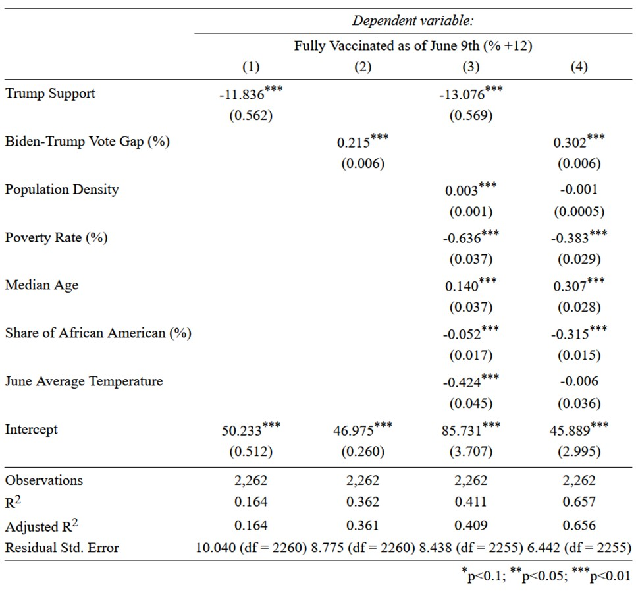
Notes: Data at the county level. The share of fully vaccinated people above 12 years old, as of June 9th, is expressed in percentage point as reported by the CDC and the states of Texas, Colorado, and Massachusetts. Trump Support is an indicator variable equal to 1 in a given county if D. Trump received more votes than J. Biden at the 2020 Presidential Election. The Biden-Trump Vote Gap measures the difference in relative votes between Trump and Biden (positive when Biden received more votes). The population density (hab/km²), poverty rate (percentage point), median age, and share of African Americans (percentage point) are obtained from the US Census 2019 estimate. The June Average Temperature is obtained from the National Centers for Environmental Information. Data exclude states of Hawaii, Georgia, West Virginia, Virginia, and Vermont due to faulty reporting. Historical vaccination data are also missing for Texas and Colorado.

Table 2
Second Stage: Covid-19 death rates by county, determined by vaccination rate and other controls.
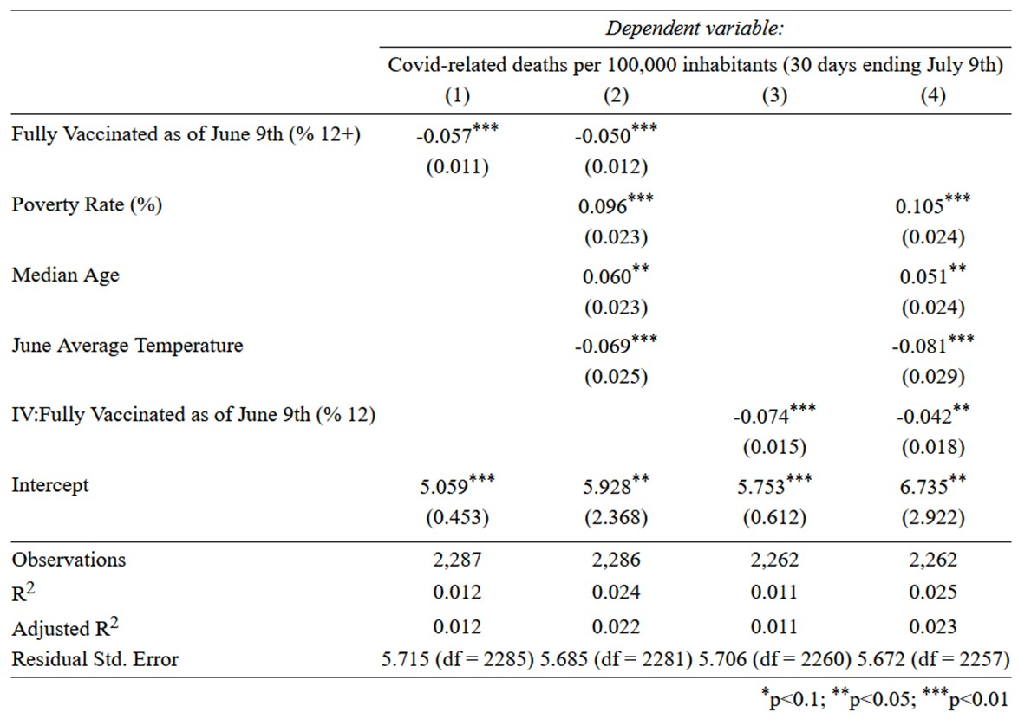
Notes: Data at the county level. The number of Covid-related deaths are aggregated between June 9th and July 9th and normalized per 100,000 inhabitants (CDC). The share of fully vaccinated people above 12 years old, as of June 9th, is expressed in percentage point as reported by the CDC and the states of Texas, Colorado, and Massachusetts. The poverty rate (percentage point) and median age are obtained from the US Census 2019 estimate, and the June Average Temperature from the National Centers for Environmental Information. IV: Fully Vaccinated as of June 9th (%) denotes an instrumented version of the vaccination rate by the vote gap between Biden and Trump at the 2020 Presidential election, the poverty rate, county median age, and June temperature. Data excludes states of Hawaii, Georgia, West Virginia, Virginia, and Vermont due to faulty reporting. Historical vaccination data are also missing for Texas and Colorado.

References

Adeel, Abdul Baseet, et al., 2020. “COVID-19 Policy Response and the Rise of the Sub-National Governments,” Canadian Public Policy (UTP Journals Press), Vol. 46, Issue 4, Dec., pp. 565-584.
Çakmaklı, Cem, Selva Demiralp, Şebnem Kalemli-Özcan, Sevcan Yesiltas, and Muhammed A Yildirim. 2020. “COVID-19 and Emerging Markets: An Epidemiological Model with International Production Networks and Capital Flows.” NBER Working Paper 27191.
———. 2021. “The Economic Case for Global Vaccinations: An Epidemiological Model with International Production Networks.” NBER Working Paper 28395.
Leonhardt, David. 2021. “Red America’s Covid Problem,” New York Times, June 28.

Neelon, Brian, Fedelis Mutiso, Noel Mueller, John L. Pearce, and Sara Benjamin-Neelon.

2021. “Associations Between Governor Political Affiliation and COVID-19 Cases, Deaths, and Testing in the U.S.,” American Journal of Preventive Medicine, Volume 61, Issue 1, 2021, Pages 115-119.
Washington Post. 2021. “Coronavirus infections dropping where people are vaccinated, rising where they are not, Post analysis finds,” June 14.

Appendix 1: Extensions and Robustness
The number of covid-19 attributed deaths reported daily suffers approximations, errors, and omissions that the New York Times endeavors to correct in its calculations of weekly rolling averages. Table 3 uses these corrected averages and focuses on counties that reported at least one death in the 30 days leading to July 9th.
Using these corrections, column 4 of Table 3 reports that a 1 percentage-point increase in a county’s vaccination rate as of June 11th reduced the covid-19 death rate during the subsequent 4 weeks (to July 9th) by .176 per 100,000 inhabitants in counties that suffered at least one covid-19 death during the same period. This estimate is substantially larger than that shown in Table 2, which indicates that vaccination has a much larger effect in the counties where covid-19 still claims lives.
Table 4 includes additional covariates (population density, race, and mask use) to the second-stage regression of covid-related deaths. The mask use index was derived from a 2020 survey from the New York Times undertaken at the county level, asking how often people would wear a mask in public. None of these additional controls appears to have a significant effect on covid-related deaths during the period June 9th to July 9th.
However, all covariates have a significant and large effect on the rate of covid contaminations. Column 1 of Table 5 shows that a 1 percentage-point increase in the number of adults (and teenagers) who were fully vaccinated in a county as of June 9th is associated with a covid-19 contamination rate during the subsequent 30 days (to July 9th) that was lower by an estimated 5.220 cases per 100,000 inhabitants. Using an instrumented variable for the vaccination rate and controlling for poverty, mask use, and the other variables lowered the estimated coefficient to 3.864 (column 5). This represents a relative reduction of 2.5 percent in the average infection rate over the 30 days ending July 9th.

Table 3
Second Stage: Covid-19 case rates by county, determined by vaccination rate and additional controls using the New York Times corrected estimates for counties reporting at least one death in the period June 11th – July 9th.
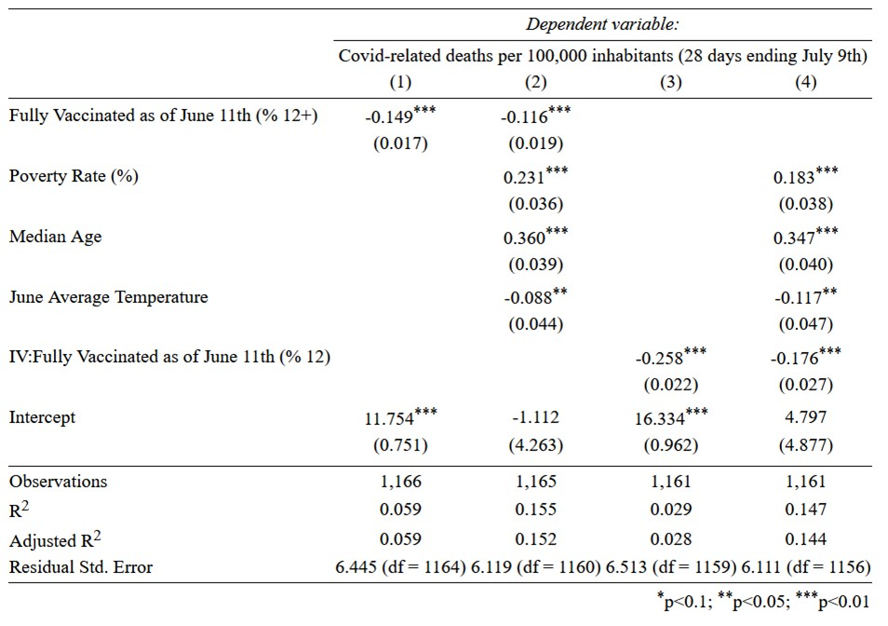
Notes: Data at the county level. The number of Covid-related cases are aggregated between June 11th and July 9th and normalized per 100,000 inhabitants using the NYT corrected rolling averages. Data excludes counties that did not report any covid-19 death in the period. The share of fully vaccinated people above 12 years old, as of June 11th, is expressed in percentage point as reported by the CDC and the states of Texas, Colorado, and Massachusetts. The poverty rate (percentage point) and median age are obtained from the US Census 2019 estimate, and the June Average Temperature from the National Centers for Environmental Information. The mask use indicator was obtained from a 2020 survey conducted by the New York Times (see data appendix for more details). IV: Fully Vaccinated as of June 9th (%) denotes an instrumented version of the vaccination rate by the vote gap between Biden and Trump at the 2020 Presidential election, the poverty rate, county median age, June temperature, log population density, share of African American, and mask use. Data excludes states of Hawaii, Georgia, West Virginia, Virginia, and Vermont due to faulty reporting. Historical vaccination data are also missing for Texas and Colorado.

Table 4
Second Stage: Covid-19 death rates by county, determined by vaccination rate and additional controls
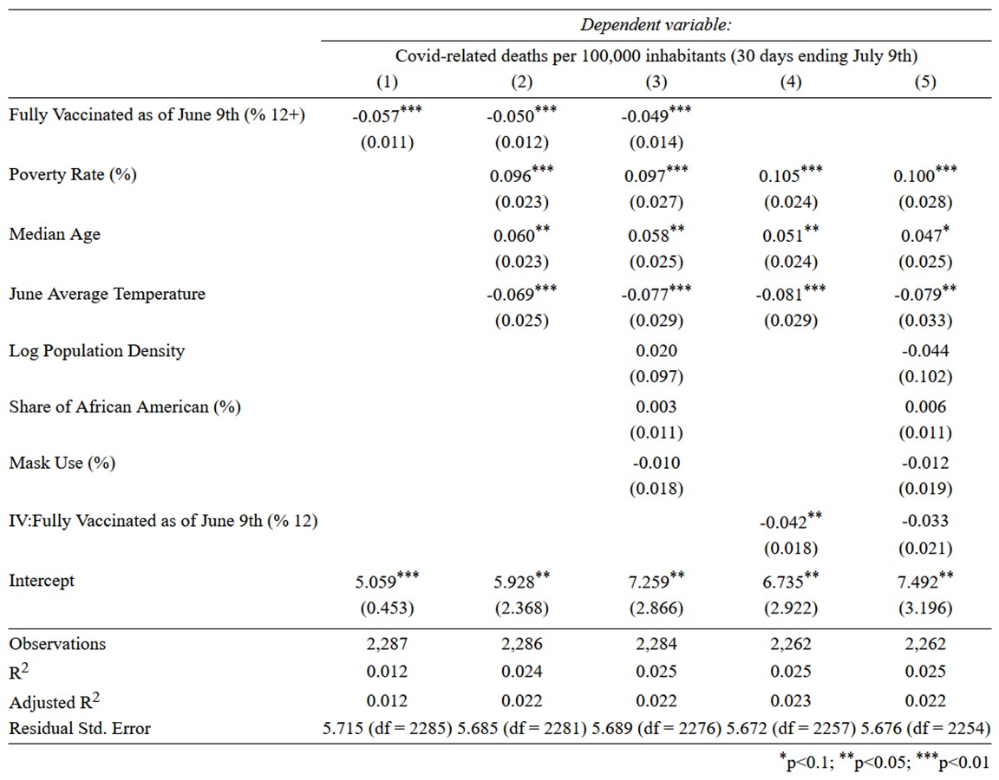
Notes: Data at the county level. The number of Covid-related deaths are aggregated between June 9th and July 9th and normalized per 100,000 inhabitants (CDC). The share of fully vaccinated people above 12 years old, as of June 9th, is expressed in percentage point as reported by the CDC and the states of Texas, Colorado, and Massachusetts. The poverty rate (percentage point), median age, population density (hab/km²), and share of African American population (percentage point) are obtained from the US Census 2019 estimate, and the June Average Temperature from the National Centers for Environmental Information. The mask use indicator was obtained from a 2020 survey conducted by the New York Times (see data appendix for more details). IV: Fully Vaccinated as of June 9th (%) denotes an instrumented version of the vaccination rate by the vote gap between Biden and Trump at the 2020 Presidential election, the poverty rate, county median age, June temperature, log population density, share of African American, and mask use. Data excludes states of Hawaii, Georgia, West Virginia, Virginia, and Vermont due to faulty reporting. Historical vaccination data are also missing for Texas and Colorado.

Table 5
Second Stage: Covid-19 case rates by county, determined by vaccination rate and additional controls
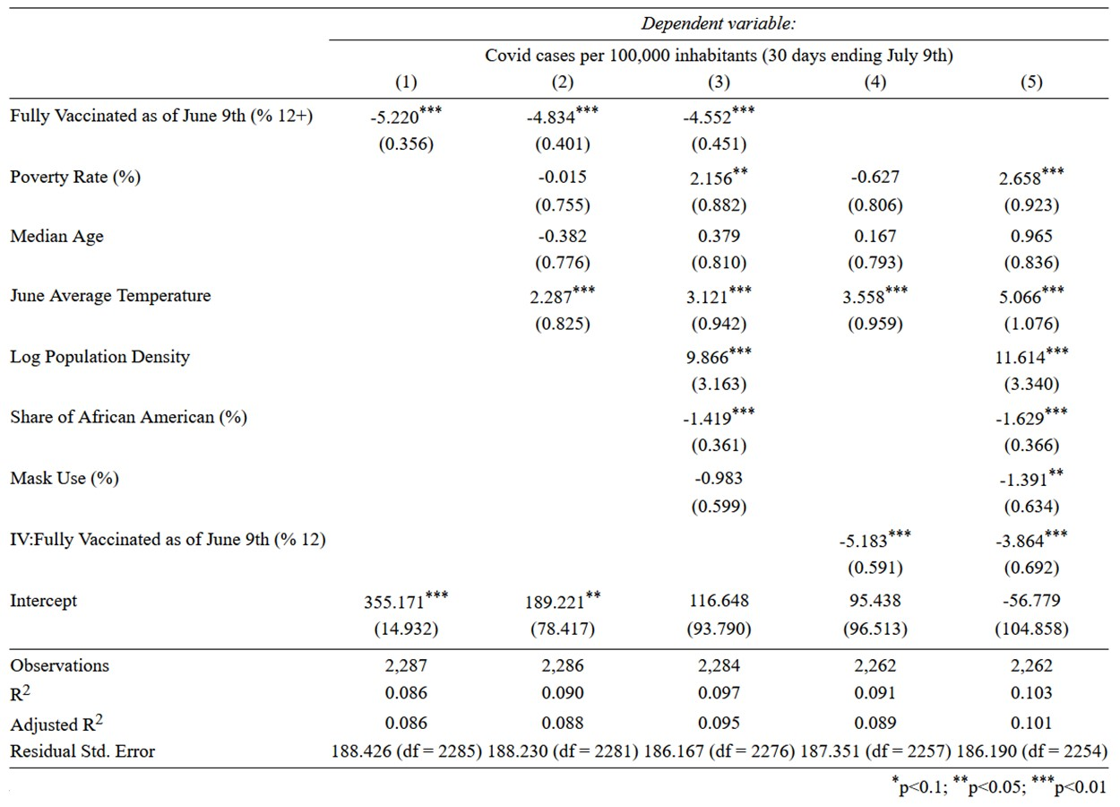
Notes: Data at the county level. The number of Covid-related cases are aggregated between June 9th and July 9th and normalized per 100,000 inhabitants (CDC). The share of fully vaccinated people above 12 years old, as of June 9th, is expressed in percentage point as reported by the CDC and the states of Texas, Colorado, and Massachusetts. The poverty rate (percentage point), median age, population density (hab/km²), and share of African American population (percentage point) are obtained from the US Census 2019 estimate, and the June Average Temperature from the National Centers for Environmental Information. The mask use indicator was obtained from a 2020 survey conducted by the New York Times (see data appendix for more details). IV: Fully Vaccinated as of June 9th (%) denotes an instrumented version of the vaccination rate by the vote gap between Biden and Trump at the 2020 Presidential election, the poverty rate, county median age, June temperature, log population density, share of African American, and mask use. Data excludes states of Hawaii, Georgia, West Virginia, Virginia, and Vermont due to faulty reporting. Historical vaccination data are also missing for Texas and Colorado.

Appendix 2: Data
The analysis relies on data gathered from different sources at the county level. We used the data made available by the Centers for Disease Control and Prevention (CDC) for covid-19 cases and deaths. The vaccination rates also come from the CDC, except for the states of Texas, Colorado, and Massachusetts, who report independently the progress of their vaccination campaigns on dedicated websites [Texas Department of State Health Services, Colorado Department of Public Health & Environment, Massachusetts Department of Public Health]. The vaccination numbers reported at the CDC level are missing for more than a quarter of the counties located in the states of Hawaii, Georgia, West Virginia, Virginia, and Vermont. Where specified, we have excluded those states altogether. We complemented covid-related data with the 2020 Presidential Election county results as reported by the MIT Election Data and Science Lab.
We also added a set of covariates at the county level likely to explain covid mortality and vaccination decisions. On the demographic side, we relied on 2019 estimates of population, poverty rate, race, and median age, computed by the US Census Bureau based on the 2019 American Community Survey. We also used counties’ land area reported by the US Census Bureau to calculate population densities. We included monthly average temperatures reported by the National Centers for Environmental Information and a survey conducted by the New York Times between July 2nd and July 14th, 2020 relative to mask use. The specific question was “How often do you wear a mask in public when you expect to be within six feet of another person?”. Based on the answers “never, rarely, sometimes, frequently, always”, we created a scale between 0 and 100, 100 meaning that the entire population in a given county reported “always” using a mask in public.
Table A1 summarizes the variables used in this paper.

Table A1
Variable | Description | Source
Biden-Trump Vote Gap (%) | Computed as the difference in relative votes obtained by J. Biden and D. Trump at the 2020 Presidential Election. In a county where D. Trump received 42% of the votes, and J. Biden 46%, the metric would be 4%. | MIT Election Data and Science Lab
Fully Vaccinated as of June 9th (% +12) | Share of the population above 12 years old who received a complete vaccination as of June 9th. | CDC and State Sources (TX, CO, MA)
Covid-related deaths per 100,000 inhabitants (30 days ending July 9th) | Deaths attributed to covid summed over 30 days ending July 9th and normalized per 100,000 inhabitants. | CDC
Poverty rate (%) | Share of population living under the income threshold as defined by the US Census, which varies by family size and composition, but not geographically (2019). | US Census Bureau
Median Age | County median age estimate (2019). | US Census Bureau
Share of African American (%) | Census estimate of the share of African American population, including people reporting multiple ethnicities (2019). | US Census Bureau
Population Density | Obtained by dividing population estimates by land areas, expressed in inhabitant per km² (2019). | US Census Bureau
Mask Use | 2020 survey asking “How often do you wear a mask in public when you expect to be within six feet of another person? never, rarely, sometimes, frequently, always”, rebased between 0 and 100. | New York Times
June Average Temperature | June monthly average temperature by county (°F). | National Centers for Environmental Information

Çakmaklı, et al. (2020, 2021).
AstraZeneca was found among the British population to have proven equally effective, despite somewhat lower efficacy in the controlled trials.
Leonhardt (2021).
Most of the key data come from a New York Times site. Appendix 1 to this paper checks the robustness of the results with respect to some decisions regarding how the covid-related death rate is counted.
Washington Post (2021).
Adeel, et al. (2000) and Neelon, et al. (2021).
The “partisan gap holds even after accounting for income, race and age demographics, population density and a county’s infection and death rate.”
The results are very similar when we add population density and race to the list of controls. These two variables do not, however, show up as statistically significant determinants of covid-19 mortality once the effects of vaccination and the poverty rate are taken into account.
Temperature can be interpreted as an exogenous determinant of vulnerability to Covid, which in turn influences the decision to get vaccinated.
A reasonable interpretation is that lower-income people are both less likely to be vaccinated (as confirmed in the 3rd and 4th columns of Table 1) and beyond that are more likely to fall victim to Covid-19.
MIT Election Data and Science Lab, 2018, "County Presidential Election Returns 2000-2020", https://doi.org/10.7910/DVN/VOQCHQ, Harvard Dataverse, V9, UNF:6:qSwUYo7FKxI6vd/3Xev2Ng== [fileUNF]
https://www.census.gov/topics/income-poverty/poverty/guidance/poverty-measures.html

